Collective Action by Contract: Prior Appropriation and the Development of Irrigation in the Western United States*

Bryan Leonard and Gary D. Libecap
May 2018

Abstract
We analyze the economic characteristics of prior appropriation water rights, adopted across the U.S. West in the 19th century. Much of the region’s massive irrigation infrastructure was developed by private irrigators. We develop a model to show how prior appropriation facilitated investment by i) securing water against future claims and ii) defining a property right to a specific amount of water that was the basis for contracting among numerous, heterogeneous agents. We construct a dataset of over 7,000 water rights in Colorado from 1852 to 2013 including location, date, size, infrastructure investment, irrigated acreage, and geographic characteristics to test the predictions of the model. We find that prior appropriation facilitated cooperation through contracting, increasing infrastructure investment, and promoting irrigated agriculture that contributed up to 16% of western state income by 1930. Areas with pre-existing norms for supporting collective action exhibit smaller differences in investment based on formal contracts.
JEL Codes: K11,N51,N52,Q15,Q25,Q28

“The peculiarity of American institutions is, the fact that they have been compelled to adapt themselves to the challenges…to the changes involved in crossing a continent…” Frederick Jackson Turner, The Significance of the Frontier in American History, 1893, 7.

1. Introduction
Property rights are fundamental institutions for shaping economic behavior. When well-defined, secure, and durable, they contribute to economic growth (Acemoglu et al., 2001, 2005; Mehlum et al., 2006; Rodrik, 2008; Dixit, 2009; Besley and Ghatak, 2009), facilitate greater investment when returns are uncertain or delayed (Besley, 1995; Jacoby et al., 2002; Galiani and Schargrodsky, 2010; Lin et al., 2010), allow for the development of markets (Grief et al., 1994; Dixit, 2009; Edwards and Ogilvie, 2012), and reduce rent dissipation associated with common-pool resources (Gordon, 1954; Scott, 1955; Wiggins and Libecap, 1985; Gaudet et al., 2001; Wilen, 2005; Costello et al., 2008). The determinants of how property rights initially emerge in unique ways and the specific economic problems they solve have received little attention because voluntary major shifts in property institutions are rare, as are the data to analyze them. Despite identification challenges, analysis of the endogenous formation of property rights is crucial for understanding the conditions under which property rights generate efficiency gains net of the costs of establishing them.
In this paper, we exploit the empirical setting of the American frontier as a laboratory for voluntary institutional innovation and examine its economic characteristics. Settlers moved west across the continent after native claims had been swept aside. Migrants, seeking ownership of natural resources—land, timber, gold, and silver—proceeded ahead of formal state and territorial governments, bringing with them basic legal norms, but confronting unfamiliar conditions that required new arrangements for economic development (Anderson and Hill, 1975). These institutions appeared spontaneously via local bargaining and persist today, molding contemporary markets and policy (Libecap, 2007).
Our focus is on the abrupt, deliberate shift from common-law riparian water rights that dominated in the eastern United States to prior appropriation. The riparian doctrine grants use of undefined amounts of surface stream water to adjacent land holders, whereas the prior appropriation doctrine assigned ownership to a specified amount of water based on a first-come, first served basis. Unlike in-stream riparian uses, appropriative rights allowed water to be diverted for beneficial use at sites distant from streams. Prior appropriation displaced riparian rights across an immense area of some 2,965,305 square miles (17 western states and 4 Canadian provinces) and was later endorsed by federal and state law.
Most prior appropriation rights were established between 1850 and 1920 when water was valued primarily as an input to irrigated agriculture, where 40 to 80% of western water use remains today (Brewer et al., 2008). Private investment provided the majority of the region’s early irrigation infrastructure across the West. By 1920, $823,236,000,000( 2015 $) had been invested in 109,174 canals and ditches spanning 159,864 miles. Figure 1 shows the range of irrigated agricultural land by 1920 due to development of water supply and delivery systems.

Figure 1: Irrigation Networks in Arid Regions, West of the 100th Meridian
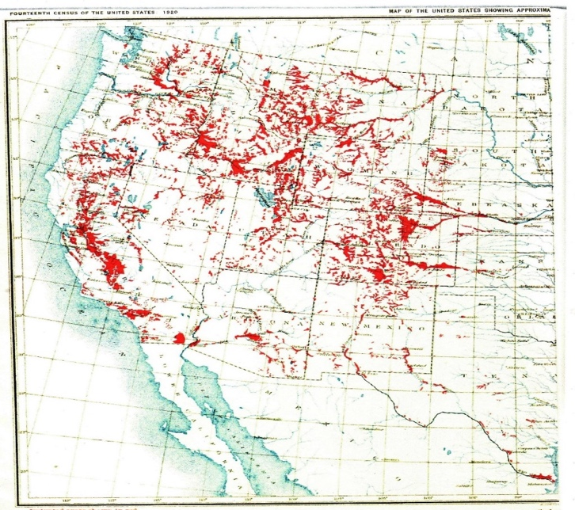
Source: US Census Bureau (1922, 1).

Previous work addresses why the riparian doctrine was not a feasible mechanism for allocating water in the rugged and semi-arid West, but has failed to explain why prior appropriation emerged as the solution (Rose, 1990; Kanazawa 2015). Potential efficiency losses associated with appropriative rights are well-studied (Burness and Quirk, 1979; Chong and Sunding, 2006; Brewer et al., 2008), but the net advantages of prior appropriation have not been examined. Given the relatively blank slate for defining property rights on the Western Frontier,
why did first possession dominate? And why create a priority-based system for allocating water rights rather than a proportional one?
Our contribution is to develop a positive explanation for the development of prior appropriation and to provide an empirical analysis of the institution’s economic role. We highlight how prior appropriation provided for relative security of water access in a semi-arid region where water was a crucial input to production. It then facilitated coordinated investment in irrigation by overcoming the credible commitment problems of concern to Teele (1904), Coman (1911), Ostrom (2011), Libecap (2011), and Hanemann (2014). Joint investment was required because individual irrigators lacked requisite funds, and external capital markets generally were unavailable on the frontier.
Our model demonstrates how quantification of water claims and priority-based allocation made collective action for investment and subsequent exchange possible. We develop a data set that includes the location, date, and size of over 7,000 water claims along with measures of infrastructure investment, irrigated acreage, crop choice, and geography in Colorado, the state where prior appropriation was most completely implemented initially. Our analysis of the institutional innovation underlying private investment in irrigation capital complements other literature that documents the role of infrastructure provision, such as railroads, in American economic development (Fogel, 1964; Donaldson and Hornbeck, 2016). In contrast to the case of publicly-subsidized railroads, we study infrastructure investment driven primarily by pivate contracting and underlying property rights arrangments.
This paper proceeds as follows. Section 2 describes the economic problem of irrigation and presents a model to illustrate how prior appropriation provided a solution. Section 3 describes the data and provides estimates of increases in per-acre agricultural income and the resulting economic development due to the appropriative system. Section 4 focuses on economic outcomes of prior appropation, demonstrating that secure property rights protected by the priority system facilitated joint action to construct larger ditch infrastructure than was otherwise possible, leading to subsequent development.
Section 5 provides additional evidence that prior appropriation rights led to cooperation by studying location choice. Section 6 compares the effect of formal property rights versus informal norms on investment cooperation among irrigators in different parts of Colorado where such institutional differences existed. We show that the added benefits of formal contracting are lacking where informal institutions had developed, but that formal property rights substaianally increase investment when Ostrom’s (1990) conditions for local resource management are not met due to large numbers of heterogeneous agents. Section 7 concludes.

2. The Economics of Water in the Semi-Arid West
2.1 . Historical and Institutional Background
Because the native population had been displaced and the federal government was remote, early migrants to the West had a relatively open slate to define different property institutions to frontier resources. Among the most dramatic shifts is the emergence of prior appropriation that assigned rights to water via first possession, based on the timing of the initial water diversion claim. First possession of water emerged as a de facto property rights system that was later formally adopted into law. Construction of an irrigation ditch to divert a specific amount of water from a given location on a stream in a timely manner for irrigation was sufficient to establish a claim and satisfy beneficial use requirements.
Prior appropriation resulted in a priority-based system of allocation during drought, whereby senior claims had to be fully satisfied before junior users could divert water, providing more certainty to water supplies for diversion and ditch investment. Critically, the priority system protected prior diversion amounts from being diminished by subsequent water claimants on a stream.
Today, return flow externalities and other third party effects make trading appropriative rights difficult (Chong and Sunding 2006; Olmstead 2010). Initially, however, the system had two key advantages over the incumbent riparian system that enabled market exchange of water rights for optimal ditch size construction. First, the explicit quantification of claims—lacking in a riparian system—is a precondition for exchange. Second, the appropriative system reduced monitoring costs because only juniors who had a “call” on them to release their water to seniors needed to be monitored, rather than every riparian user.
Figure 2 shows the distribution of major streams and the change in property rights regimes for water that occurred in jurisdictions west of the 100th meridian. The dates indicate constitutional, legislative, or judicial adoption of prior appropriation in each state. Populations in states with abundant water resources held to the riparian doctrine; those in states with both dry and wet regions maintained mixed systems, at least for awhile; and those in the most arid states with lower stream density rapidly adopted prior appropriation exclusively.

Figure 2: Prior Appropriation West of the 100th Meridian

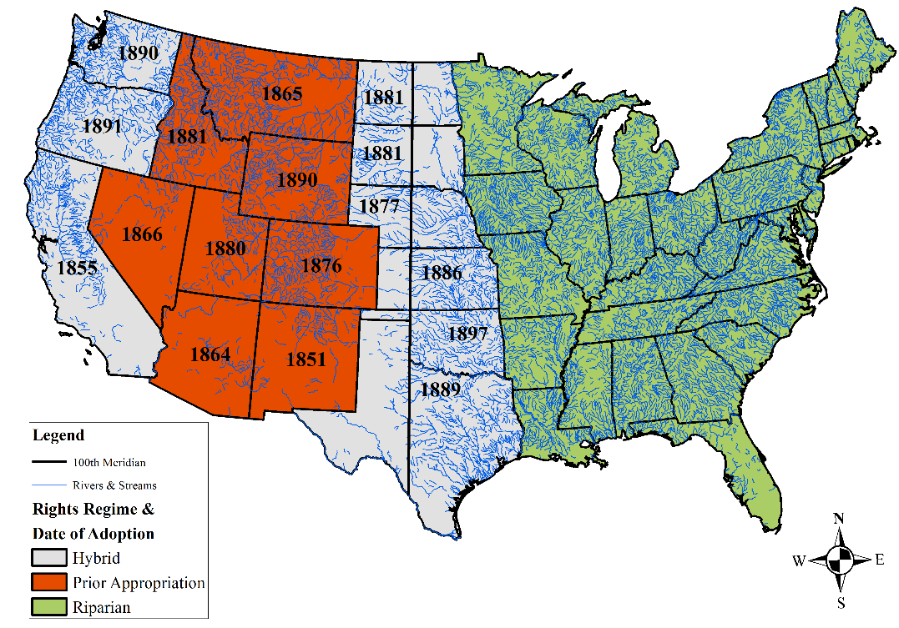

We focus on Colorado—the place where westward migrants along the agricultural frontier first encountered a semi-arid climate. Colorado exhibits the initial conditions facing settlers prior to the construction of large Bureau of Reclamation projects in 1920, and the state played a disproportionate role in influencing prior appropriation water rights development in other states with what became known as “The Colorado Doctrine” (Colorado Water Institute, ND, p. 1; Boyd, 1890, p. 136; Mead, 1901, p. 14; Hess, 1916, pp. 652-6; Hemphill, 1922, pp. 15-8; Dunbar, 1950, 1983, 1985; Hobbs, 1997; Schorr, 2005; Stenzel and Cech, 2013, p. 223).
Colorado covers an area of 66,620,160 acres containing over 107,000 miles of streams with elevations ranging from 3,317 to 14,440 feet. Figure 3 shows the evolution of water claims in Colorado over time and indicates that claimants arrived in waves, primarily late in the 19th century. The population of Colorado jumped sharply from 39,864 in 1870 to 539,700 people by 1900, fueled by migration into the farming regions east of the Rocky Mountains. The heterogeneity of migrants is demonstrated by the varied regions in the United States from which they came and by the large share of foreign-born individuals. For example, in 1880, 20.5% of the state’s population came from abroad (Gibson and Jung, 2006, Table 14).

Figure 3: The Timing and Volume of Water Claims in Colorado
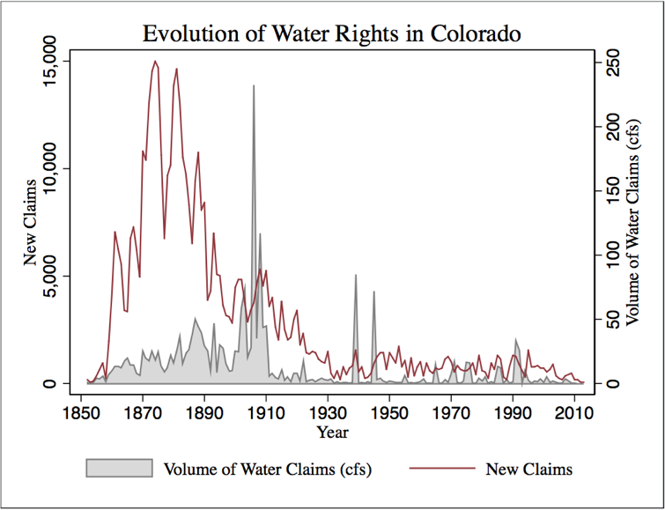

Colorado’s formal water rights institutions developed over time as competition increased, consistent with Demsetz (1967). In 1876, the Colorado Constitution formally proclaimed prior appropriation as the basis for water rights in the state. Statutes in 1879 and 1881 added administrative structures for the adjudication of conflicting water rights claims, measurement, monitoring, dispute resolution, and enforcement. The state was divided into 10 water districts with local water commissioners and water courts to determine and enforce priority. A state Hydrologic Engineer’s Office was created and county clerks were to record and define priority for appropriative claims that previously had been announced informally at diversion sites (Stenzel and Cech, 2013, pp. 188-215).
Finally, in 1882 the Colorado Supreme Court in Coffin v Left Hand Ditch Co (6 Colo 443) rejected remnants of riparianism in favor of prior appropriation (Colorado Water Institute ND, pp. 3-8; Dunbar, 1950, pp. 245-60; Hobbs, 1997, pp. 6-10, 31-2; Romero, 2002, pp. 536-9). The U.S. Census Bureau in 1913 (p. 844) noted that Colorado had by far the most well-defined water rights system among western states. Next, we examine the economic implications of this legal infrastructure that provided for the official designation and enforcement of water rights.

2.2 Irrigation and Collective Action without Property Rights
The economic problem of western irrigation centered around the development of infrastructure, including dams, reservoirs, canals, and feeder ditches to store, and deliver water for distant arable land. Coman (1911), Ostrom (2011), and Hanemann (2014) agree that the ability to share diversion capacity in large main ditches, coupled with individual credit constraints, made irrigation a classic collective-action problem. Settlers could potentially combine their financial resources and diversion water rights to construct large ditches, often organized as mutual ditch companies. Construction of these ditches required collective action among numerous, heterogeneous agents who arrived in the region across several decades.
Early water claimants faced uncertainty both about the amount of long-term water available to the ditch, and about allocation of water within the ditch. The threat of new entry and subsequent diversions upstream was exacerbated by the fact that land claims were generally allocated in small, 160-acre increments under the Homestead Acts, creating the potential for large numbers of potential water claimants. If the problem of obtaining sufficient water, safe from later claimants, was solved, there remained the possibility of opportunism among ditch water extractors, who could cheat in their water use (Ostrom and Gardner, 1993). Because they were anticipated by claimants, either of these problems could defeat collaborative investment.
We extend Ostrom and Gardner’s (1993) model of irrigators in an asymmetric commons to demonstrate how prior appropriation solved these problems. Consider two irrigators, denoted Player 1 and Player 2, who must decide whether to jointly construct irrigation works. Investment decisions are made in the first period and water is delivered to the ditch in the second period. We assume that Player 1 (the “head-ender”) can extract the water before it reaches Player 2 (the “tail-ender”) during the second stage. We treat the model as two-stage game and solve for the subgame perfect Nash equilibrium.
We add a fixed cost $F$ for ditch investment to Ostrom and Garnder’s production function for water to analyze settings where irrigators cannot profitably invest in infrastructure without cooperating, consistent with Hanemann (2014). We also add a probability of water delivery to the ditch, given the threat of entry of other users along the stream, denoted $δ$. Regardless of how the internal collective action problem within a ditch is solved, there is always the possibility that additional irrigators arrive on stream and claim water, reducing actual flow to the ditch. Our production function for water is:
- $W=2δ(x_{1}^{1/2}+x_{2}^{1/2})-F$
where $x_{1}$ and $x_{2}$ are the investment contributions of Players 1 and 2, respectively. We assume that $δ^{2}<F$; neither player can profitably construct a ditch without joint investment.
If individuals act jointly to construct a ditch they must then share the water that is delivered to the ditch. Suppose Player 1’s share is given by $θ∈[0,1]$ so that Player 1 gets $θW$ expected units of water and Player 2 gets $\left(1-θ\right)W$ expected units of water in the second stage.
We treat the sharing rule as a choice variable and examine whether there is an equilibrium sharing rule $θ$ that results in joint investment. The ditch is only constructed if both players choose to invest in the first stage. If the ditch is constructed, the game proceeds to the second stage and Player 1 selects a sharing rule $θ$ to maximize his payoff. We summarize the result of the game with the following proposition:

Proposition 1: In the unique, pure-strategy subgame perfect Nash equilibrium of the no-contract irrigation game, both players choose not to invest and earn 0 profits.
Proof: see Appendix.
In the second stage, after investment decisions have been made, Player 1 is able to choose any $θ∈[0,1]$. Player 1’s dominant strategy is to set $θ=1$, resulting in an expected payoff of $W-F-x_{1}$ for Player 1 and $-x_{2}$ for Player 2. Even though Player 1 would be better off with a cooperative arrangement, it is not possible to credibly commit to a $θ$ that is incentive-compatible for Player 2 in the first stage. Before the advent of prior appropriation, such contracts to specify ditch investment levels and individual extraction from the ditch in the second stage were not enforceable because i) water could not be legally diverted from the stream, so there was no legal basis for disputing a sharing rule within a ditch, and ii) use rights were not explicitly quantified.

2.3 Contracting with Prior Appropriation Property Rights
Next, we model optimal contracts that are based on the structure of prior appropriation claims. Decisions over investment and extraction size are made simultaneously because appropriative claims are tied to the date of the claim, so the problem reduces to a single-stage game. The optimal contracting problem is to maximize joint profits by choosing an investment level $x_{i}$ and an extraction claim size $d_{i}$ tied to an appropriative right for each user, subject to a total ditch water availability constraint:
(2) $\max_{d_{i},x_{i}}{π_{1}+π_{2}=d_{1}-x_{1}+d_{2}-x_{2}-2e s.t. d_{1}+d_{2}≤W=2δ}\left(x_{1}^{\frac{1}{2}}+x_{2 }^{\frac{1}{2}}\right)-F$
where $e$ denotes per-user enforcement costs associated with formal contracting. The investment levels $x_{i}$determine the total amount of water available to the ditch while the individual extraction claims specify an internal allocation of the water ex ante.
By establishing appropriative rights corresponding to $d_{1}$ and $d_{2}$ simultaneously, both players commit to extract only the specified amount of water from the ditch and their later actions are constrained by this initial commitment. Now, Player 1’s commitment is credible because extractions exceeding $d_{1}$ would impair Player 2’s claim and be actionable in court. Moreover, this priority-based allocation of water under prior appropriation made incumbent users secure against future claims along the stream (increasing $δ$ relative to a riparian system).
The optimal investment levels for maximizing the joint surplus are given by $x_{1}^{*}=x_{2}^{*}=δ^{2}$. With a binding contract, bargaining over the surplus (the distribution of water within the ditch) occurs simultaneously with investment decisions, so both parties have an incentive to improve possible bargaining outcomes by maximizing the surplus. Users divide the surplus from their joint investment. The set of possible extraction claims is bounded by incentive compatibility constraints for each user. This allows us to state our second proposition.
Proposition 2: The efficient, incentive compatible prior appropriation contracts are characterized by investment levels $x_{1}^{*}=x_{2}^{*}=δ^{2}$ and extractions satisfying:
- $d_{1}∈(δ^{2}-e,3δ^{2}-F-e)$
- $d_{2}=4δ^{2}-F-d_{1}$

Proof: see Appendix.
Any combination of extractions in the set in Proposition 2 makes both players weakly better off than not investing in the ditch, and hence characterize an equilibrium. The ability of the contract to generate a surplus is our main focus; we do not model the division of the surplus, but emphasize that any division satisfying Proposition 2 is welfare-enhancing for both players.

2.4 Gains from Contracting and Collective Action
One implication of Proposition 2 is that the relative advantage of prior appropriation increases as fixed investment costs become large. The relationship between fixed costs and the aggregate gains from the prior appropriation contract relative to uncoordinated investment is depicted in Panel A of Figure 4. With low enough fixed costs of ditch investment (as would be the case for short, small diversion ditches found in riparian areas) there is no need for collaboration and the no-contracting outcome dominates because it avoids the costs of defining and enforcing cooperative contracts, $e$.
As fixed costs of ditch investment grow when more water is moved further from the source stream across rugged terrain, prior appropriation contracts allow for irrigators to work together to build infrastructure. Pooling investment across a larger group of irrigators reduces the share of the fixed costs borne by each individual and makes larger projects feasible. If $N$ users agree to equal ditch water extraction amounts $d_{i}=\frac{W}{N}$, then individual profits are increasing as a function of the number of irrigators involved in a contract and security of the property right: $\frac{{∂π}_{i}(δ, F,N)}{∂N}>0$ and $\frac{{∂π}_{i}(δ, F,N)}{∂δ }>0$.
Figure 4: Gains from Contracting
- Fixed Costs and Gains from Contracting | - Group Size and Gains from Contracting
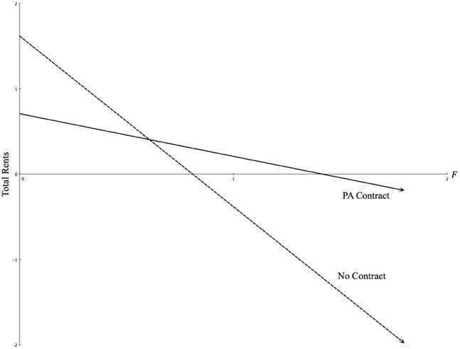 | 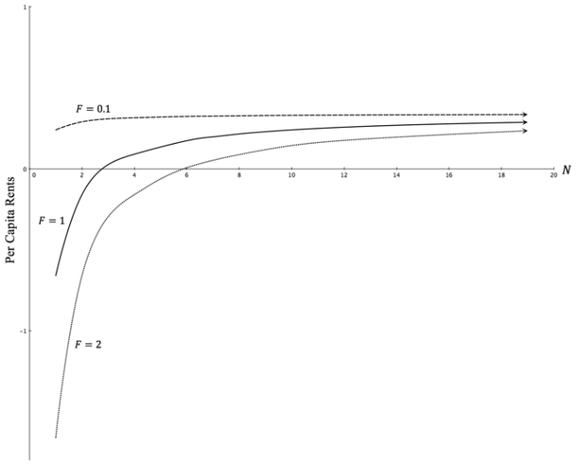

These results are summarized in Panel B of Figure 4, which shows the profit for an individual irrigator engaged in a contract as a function of total group size $N$. The curves correspond to different ditch fixed costs and the minimum feasible group size is found where each curve crosses the horizontal axis. With low enough fixed costs, no collective action is necessary for profitable irrigation—profit is positive even for $N=1$. As fixed costs rise, the minimum number of irrigators required for profitable investment also rises.
The relationship in Panel B of Figure 4 is a striking contrast to characterizations of collective-action problems by Olson (1965) and Ostrom (1990). The gains from contracting rise with group size. This sheds further light on the rapid and large-scale development of prior appropriation: contractual arrangements based on specified water diversion rights constrained by priority via prior appropriation formed the primary basis for cooperation where a large number of parties were required to fund infrastructure. At the same time, the many heterogeneous migrants who arrived over a broad time horizon precluded an Ostrom (1990)-style solution to the collective action problems associated with joint private irrigation investment.

2.5 Testable Predictions
Testable predictions of the model about the behavior of irrigators under prior appropriation center on two important decisions facing agents: where to establish a diversion claim in light of multiple options and whether to formally coordinate investment decisions with other claimants once a diversion claim had been made on a stream. The decision of where to establish a water right provides reduced-form evidence of the benefits of cooperation, whereas outcomes associated with ditch investment provide more direct measures of these benefits.
Our model predicts that cooperation is more likely when claims are more secure against future entry (higher $δ$), lowering the risk of diminished water diversions. We predict that higher priority rights holders are more likely to cooperate and jointly invest than are lower priority rights holders—a direct test of the notion that priority differentiated rights developed to support investment and collective action. This also implies that that cooperative users will tend to establish larger diversion infrastructure (longer ditches) on a per-user basis than noncooperative users and that larger group size will be associated with larger ditches, again on a per-user basis.
The returns to joint investment under prior appropriation are increasing in $N$, hence co-locating increases the capacity to share fixed investment costs with other water users because rights to water were clearly defined. This is in direct contrast to the prevailing incentives in the absence of collective action: junior claimants have lower priority rights with less access to water (Burness and Quirk, 1980) and so would avoid prior claimants unless collective action benefits exist.
The investment-related benefits of clustering claims in space and time would have diminished over time. As streams became more fully appropriated the security and size of junior rights would diminish, raising the cost of following recent claimants. Moreover, alternative institutions to support investment developed over time beginning with corporate financing in the 1890s that gave way to larger Bureau of Reclamation Projects in the 20th century. Hence, we also predict that the relative advantage of following recent users should fall over time. We summarize our hypotheses below:

- Users with higher priority are more likely to cooperate in ditch construction.
- Cooperative claimants make larger investments than non-cooperative claimants.
- Larger investments, indicated by ditch length, require more cooperating claimants.
- An increase in the number of new claims on a stream will increase the probability of subsequent claims on that stream, but the effect will diminish over time.

3. Irrigation, Income, and Economic Development
3.1 Data Description
This section describes the data and provides a series of back-of-the-envelope estimates of the aggregate benefits of prior appropriation to motivate the empirical tests that follow. Our calculations are necessarily limited by available data, but they are an important first step in estimating the benefits of prior appropriation. We assemble a data set of all known original surface water claims in Colorado by combining information on the point of diversion for each right with data on hydrology, soil quality, elevation, homestead claims, and irrigation.
We focus on Water Divisions 1 (the South Platte), 2 (the Arkansas), and 3(the Rio Grande), which comprise the eastern half of Colorado, are home to the majority of the state's agriculture, and have more complete diversion data available than other divisions. For each claim, we know i) the date and location of original appropriation; ii) the name of the structure associated with the diversion; iii) the name of the water source; iv) the size of the diversion; and v) the use or type of right. We restrict our analysis to the 7,999 agricultural rights in our data.
Each water right has a unique identifier number that we use to match to ditches and irrigated lands, resulting in 7,999 rights for which we have complete ditch data and 778 rights for which we have complete data on irrigated lands by crop. Summary statistics are presented in Table 1. These data allow us to examine our hypotheses regarding priority and cooperation; cooperation and investment; and group size and investment, as well as to calculate the productivity and income effects of moving water off stream.
We use contemporary stream flow estimates from NHDPLUS V2 to calibrate a hydrologic model from the U.S. Geological Survey that uses rainfall and terrain to predict streamflow. We fit the model using modern stream flow and rainfall data and then combine parameter estimates with historic rainfall from the PRISM climate dataset to estimate stream flow across Eastern Colorado over the period 1895-2000 and construct a long-run average summer stream flow for each stream (details are in the Appendix).

Table 1: Claim-Level Summary Statistics
Variable | N | Mean | S.D. | Min | Max | Definition
Claim Size | 7,999 | 15.63 | 123.4 | 0 | 8,631 | Volume of water (cfs).
Claim Date | 7,999 | -23,211 | 11,900 | -39,346 | 19,395 | Days since 1/1/1960.
Total Income | 778 | 605,953 | 2,833,755 | 0 | 4.56e+07 | Income from acres irrigated using right $i$in year $t.$
Irrigated Acres | 778 | 1,592.6 | 5,811.7 | 1.516 | 91,987 | Total acres irrigated using right $i$ in year $t$.
Income Per Acre | 778 | 544.44 | 390.91 | 68.23 | 1,933 | Income per acre from acres irrigated using right $i$ in year $t$.
Ditch Meters | 778 | 10,658 | 28,420 | 45.06 | 352,729 | Meters of ditch associated with right $i$.
Percent Loamy Soil | 778 | 1.022 | 4.803 | 0 | 1 | Share of Irrigated Acres possessing loamy soil.
Acres Loamy Soil (Parcel) | 778 | 37.43 | 102.3 | 0 | 640 | Acres of loamy soil on acres irrigated by right $i$.
Acres Loamy Soil (Proximity) | 6,482 | 3,804 | 4,078 | 0 | 16,291 | Acres of loamy soil within 10 miles of right $i$.
Stream Length | 7,889 | 5.258 | 4.291 | 0.0550 | 36.23 | Length of stream (km) that right $i$ lies on.
CoOp | 7,999 | 0.259 | 0.438 | 0 | 1 | Dummy var. = 1 for rights associated with cooperation or mutual ditches.
Group Size | 778 | 1.017 | 2.169 | 0 | 11 | Size of group associated with claim (=0 for noncooperative claims)
Summer Flow | 7,889 | 501.8 | 1,266 | 0 | 8,470 | Flow (cfs) on stream $j$ from May to August, averaged over 1890-2000.
Flow Variability | 6,337 | 23.82 | 145.6 | 0 | 1,224 | S. D. of summer ow from 1890 to 2000.
Roughness | 6,479 | 142.7 | 107.7 | 0.0720 | 934.2 | Avg. Slope times S. D. of Slope (within 10 miles of right).
Acres | 6,482 | 11,022 | 11,902 | 0 | 53,696 | Total acres near stream $j$ associated with right $i$.
Claim Year | 7,999 | 1896 | 32.54 | 1852 | 2013 | Year in which right $i$ was established.
Homesteaded Acres | 7,999 | 346.3 | 1,297 | 0 | 35,463 | Acres homesteaded during year in which right $i$ was established.
Homesteads | 7,999 | 2.179 | 7.024 | 0 | 131 | Number of new homesteads during year in which right $i$ was established.
1st Priority Decile | 7,999 | 0.248 | 0.432 | 0 | 1 | Dummy var. =1 claims with priority in top 10% on a stream.
2nd Priority Decile | 7,999 | 0.0815 | 0.274 | 0 | 1 | Dummy var. =1 claims with priority in 11-20% on a stream.
3rd Priority Decile | 7,999 | 0.0911 | 0.288 | 0 | 1 | Dummy var. =1 claims with priority in 21-30% on a stream.
4th Priority Decile | 7,999 | 0.0913 | 0.288 | 0 | 1 | Dummy var. =1 claims with priority in 31-40% on a stream.
5th Priority Decile | 7,999 | 0.0729 | 0.260 | 0 | 1 | Dummy var. =1 claims with priority in 41-50% on a stream.
6th Priority Decile | 7,999 | 0.111 | 0.314 | 0 | 1 | Dummy var. =1 claims with priority in 51-60% on a stream.
7th Priority Decile | 7,999 | 0.0973 | 0.296 | 0 | 1 | Dummy var. =1 claims with priority in 61-70% on a stream.
8th Priority Decile | 7,999 | 0.0783 | 0.269 | 0 | 1 | Dummy var. =1 claims with priority in 71-80% on a stream.
9th Priority Decile | 7,999 | 0.0780 | 0.268 | 0 | 1 | Dummy var. =1 claims with priority in 81-90% on a stream.
99th Priority Decile | 7,999 | 0.0499 | 0.218 | 0 | 1 | Dummy var. =1 claims with priority in 91-99% on a stream.
Note: We have data on 7,999 claims in eastern Colorado, but only 778 claims have matching ditch data. Of these, only 678 have complete elevation and
flow data available.

For each right, we also calculate the number of acres of loamy soil (hydrologic soil class B) and roughness of the terrain (standard deviation of elevation) within 10 miles of the point of diversion to capture the quality of the land in proximity to each right. We obtained additional GIS data on ditch length, cropping patterns, and irrigated acreage by crop for 1936 (Division 3) and 1956 (Division 1) for water rights in those districts from the Colorado Department of Water Resources. We also calculate the number of annual homestead entries with the General Land Office and total homesteaded acres in all townships that the stream associated with a water right flows through.

3.2 Potential Gains from Prior Appropriation
We begin by estimating the extent of land resources that could have been irrigated under the riparian doctrine, given homesteads of 160-320 acres that were typically a half-mile to a side. We assume that land within a half-mile of a stream or river could have been claimed and used with riparian water rights. This an upper bound on what riparian farms might have looked like in Colorado under the Homestead Act.
Recall that under a riparian water rights system, diversions from a stream cannot harm downstream parties, a factor that would have limited the total amount of water that could be moved among cooperating homesteaders even if the collective action problems identified in our model had been overcome. Note also that as shown in Figure 5, productive, loamy soil tended to be remote from streams on flat benchlands. Streams flowing from mountains, the common setting in the West, moved rapidly creating narrow canyons, limiting productive agricultural land in riparian area.
We use a subset of our data (778 rights) for which we also have GIS data on actual irrigated acreage in 1956 for Division 1 and 1936 for Division 3—prior to the advent of groundwater pumping—to calculate the contribution of the prior appropriation doctrine to agriculture in the region. Figure 5 depicts riparian land and actual irrigated acreage for Divisions 1 and 3. The green shading indicates loamy soil that is productive for farming.
Roughly 45% of the irrigated land in Division 1 and 34% in Division 3 was riparian. The ability to claim water from streams and put it to use on non-adjacent land allowed for substantial growth in irrigated acreage in both divisions, resulting in an combined addition of 546,552 acres of irrigated farmland—an increase of 133% relative to the 410,267 irrigated acres within the riparian corridor (see Table 2).
We also estimate the value of irrigated crop production associated with each water right. We multiply irrigated acreage for crop $i$in year $t$ from the water rights data by the average yield per acre for crop $i$in year $t$ in Colorado from the US Census of Agriculture to estimate total production of each crop assocaited with each water right. We then use average prices from Colorado for crop $i$in year $t$ to estimate the value of output for each crop and sum across crops for each water right.

Figure 5: Riparian and Irrigated Land, Divisions 1 & 3
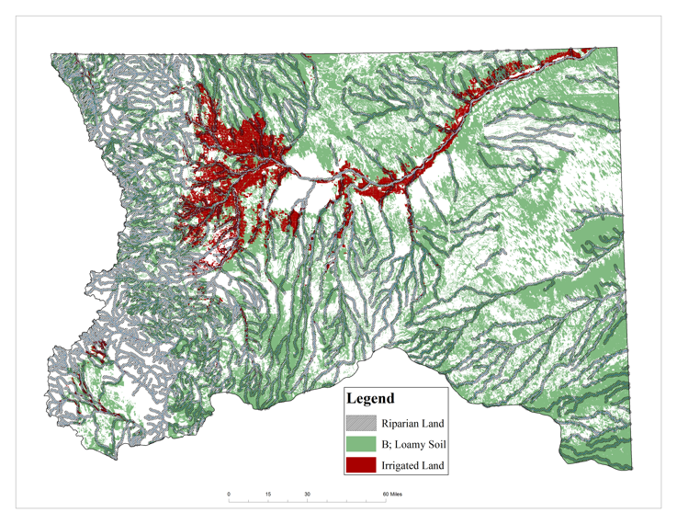 | 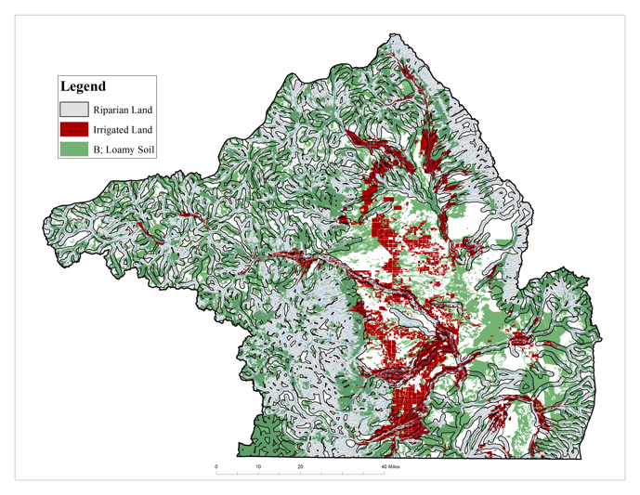
The variable Total Income reports the crop income associated with a right in a given year, in 2015 dollars. The results are summarized in Table 2. The ability to move water away from streams more than doubled crop income, increasing combined agricultural output in Colorado in our sample years by 134%. Access to non-riparian lands increased output, but came at the cost of substantial investment. We estimate the net value of an additional irrigated acre by calculating the area-weighted average value of irrigated land using county-level data from the 1930 Census of Agriculture. Irrigated land was worth $910.55 per acre in Divsision 1 and $389.29 per acre in Division 3.
Next, we estimate upper and lower bounds on the increase in total land value in our sample due to prior appropriation and report them in Table 2. To obtain the upper bound we assume that no additional riparian lands would have been irrigated in the absence of prior appropriation. In this case, the added value from prior appropriation is the per-acre value of irrigated lands multiplied by non-riparian irrigated acreage. The estimated value of non-riparian irrigated land was $371,754,801 in Division 1 and $53,829,853 in Division 3.
To obtain the lower bound, we assume that every acre of production on non-riparian lands would have been shifted to riparian land under the riparian doctrine. In this scenario we assume that the difference in land value for riparian vs. non-riparian lands is proportional to the difference in average income per acre observed in our data. Riparian land was 4% less productive than non-riparian land in Division 1 and approximately equivalent to non-riparian land in Division 3. The lower-bound estimated gain from prior appropriation is this difference in land value multipled by the number of non-riparian acres.

Table 2: Riparian vs. Non-Riparian Land (2015 $)
 | Division 1 |  | Division 3
 | Riparian | Non-Riparian | Riparian | Non-Riparian
Irrigated Acres | 337,917 | 408,275 | 72,350 | 138,277
Total Farm Income | $183,310,710 | $228,480,781 | $30,948,204 | $58,583,937
Median Farm Size | 147 | 760 | 99 | 262
Average Income Per Acre | $527.50 | $548.32 | $601.67 | $600.10
 | (3.28) | (3.05) | (14.64) | (12.36)
Average Value per Acre (Irrigated) | $910.55 |  | $389.29
Lower Bound Valued Added | ($910.55-0.96*$910.55)x408,275  =$357,639,075.10 |  | ($0)* $389.29x138,277  =$0
Upper Bound Value Added | $910.55x408,275  = $371,754,801.25 |  | $389.29x138,277= $53,829,853.33
Standard error of the mean reported in parentheses for Income Per Acre

The estimated value of non-riparian irrigated land was $357,639,075 in Division 1 and $0 in Division 3. We view this lower bound as optimisitic with respect to the prodtuctivty of riparian lands, given farmers’ observed willingness to invest substantial sums to avoid riparian land and given the observed differences in income per acre and median farm size, particularly in Divison 1.
The results in Table 2 indicate that the riparian system would have constrained rights holders to the more rugged terrain adjacent to streams and limited total farm size, assuming only riparian homesteads had access to water. This, in turn, would have precluded important 20th-century innovations in farming technology centered around the development of large, flat farms in the West (Gardner, 2009; Olmstead and Rhode, 2001). These estimates are the first empirical evidence that non-riparian lands were more productive and allowed for larger farms than lands that would have been irrigable under the riparian doctrine. This is consistent with previous discussions of prior appropriation that have emphasized the ability to separate water from streams as a necessary condition for irrigation in the semi-arid West. The benefits are notably larger in Division 1; we explore this fact further in Section 6.

3.3 Irrigated Agriculture and Economic Development
By the late 19th century the role of irrigated agriculture in expanding economies was increasingly recognized (Newell, 1894). We perform a back-of-the-envelope calculation of the contribution of irrigated agriculture in general and prior appropriation in particular to economic development in the Western United States in the early 20th century. Table 3 presents our estimates of the total annualized value of irrigated land in western states in 1930. We combine county-level data from the 1930 US Censuses of Agriculture on irrgated farm value per acre with total irrigated acreage to calculate the total value of irrigated land.
We then apply Fogel’s (1964) 7.91% percent discount rate and express the annualized value of irrigated land as a percentage of state or territory income, obtained from Easterlin (1960) and from the Bureau of Economic Analysis on personal income by state. Finally, using a 57% average of the share of non-riparian land in total irrigated area from Divisions 1 and 3 in Colorado based on Table 2, we estimate the value of non-riparian irrigated land as a percentage of state income. This represents the estimated share of state income due to agricultural production that could not have taken place under the riparian doctrine. This approach likely understates the contribution of prior appropriation because it assumes that riparian and non-riaprian lands are equally valuable.

Table 3: Contribution of Agriculture to State/Territory Income
 |  | 1910 |  | 1930
 | Annualized Value of Irrigated Land | % of State Income | Non-Rip % of State Income | % of State Income | Non-Rip % of State Income
Arizona | $167,447,197 | 12.0% | 6.8% | 5% | 3.0%
California | $2,737,310,748 | 12.3% | 7.0% | 4% | 2.2%
Colorado | $433,397,793 | 7.0% | 4.0% | 5% | 2.9%
Idaho | $324,832,334 | 20.5% | 11.7% | 11% | 6.0%
Montana | $213,370,122 | 7.7% | 4.4% | 6% | 3.2%
Nevada | $302,745,614 | 46.1% | 26.3% | 28% | 16.0%
New Mexico | $98,639,808 | 6.9% | 3.9% | 5% | 2.8%
Oregon | $180,667,668 | 3.9% | 2.2% | 2% | 1.3%
Utah | $224,508,283 | 9.5% | 5.4% | 6% | 3.6%
Washington | $219,359,520 | 3.5% | 2.0% | 2% | 0.9%
Wyoming | $134,935,704 | 10.1% | 5.8% | 7% | 4.1%
Notes: 1) All dollar amounts are reported in 2015 dollars. 2) Territory income is used for states prior to statehood. 3) Calculations are detailed in footnote 38.

Irrigation of non-riparian lands contributed 2% to 26% of state income in 1910 and 1% to 16% in 1930 (Table 3), prior to the rollout of most Bureau of Reclamation projects and the advent of groundwater pumping. Adelman and Robinson’s (1986) estimation of general equilibrium multipliers from increases in the value of agricultural production suggest that the contribution of irrigated agriculture to state incomes reported here due to access to more productive non-riparian lands may be understated. Still, our calculation gives a sense of the importance of private infrastructure investment for irrigated agriculture.

4. Cooperation and Investment under Prior Appropriation

4.1 Priority and Cooperation
This section explores the relationship between appropriatve water rights and cooperative investment described in hypotheses 1 through 3. We use a single water right as the unit of analysis in this section to examine the determinants of cooperation, focusing on the prediction that users with more secure (higher-priority) water rights are more likely to jointly engage in irrigation investment. To allow for a non-linear, semi-parametric effect of priority on cooperation, we rank rights by priority and create bins for each decile of the distribution of priority by stream, yielding 10 dummy variables—one for each decile. For example, if the 1st Decile Dummy is equal to one, the associated water right was among the first 10% of claims along its stream and had high-priority access to water during drought. This approach allows changes in priority to affect the probability of joint investment differently at various points in the distribution of priority.
We estimate the marginal effect of priority on cooperation among rights holders, relying primarily on within-watershed and within-year variation for identification. The dependent variable, CoOp, is a dummy that is equal to one for rights that are established on the same stream reach on the same day as other rights. These rights likely are associated with joint ditch companies (Hutchins, 1929). We estimate Equation 3 using a logit regression and cluster standard errors by watershed.

(3) $CoOp_{iw}=αZ_{i}+\sum_{k}{β_{k}1(Priority_{k})}+ϕ_{w}+τ_{t}+ε_{iw}$

where $Z_{i}$ is a vector of characteristics of water right i, $β_{k}$ capture the effects of each priority bin, $ϕ_{w}$ are watershed fixed effects and $τ_{t}$ are claim-year fixed effects equal to one for all rights established in a given year. Figure 6 depicts the estimated marginal effects of each priority decile on cooperation; regression output is available in Appendix Table A1.
Consistent with our hypothesis, we find a higher probability of cooperation for rights above the 5th Decile and a lower probability for rights below the 5th Decile. Users with prior appropriation water rights in the top 10% of priority on a given stream are about 12 percentage points more likely to jointly establish claims and ditches than are users in the middle decile, while very junior right-holders in the 10th decile are 20-30 percentage points less likely to do so. Taken together, these estimates imply that water right-holders with the highest priority on a stream were 40 percentage points more likely to coordinate with one another than were the most junior rights holders. This is consistent with the prediction from our model that the benefits of cooperating are larger with more secure property rights: $\frac{{∂π}_{i}(δ, F,N)}{∂δ }>0$.

Figure 6: Marginal Effects of Priority on Cooperation
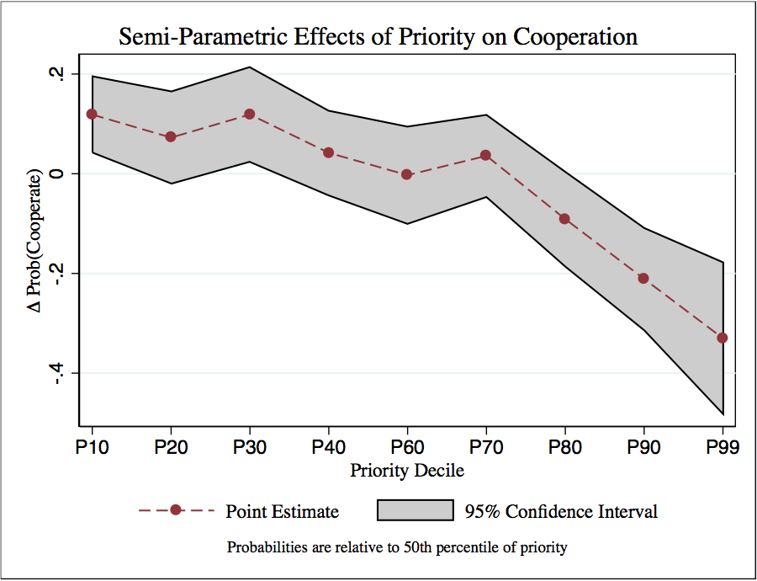

One caveat to the findings depicted in Figure 6 is reverse causality that may occur if claimants who already intend to cooperatively invest due to factors we do not observe seek out streams where they can establish a higher priority right. Even if this were the case, the finding that priority and collective action are highly correlated is consistent with the predictions of our model—to the extent that users exogenously decide to cooperatively invest and leverage priority to secure that investment, the priority differentiation of appropriative rights is still a crucial factor in the investment decision. Reverse causality only threatens our result if omitted drivers of cooperation are systematically related to priority within watershed or within-year.

4.2 Cooperation and Investment
We now assess whether cooperation among water claimants led to greater irrigation infrastructure investment. Our measure of investment is the length of the ditch (in meters) associated with a given water right. Longer ditches were costlier to construct, but allowed users access to more valuable farmland, particularly in Colorado, where land adjacent to streams was often rugged and unsuitable for farming (Hayden 1869). Users who cooperated still developed individual ditches known as laterals to bring water to their own particular fields, giving us unique ditch lengths for each water right in this portion of our sample. This allows us to estimate the effect of cooperation on investment per claimant.
Data on ditch legnths allow us to test hypotheses 2 and 3: that cooperative claimants will build larger ditches than sole claimants and that larger cooperatives with more members will lead to larger ditches. The variable Group Size measures the total number of claims established on the same stream reach on the same day, proxying for the size of the cooperative associated with a given right. Table 4 reports our estimates of the effect of CoOp (Columns 1 and 2) and Group Size (Columns 3 and 4) on Ditch Meters using linear probability model. We use the GMM technique developed by Hsiang (2010) that allows spatial autocorrelation following Conley (2008) in addition to serial autocorrelation. We include watershed and decade fixed effects and a variety of controls for the quality of water and land resources. Columns 1 and 3 omit controls for the priority of a given right, while columns 2 and 4 include them.

Table 4: Effects of Cooperation on Investment
 | (1) | (2) | (3) | (4)
 | Y=Ditch Meters
CoOp | 5482.0*** | 4258.1**
 | (1857.2) | (1825.9)
Group Size |  |  | 2516.2*** | 2249.1***
 |  |  | (733.0) | (717.4)
Claim Size | 268.8*** | 277.0*** | 276.5*** | 280.8***
 | (63.77) | (61.00) | (63.86) | (61.09)
Homesteaded Acres | -1.891 | -1.639 | -1.875 | -1.711
 | (1.375) | (1.441) | (1.356) | (1.426)
Summer Flow | 0.769 | 0.857 | 0.541 | 0.602
 | (0.961) | (0.926) | (0.940) | (0.902)
Roughness | -24.10 | -30.86 | -35.56 | -35.33
 | (46.39) | (29.32) | (47.41) | (29.90)
Acres Loamy Soil | 1.088 | 0.999 | 1.286 | 1.240
 | (1.838) | (1.933) | (1.833) | (1.932)
Priority Controls | No | Yes | No | Yes
Watershed Fixed Effects | Yes | Yes | Yes | Yes
Decade Fixed Effects | Yes | Yes | Yes | Yes
Observations | 678 | 678 | 678 | 678
R² | 0.451 | 0.458 | 0.464 | 0.468
Notes: Spatial HAC standard errors in parentheses * p < .1, ** p < .05, *** p < .01. N=678 is the
number of rights for which we have overlapping data on all covariates (Summer Flow is not
available for approximately 100 of the rights).

The coefficient estimate for CoOp in Column 2 of Table 4 indicates that cooperative claimants’ ditches are on average 4,258 meters (2.6 miles) longer than non-cooperative claimants’. The mean ditch in the sample is 10,578 meters (6.6 miles) long. This effect is statistically significant and robust to the inclusion of controls for the priority and size of a water right and various resource characteristics.
On the intensive margin, the estimates in Column 4 suggest that adding an additional member to a group increases each group member’s average ditch length 2,250 meters (1.4 miles), possibly due to returns to scale in the presence of high fixed costs. These results provide evidence that the function of joint investment under the appropriative system is consistent with our model—larger infrastructure projects required the cooperation of additional group members to help share the large fixed fosts of investment. Section 6 provides additional evidence on the specific role of prior appropriation vs. other mechanisms for facilitating collective action.

5. Empirical Evolution of Prior Appropriation Claims

5.1 Location Data
To test hypothesis 4, we divide Divisions 1 through 3 into a grid of stream-adjacent 1-square-mile sections and create measures of location quality by grid cell. Figure 7 shows the original location of all claims in our data set, the major streams, and the grid squares used for the analysis. We aggregate grid-level characteristics up to the stream-reach level and construct a panel of over 2,000 stream reaches (which we refer to as streams) from 1852 to 2013. A stream-reach is the level at which the National Hydrography Dataset reports stream flow estimates, and it includes small perennial streams and subsets of larger rivers. The average stream-reach in our sample is 10.7 miles long.
Table 5 provides variable names, definitions, and summary statistics for the stream-level data and Appendix B provides detailed descriptions of how the geographic covariates were constructed. In addition to the geographic covariates used in Section 4, we construct a drought indicator that is equal to 1 for years in which a major drought occurred, according to Henz et al. (2004).

Figure 7: Possible and Actual Claim Sites
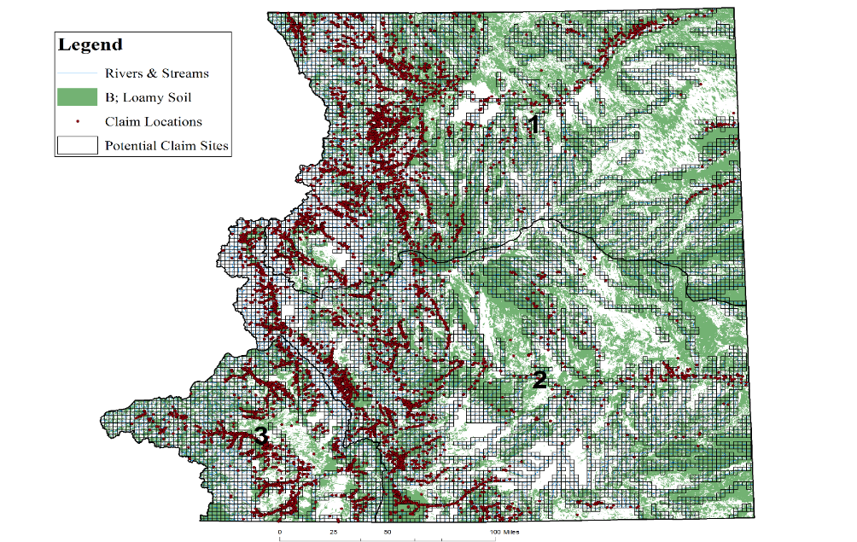

Table 5: Stream-Level Panel Summary Statistics
Variable | N | Mean | S.D. | Min | Max | Definition
New Claim | 430,836 | 0.0109 | 0.1037 | 0 | 1 | Dummy variable equal to 1 if New Claims $> 0$ on stream $j$ in year $t$.
Lagged Claims | 430,836 | 0.0166 | 0.2018 | 0 | 14 | Number of new claims on stream $j$ in year $t-1$
Stream Length | 430,836 | 10.74 | 19.00 | 0.634 | 362.72 | Length of stream reach $j$ (in miles).
Summer Flow | 430,836 | 113.95 | 348.63 | 0 | 8,342.4 | Flow (cfs) on stream $j$from May to August, averaged over 1890-2000.
Roughness | 430,836 | 0.00029 | 0.00028 | 1.17e-07 | 0.0030 | S. D. of slope multiplied by average slope along stream $j$.
Drought | 430,836 | 0.161 | 0.367 | 0 | 1 | Dummy variable = 1 during major drought years.
Homestead Claims_{t-1} | 430,836 | 0.284 | 2.4 | 0 | 242 | Number of homestead claims in township crossed by stream $j$ in year $t-1$.
Total Homesteaded Acres | 430,836 | 5,657 | 17,374 | 0 | 326,297 | Cumulative acres homesteaded in township crossed by stream $j$ as of year $t$.
Watershed Acres | 430,836 | 5,460.68 | 187,325.2 | 18.43 | 8,215,323 | Total size of watershed containing stream $j$.
Acres Loamy Soil | 430,836 | 549.31 | 1,139.3 | 0 | 15,188 | Acres within 10 miles of stream $j$ with loamy soil.
Notes: 1) Data on homesteads were provided by Dippel et al. (2014) and are based on Bureau of Land Management digitization of all land patents from the settlement of the western United States. 2) Drought variables are based on major drought years described in Henz et al. (2004). 3) Annual historical flow estimates used to calculate flow variability could be constructed only for a subset of data due to the availability of other variables used in the hydrologic model.

5.2 The Effect of Prior Claims on Location Choice
We test our final prediction by estimating the effect of recent claims on a stream on the probability of subsequent claims on that stream. The primary identification challenge is that the history of claims on a given stream could proxy for unobserved stream quality and bias our estimates. We address this concern by including stream and year fixed effects to control for time invariant differences across streams and yearly shocks that affect all streams. These fixed effects absorb all fixed cross-stream differences in resource quality that might be observable to claimants, but not to the econometrician.
Our homestead controls also allow us to identify the effect of new water claims on subsequent claiming separately from secular trends in settlement. Within-stream, within-year variation in homestead claims also serves as a control for other unobserved factors that affect the probability of new claims within stream, within year. Our primary estimating equation is

(4) $Y_{s,t}=New Claims_{s,t-1}+New Homesteads_{s,t-1}+HomesteadedAcres_{s,t}+τ_{t}+γ_{s}+u_{s,t}$

$Y_{s,t}$ is a dummy variable equal to one if there is at least one new claim on stream s in year t and zero otherwise. $τ_{t}$ is a vector of year fixed effects and $γ_{s}$ is vector of stream fixed effects. We estimate Equation 4 using a fixed effects logit and cluster standard errors by stream. We also estimate the baseline model with no fixed effects to evaluate the effect of time-constant stream characteristics and time-specific droughts that would otherwise be absorbed by the fixed effects.
We address possible spatial and serial autocorrelation by estimating a linear probability model using Hsiang’s (2010) estimator that allows spatial autocorrelation following Conley (2008) in addition to serial autocorrelation. We also specify an explicitly dynamic linear probability model, as developed by Arellano and Bond (1991). In this model we use a lagged claim indicator as the measure of previous claiming activity.
Table 6 reports the estimated average marginal effects of each of the covariates on the probability of a stream receiving at least one new claim in a given year, evaluated at the means of other variables. Columns 1 through 3 are estimated using a logit model with standard errors clustered by stream. Column 5 reports the results of the Hsiang (2010) GMM technique allowing for time-series and spatial autocorrelation. Column 6 reports the results of the Arellano-Bond estimator. Column 1 omits stream and year fixed effects. Column 2 includes stream fixed effects, but omits year fixed effects. Columns 3 through 5 include stream and year fixed effects.
Nearly all of the variables in Table 6 have intuitive signs. Claims are more likely on streams with larger expected Summer Flows. Summer Flow was especially critical for maintaining crops through the most arid months of the year before harvest in the Fall. Claims are .9 percentage points less likely during a drought. Claims also are less likely along more rugged stream terrains where the cost of developing ditches is higher. Soil quality does not appear to have a detectable effect on the probability of a new claim. This may be due to early migrants’ unfamiliarity with the region and inability to assess soil quality.
Across all three estimators, the probability of new water claims is greater when there are more Lagged Water Claims. This effect is statistically significant, robust, and of substantial importance for the overall claiming decision. Focusing on the coefficient estimate from Column 3, the probability of a new claim increases by 1.2 percentage points for each claim in the prior year. This is the same order of magnitude as the effect of a major drought on the probability of claim (Columns 1 and 2) and is a 35% increase in the probability of a new claim for each additional lagged claim (evaluated at the means of each variable). Hence, the presence of two new claims on a stream approximately doubles the probability of an additional claim on that stream in the following year.

Table 6: Empirical Determinants of Prior Appropriation Claims
$$\frac{∂Pr⁡(NewClaims>0)}{∂x}$$ | (1) | (2) | (3) | (4) | (5)
 | Logit |  |  | Conley SEs | Arellano-Bond
Lagged Claims | 0.0420*** | 0.0163*** | 0.0125*** | 0.0842***
 | (0.00413) | (0.000800) | (0.00108) | (0.00194)
Lagged Claim |  |  |  |  | 0.217***
Dummy |  |  |  |  | (0.0252)
Prime Acres | 0.00000217
 | (0.00000168)
Roughness | -23.05***
 | (4.523)
Avg. Summer Flow | 0.0000107***
 | (0.00000258)
Stream Length | 0.000422***
 | (0.000106)
Drought | -0.0124*** | -0.00846***
 | (0.00178) | (0.00111)
Lagged HS Claims | 0.000676*** | 0.000543*** | 0.000119 | 0.00109 | -0.00144
 | (0.000135) | (0.000134) | (0.000089) | (0.0012) | (0.00115)
Homesteaded Acres | -0.000000485*** | -0.000000464*** | -5.84e-08 | -0.000000495 | -0.00000827***
 | (9.34e-08) | (0.000000153) | (3.27e-08) | (0.00000031) | (0.00000137)
Year FE | No | No | Yes | Yes | Yes
Stream FE | No | Yes | Yes | Yes | Yes
N | 430836 | 186599 | 184281 | 184281 | 179645
adj. R² | 0.1173 | 0.1644 | 0.2566 | 0.126
Notes: Estimated marginal effects evaluated at the means of each variable are reported in Columns 1-3. Standard errors are clustered by stream in Columns 1-3. We allow for up to 12 lags in autocorrelation structure in Column 5, following Greene’s (2007) suggestion to allow for $\sqrt{T}$ lags. Columns 2-5 contain more observations than Column 1 because the inclusion of stream fixed effects drops streams that never receive any claims. Column 5 contains fewer observations because the first year of the panel is dropped to create the lagged dependent variable. * p < .1, ** p < .05, *** p < .01.

The existence of new homestead claims in the same township as a stream makes new claims on that stream more likely, but the effect is an order of magnitude smaller than the effect of lagged water claims. Moreover, this effect is not statistically significant in Columns 3 through 5 when stream and year fixed effects are included—this also suggests that the stream and year fixed effects adequately capture unobserved heterogeneity across streams and over time. The effect of cumulative homesteaded acres along a stream does suggest competition for land resources—claims are less likely along streams where more land has already been claimed. Appendix Table A3 shows that the results in Table 6 are robust to the omission of homestead controls. Together, these results indicate that water claimants' decision to follow prior claimants was driven by benefits specific to the definition of water rights, rather than by a general benefit of locating near other settlers. Appendix Table A4 provides a series of robustness checks of our main result that Lagged Claims increase the probability of new claims.
Next, we show how the effect of Lagged Claims changes over time as the basic nature of the collective action problem changed. By 1890, much of the Front Range had been settled and irrigation development had tapped into capital markets (Crifasi 2015). Under these conditions the disadvantages of being the junior claimant on a heavily-claimed stream could overwhelm the much-diminished benefits of cooperating through a joint ditch. As an additional test of the hypothesis that claiming decisions were driven by the need to jointly construct infrastructure, we re-estimate the fixed effects logit model in Column 3 separately in 20-year intervals. Our intuition is that the effect of lagged claims should be largest initially, but decline over time as claims exhaust available water resources and federal reclamation projects become the dominant form of infrastructure development (Tyler, 1992).
We plot the results in Figure 8, which depicts the estimated marginal effect of Lagged Claims on the probability of a new claim for each period. The effect of prior claims is positive and significant prior to 1890, statistically indistinguishable from zero over 1890-1930, and negative and significant from 1930 to 1950. This is consistent with our theory that emphasizes the importance of prior appropriation early in the development of private irrigation infrastructure. The benefits of following prior users fall over time as a stream became more fully appropriated and alternative institutions for investment emerged.

Figure 8: The Effect of Lagged Claims Over Time
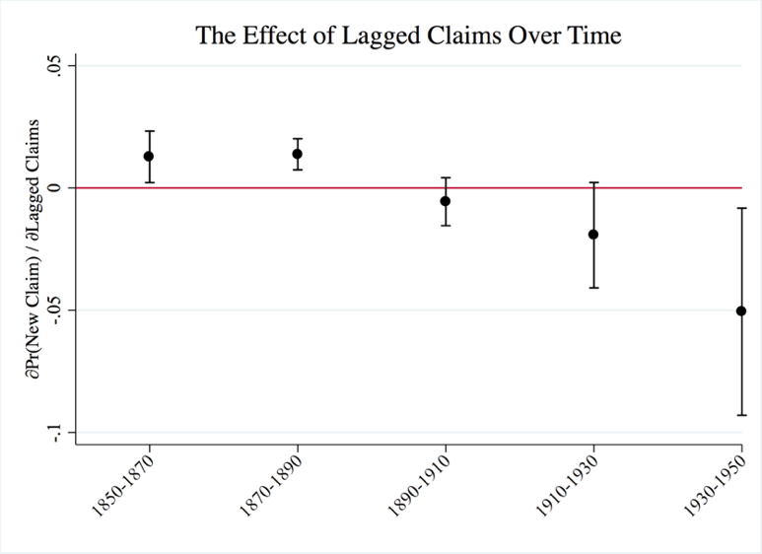

6. Formal Property vs. Informal Norms
6.1 Institutions for Collective Action
Our account of prior appropriation emphasizes its utility as a basis for collective action through formal contracting, and we exploit the specific features of Colorado’s history to provide an additional test to support this claim. Differences in geography, culture, and the rate of settlement between the South Platte (Division 1) and the San Luis Valley (Division 3) enable us to analyze the benefits of formal property rights with and without overlapping informal institutions like those studied by Ostrom (1990). Appendix Table A5 provides a comparison of key variables across the two groups.
Division 3, composed mainly of the San Luis River Valley in south-central Colorado, was one of the oldest settled regions in Colorado. Division 3 had a predominantly Hispanic population living in small, close-knit communities with long use of communal norms to govern ditch investment and management as well as irrigation water allocation (Mead, 1901; Hutchins, 1928; Crawford, 1988; Smith, 2016). Community-owned large ditches, or acequia madres, were managed by ditch bosses (mayordomos) who oversaw construction and annual maintenance contributions by local users, rotated water access, and arbitrated disputes. This setting required little outside capital investment and collective action problems were solved by custom (Hutchins, 1928; Meyer, 1984, pp. 64-73, 81; Smith, 2016).
Division 1 was comprised of heterogeneous migrants from elsewhere in the US and Europe (Hicks and Pena, 2003). There was much greater potential for new entry of subsequent claimants than in Division 3; the average number of potential riparian homesteads across all streams was 50 in Division 1 but just 28 in Division 3. In fact, Division 1 was more heavily settled than Division 3, increasing potential bargaining costs for water users in the absence of formal property rights. The average township in Division 1 had 84 homestead claims, compared to 11 homesteads per township in Division 3. In this setting, the legal doctrine of prior appropriation was the common denominator among parties seeking to form and finance an irrigation network (Hobbs, 1997, p. 4; Crisfasi, 2015).
We rely on these differences to assess the benefits of formal property rights relative to norms. In Division 3 informal institutions may have limited entry and enforced cooperation in ditch construction and water extraction from it. By contrast, there were no such institutions in Division 1, where appropriative rights and formal contracting would have been the basis for water allocation and ditch investment.

6.2 Heterogeneity in the Effects of Prior Appropriation
To the extent that informal institutions existed to overcome credible commitment problems in Division 3, the benefits of formal cooperation under the prior appropriation doctrine would have been much smaller there than in Division 1. This implies that the effects of cooperation explored in Section 4 should differ across the two divisions. We use a difference-in-difference framework to directly test the hypothesis that collective action based on appropriative rights had a larger effect on investment in Division 1 than Division 3 by including a dummy variable for whether a water right is in Division 1 and interacting it with our measures of cooperation. All columns include watershed and decade fixed effects.
The coefficient on the Division 1 dummy reports the average difference in claimants’ ditch length across the two divisions; the coefficient on CoOp (or Group Size) gives the effect of cooperation (group size) on investment in Division 3; and the interaction between the Division 1 dummy and CoOp (Group Size) reports the difference-in-difference coefficient that measures the differential effect of formal cooperation in Division 1, relative to Division 3. The results are reported in Table 7. Columns 1 and 3 omit controls for the priority of a given right, while Columns 2 and 4 include them.
Across all four Columns, average ditch length is not statistically different between the two divisions, suggesting that underlying factors influencing the profitability of ditch investment were similar across divisions. The effect of cooperation on ditch investment differs markedly, however. There is no statistically distinguishable difference between cooperative and non-cooperative ditches in Division 3, but in Division 1 cooperative claimants’ ditches are 13,591 to 14,689 meters (8.4 to 9.1 miles) longer than are those of non-cooperative claimants. This is a more than doubling of infrastructuree investment per claimant, as the average ditch in our sample was 10,578 meters long.

Table 7: Coordinated Investment in Division (1) vs. Division (3)
 | (1) | (2) | (3) | (4)
 | Y=Ditch Meters
Division 1 | 5765.4 | 5020.8 | 3862.2 | 5150.1
 | (5379.5) | (6415.2) | (5469.2) | (6502.6)
CoOp | -953.7 | -1408.5
 | (1730.1) | (1756.0)
Group Size |  |  | 584.0* | 499.1
 |  |  | (339.4) | (368.4)
Division 1 X CoOp | 14689.8*** | 13591.4***
 | (4266.7) | (3978.2)
Division 1 X Group Size |  |  | 2882.5** | 2719.8**
 |  |  | (1159.3) | (1191.3)
Claim Size | 269.3*** | 274.4*** | 275.1*** | 277.8***
Homesteaded Acres | -1.674 | -1.507 | -1.579 | -1.456
Summer Flow | 0.641 | 0.702 | 0.441 | 0.457
Roughness | -56.63 | -55.88 | -51.47 | -51.32
Acres Loamy Soil | 0.895 | 0.878 | 1.094 | 1.070
Priority Controls | No | Yes | No | Yes
Observations | 678 | 678 | 678 | 678
R² | 0.458 | 0.464 | 0.469 | 0.472
Notes: Spatial HAC standard errors in parentheses * p < .1, ** p < .05, *** p < .01. N=678 is the
number of rights for which we have overlapping data on all covariates.

The effect of group size on ditch investment is also much greater in Division 1 than in Division 3. Column 3 suggests a modest effect of about 584 ditch meters (.4 miles) per additional group member in Division 3, but this effect is not robust to controlling for priority. In Division 1, adding an additional group member increases ditch length for other rightsholders by an additional 3,000 meters (1.9 miles). Our interpretation of the results in Table 7 is that the communal norms in Division 3 were sufficient for facilitating coordinated investment, so that formal contracting generated little in the way of added benefits. The contrasting large effects in Division 1 underscore the advantages of formal property rights when Ostrom’s (1990) conditions are not met. Moreover, these results provide additional support for findings in Section 4 on the relationship between collective action and investment within the appropriative system.

7. Conclusion
This paper develops an economic explanation for the development of prior appropriation and provides a empirical evidence on of the evolution of appropriative water rights and their lasting economic significance. Irrigation in the semi-arid West required collective action to finance large-scale private irrigation works. Without a formal property system for water, individuals had little incentive to collaborate and contribute to shared irrigation works due to opportunism and the threat of new entry. Defining rights to specific quantities of water based on the timing of claims solved these credible commitment problems.
We use data on historical water claims to provide evidence of the benefits of cooperative irrigation development based on claimants’ decisions about where to establish claims, whether to coordinate with other users, and how much to invest in irrigation works. Each new claim along a stream raises the probability of subsequent claims by over 35%, suggesting large benefits of coordinated activity. Cooperation relied on secure property rights, however—the top 10% of senior claimants were 40 percentage points more likely to form ditch companies than were those below the median priority.
The benefits of formal property rights are greatest in areas without informal norms for collective action. Cooperative ventures and larger groups are not associated with larger ditches in the San Luis Valley (Division 3), which had a long history of community-run acequias that meet Ostrom’s (1990) conditions for successful collective action. In Northeastern Colorado (Division1), where large numbers of heterogeneous users arrived rapidly, formal cooperation via the property rights system led to a more than doubling of average ditch length (and additional13 km, or 8 miles, relative to a mean of 10 km, or 6.2 miles).
Comparing output across riparian and non-riparian lands and extrapolating beyond Colorado suggests that up to 16% of western state incomes by 1930 were directly attributable to irrigated agriculture, much of which would not have been feasible without prior appropriation to facilitate investment. These estimates do not incorporate multiplier effects from higher agricultural incomes that might have doubled the economic impact in each state. This system of property rights persists today and provides a basis for climate adaptation through market exchanges that facilitate reallocation and information generation about alternative values.
Our analysis provides new insights about the conditions under which private contractual arrangements have advantages over both informal, norm based, and direct government provision of collective goods. Wittfogel (1959) and Worster (1985) argue that such projects were not feasible without government provision, while Ostrom (1990, 2011) emphasizes the capacity for communal norms to align incentives. We demonstrate that private contractual arrangements based on well-specified property rights facilitate economically-valuable, private collective action to facilitate adaptation to a new an uncertain climate.
Western migrants faced an unfamiliar climate that was substantially more arid and variable than what they had experienced previously. Studying the development of new institutions that facilitated adaptation can provide lessons for resource management in arid areas facing new uncertainties about precipitation and temperature across the globe. Prior appropriation, developed in the 19th century, has continued to mold expectations about water ownership, investment, and allocation. It is one of the few formal private property rights to water, separable from land, found anywhere in the world (Grafton et al, 2011). This contribution has occurred historically and is more critical as water demands rise and supplies become less predictable with climate change.

References

Acemoglu, D., S. Johnson, and J. Robinson. “The Colonial Origins of Comparative Development: An Empirical Investigation.” American Economic Review 91 (2001), 1369-1401.
Acemoglu, D., S. Johnson, and J. Robinson. “The Rise of Europe: Atlantic trade, Institutional Change, and Economic Growth.” American Economic Review 95 (2005), 546-579.

Adams, F. et al.. Delivery of Water to Irrigators. Bulletin (United States. Office of
Experiment Stations); no. 229 Washington D.C.: Government Accounting Office. (1910)
Adelman, I. and S. Robinson. U.S. “Agriculture in a General Equilibrium Framework: Analysis with a Social Accounting Matrix.” American Journal of Agricultural Economics, 68 (1986), 1196-1207.
Allen, D., & Lueck, D. “Contract choice in modern agriculture: cash rent versus cropshare.” The Journal of Law and Economics, 35 (1992), 397-426.
—. “Transaction costs and the design of cropshare contracts.” The RAND Journal of Economics, (1993) 78-100.

Anderson, T. L. and P. J. Hill. “The Evolution of Property rights: A Study of the American West.” Journal of Law and Economics 18 (1975), 163-179.
Arellano, M., & Bond, S. “Some tests of specification for panel data: Monte Carlo evidence and an application to employment equations.” The Review of Economic Studies, 58 (1991), 277-297.
Barzel, Y. “Optimal Timing of Innovations.” Review of Economics and Statistics 50 (1968),
348-355.
— . “The Capture of Wealth by Monopolists and the Protection of Property
Rights.” International Review of Law and Economics 14 (1994), 393-409.
— . Economic Analysis of Property Rights. New York: Cambridge University
Press. (1997).

Besley, T. J. “Property Rights and Investment Incentives: Theory and Evidence from
Ghana.” Journal of Political Economy 103 (1995), 903-937.
Besley, T. J. and M. Ghatak. Property Rights and Economic Development, Volume 5 (2009).
New York: Elsevier Publishing.

Bohn, H. and R. T. Deacon. “Ownership Risk, Investment, and the Use of Natural
Resources.” American Economic Review 90 (2000), 526-549.
Bolton, P., & Dewatripont, M. Contract theory. MIT press. (2005)
Boyd, D. A History: Greeley and the Union Colony of Colorado. Greeley, CO:
Greeley Tribune Press. (1890)
Brewer, J., R. Glennon, A. Ker, and G. Libecap. “Water Markets in the West: Prices,
Trading, and Contractual Forms.” Economic Inquiry 46 (2008), 91-112.

Burness, S. and J. Quirk. “Appropriative Water Rights and the Efficient Allocation
of Resources.” American Economic Review 69 (1979), 25-37.
—. “Economic Aspects of Appropriative Water Rights.” Journal of Environmental
Economics and Management 7 (1980)., 372-388.
—. “Water Law, Water Transfers, and Economic Efficiency: The Colorado River.”
Journal of Law and Economics 23 (1980), 111-134.

Casey, K. E., C. M. Dewees, B. R. Turris, and J. E. Wilen. “The Effects of Individual
Vessel Quotas in the British Columbia Halibut Fishery.” Marine Resource Economics 10 (1995), 211-230.

Cheung, S. N.. “The Structure of a Contract and the Theory of a Non-Exclusive
Resource.” Journal of Law and Economics 13 (1970), 49-70.
Chong, H. and D. Sunding. “Water Markets and Trading.” Annual Review of Environ-
mental and Resource Economics 31 (2006), 239-264.
Clay, K. and Wright, G., 2005. Order without law? Property rights during the California gold rush. Explorations in Economic History, 42(2), pp.155-183.
Coman, K.. “Some Unsettled Problems of Irrigation.” American Economic Review 1 (1911),
1-19.

Conley, T. Spatial Econometrics. New Palgrave Dictionary of Economics, 741-7. (2008)

Costello, C., S. D. Gaines, and J. Lynham. “Can Catch Shares Prevent Fisheries
Collapse?” Science 321 (2008), 1678-1681.
Crawford, S.G. Mayordomo: Chronicle of an Acequia in Northern New Mexico. Albuquerque: University of New Mexico Press. (1988)

Crifasi, R. R.. A Land Made From Water. Boulder, Colorado: University Press of
Colorado. (2015)

Culp, P. W., R. Glennon, and G. Libecap. How the Market Can Mitigate Water
Shortages in the American West. Washington D.C.: Island Press. (2014)

Demsetz, Harold. “Toward a Theory of Property Rights.” American Economic Review
57 (1967), 347-359.

Dippel, Christian, Trevor O'Grady, C. Snider, and A. Whalley. “The American Frontier
1820-1940: Theory and Evidence from 5 Million Settler Choices.” Working Paper. (2015)

Dixit, A. “Governance Institutions and Economic Activity.” American Economic
Review 99 (2009), 3-24.
Donaldson, D. and R. Hornbeck. “Railroads and Economic Growth: A “Market Acces” Approach.” The Quarterly Journal of Economics, 131 (2016): 799-858.

Dunbar, R. G. “The Origins of the Colorado System of Water-right Control.” The
Colorado Magazine 27 (1950), 241-262.
—. Forging New Rights in Western Waters. Lincoln, Nebraska: University
of Nebraska Press. (1983)
—. “The Adaptability of Water Law to the Aridity of the West.” Journal of the West 24 (1985),
57-65.

Easterlin, R.. “Interregional Differences in Per Capita Income, Population, and Total
Income, 1840-1950.” In Trends in the American Economy in the Nineteenth Century, pp.
73-140. Princeton, New York: Princeton University Press. (1960)

Edwards, J. and S. Ogilvie. “What Lessons for Economic Development Can We Draw
from the Champagne Fairs?” Explorations in Economic History 49 (2012), 131-148.

Ellickson, R. C. “Property in Land.” Yale Law Journal 102 (1993), 1315-1400.

Epstein, R. A. “Possession as the Root of Title.” Georgia Law Review 13 (1978), 1221-1243.
Eswaran, M., & Kotwal, A. “A theory of contractual structure in agriculture.” The American Economic Review, 75 (1985), 352-367.
Fogel, R.W. Railroads and American Economic Growth: Essays in Econometric History. Baltimore: Johns Hopkins Press. (1964)
Galiani, S. and E. Schargrodsky. “Property Rights for the Poor: Effects of Land Titling.”
Journal of Public Economics 94 (2010), 700-729.

Gardner, B. L.. American Agriculture in the Twentieth Century: How it Flourished and
What it Cost. Cambridge, MA: Harvard University Press. (2009)

Gates, P.. History of Public Land Law Development. Washington D.C.: Public Land Law
Review Commission. (1968)

Gaudet, G., M. Moreaux, and S. W. Salant. “Intertemporal Depletion of Resource Sites by
Spatially Distributed Users.” American Economic Review 91 (2001), 1149-1159.

Getches, D. H. Water Law in a Nutshell. Eagan, MN: Thomson/West. (2009)
Gibson, C. and K. Jung. Historical Statistics of the Foreign-Born Population of the United States, 1850-2000, US Census Bureau Working Paper 81. Washington D.C. (2006)

Gordon, H. S. “The Economic Theory of a Common-Property Resource: The Fishery.” The
Journal of Political Economy 62 (1954), 124-142.

Grafton, R. Q., D. Squires, and K. J. Fox. “Private Property and Economic Efficiency: A
Study of a Common-Pool Resource.” Journal of Law and Economics 43 (2000), 679-714.
Grafton, R. Q., G. D. Libecap, S. McGlennon, C. Landry, and R.J. O’Brien, “An Integrated Assessment of Water Markets: A Cross-Country Comparison” Review of Environmental Economics and Policy, 5 (2011): 219–239.

Greif, A., P. Milgrom, and B. R. Weingast. “Coordination, Commitment, and
Enforcement: The Case of the Merchant Guild.” Journal of Political Economy 102 (1994), 745-776.

Hanemann, M. “Property Rights and Sustainable Irrigation: A Developed World
Perspective.” Agricultural Water Management 145 (2014), 5-22.

Hansen, Z. K. and G. D. Libecap. “Small Farms, Externalities, and the Dust Bowl of the
1930s.” Journal of Political Economy 112 (2004), 665-694.
—. “The Allocation of Property Rights to Land: U.S. Land Policy and Farm Failure in the
Northern Great Plains.” Explorations in Economic History 41 (2004), 103-129.

Hausman, J., B. H. Hall, Z. Griliches, et al.. “Econometric Models for Count Data with an
Application to the Patents-R&D Relationship.” Econometrica 52 (1984), 909-938.

Hayden, F.. Preliminary Field Report of the United States Geological Survey of Colorado
and New Mexico: US Geological Survey of the Territories, Third Annual Report. Washington D.C.: Government Printing Office. (1869)
Hemphill, R. G.. Irrigation in Northern Colorado, USDA Bulletin Number 1026.
Washington D.C.: US Government Printing Office. (1922)

Henz, J., S. Turner, W. Badini, and J. Kenny. Historical Perspectives on Colorado
Drought. Denver: Colorado Drought and Water Supply Assessment, Chapter 1. Colorado Department of Natural Resources. (2004)

Hess, R. H.. “The Colorado Water Right.” Columbia Law Review 16 (1916), 649-664.

Hicks, G. A. and D. G. Pena. “Community Acequias in Colorado's Rio Culebra
Watershed: A Customary Commons in the Domain of Prior Appropriation.” University of
Colorado Law Review 74 (2003), 387-486.

Hobbs, G. J. “Colorado Water Law: An Historical Overview.” University of Denver Water
Law Review 1 (1997), 1-4.
Howe, C. W. “Property Rights, Water Rights and the Changing Scene in Western Water.”
In C. Gopalakrishnan, C. Tortajada, and A. K. Biswas (Eds.), Water Institutions: Policies, Performance and Prospects, pp. 175-185. New York: Springer. (2005)

Hsiang, S. M. “Temperatures and Cyclones Strongly Associated with Economic
Production in the Caribbean and Central America.” Proceedings of the National Academy of Sciences 107 (2010), 15367-15372.

Hutchins, W. A. “The Community Acequia: Its Origin and Development.” Southwestern
Historical Quarterly 31 (1928), 261-284.
—. Mutual Irrigation Companies, USDA Technical Bulletin 82.
Washington D.C.: Government Printing Office. (1929)
—. Commercial Irrigation Companies, USDA Technical Bulletin 177. Washington D.C.: Government Printing Office. (1930)
—. Irrigation Districts, Their Organization, Operation, and Financing. USDA Technical Bulletin 254. Washington D.C.: Government Printing Office. (1931).
—. Water Rights Laws in the Nineteen Western States, Volume 3. Natural

Resource Economics Division, Economic Research Service, United States Department
of Agriculture. (1977)

Jacoby, H. G., G. Li, and S. Rozelle. “Hazards of Expropriation: Tenure Insecurity and
Investment in Rural China.” American Economic Review 92 (2002), 1420-1447.

Johnson, R. N., M. Gisser, and M. Werner “The Definition of a Surface Water Right and
Transferability.” Journal of Law and Economics 24 (1981)., 273-288.

Kanazawa, M. T. “Possession is Nine Points of the Law: The Political Economy of Early
Public Land Disposal.” Explorations in Economic History 33 (1996), 227-249.

—. Golden Rules. Chicago: University of Chicago Press. (2015)
Leffler, K. B., & Rucker, R. R. “Transactions Costs and the Efficient Organization of Production: A Study of Timber-Harvesting Contracts.” Journal of Political Economy, 99 (1991), 1060-1087.
Leonard, B. and G. D. Libecap. “Endogenous First-Possession Property Rights in Open-
Access Resources.” Iowa Law Review 100 (2015), 2457-2507.
Libecap, G. D. “The Assignment of Property Rights on the Western Frontier: Lessons for
Contemporary Environmental and Resource Policy.” Journal of Economic History 67 (2007), 257-291.
—. “Institutional Path Dependence in Climate Adaptation: Coman’s “Some Unsettled Problems of Irrigation.”” American Economic Review 101 (2011), 64-80.
Libecap, G. D. and Z. K. Hansen. ““Rain Follows the Plow” and Dryfarming Doctrine: The Climate Information Problem and Homestead Failure in the Upper Great Plains, 1890-1925.” Journal of Economic History 62 (2002), 86-120.
Libecap, G. D. and R. N. Johnson. “Property Rights, Nineteenth-Century Federal Timber Policy, and the Conservation Movement.” Journal of Economic History 39 (1979), 129-142.
Libecap, G. D., D. Lueck, and T. O'Grady. “Large-Scale Institutional Changes: Land Demarcation in the British Empire.” Journal of Law and Economics 54 (2011), 295-327.
Lueck, D.. “The Rule of First Possession and the Design of the Law.” Journal of Law and Economics 38 (1995), 393-436.
—. First Possession. In P. Newman (Ed.), The New Palgrave Dictionary of Economics and the Law, Volume 2, pp. 132-144. New York: Macmillan. (1998)
MacIntyre, D. D. “The Prior Appropriation Doctrine in Montana: Rooted in Mid Nineteenth Century Goals—Responding to Twenty-First Century Needs.” Montana Law Review 55 (1994), 303.

Mead, E.. “Irrigation in the United States.” USDA Bulletin 105, Office of Experiment Stations. Washington D.C.: Government Printing Office. (1901)
Mehlum, H., K. Moene, and R. Torvik. “Institutions and the Resource Curse.” Economic Journal 116 (2006), 1-20.
Meyer, M.. Water in the Hispanic Southwest: A Social and Legal History, 1550-1850. Tucson: University of Arizona Press. (1984)
Murphy, J. J., A. Dinar, R. E. Howitt, S. J. Rassenti, V. L. Smith, and M. Weinberg. “The Design of Water Markets When Instream Flows Have Value.” Journal of Environmental Management 90 (2009), 1089-1096.
NASS, USDA. "Census of agriculture." US Department of Agriculture, National Agricultural Statistics Service, Washington, DC 1 (1935)
NASS, USDA. "Census of agriculture." US Department of Agriculture, National Agricultural Statistics Service, Washington, DC 1 (1954).
Newell, F. H.. Report on Agriculture by Irrigation in the Western Part of the United States, at the Eleventh Census: 1890. Washington D.C.: US Government Printing Office. (1894)
Olmstead, A. L. and P. W. Rhode. “Reshaping the Landscape: The Impact and Diffusion of the Tractor in American Agriculture, 1910-1960.” The Journal of Economic History 61 (2001), 663-698.
Olmstead, Sheila M. "The economics of managing scarce water resources." Review of Environmental Economics and Policy 4, no. 2 (2010): 179-198.
Ostrom, E. Governing the Commons: The Evolution of Institutions for Collective Action. Cambridge University Press. (1990)
—. “Reflections on “Some Unsettled Problems of Irrigation.”” American Economic Review 101 (2011), 49-63.
Ostrom, E. and R. Gardner. “Coping with Asymmetries in the Commons: Self-Governing Irrigation Systems Can Work.” Journal of Economic Perspectives. 7 (1993): 93–112.
Ostrom, V. “State Administration of Natural Resources in the West.” American Political Science Review 47 (1953), 478-493.
Ostrom, V. and E. Ostrom. “Legal and Political Conditions of Water Resource Development.” Land Economics 48 (1972), 1-14.
Pisani, D. J. To Reclaim a Divided West: Water, Law, and Public Policy, 1848-1902. Albuquerque: University of New Mexico Press. (1992)
—. Water and American Government: The Reclamation Bureau, National Water Policy, and the West, 1902-1935. Berkeley: University of California Press. (2002)
Powell, J.W. Report on the Lands of the Arid Region of the United States. Second Edition. Washington D.C: Government Printing Office. (1879)
Rettig, P. J.. “Tracing the Source of Irrigation: An Examination of Colorado Ditch Company Collections in Archival Repositories.” Journal of Western Archives 3 (2012): 1-20.

Rodrik, D. “Second-Best Institutions.” American Economic Review 98 (2008), 100-104.
Romero, T. I. “Uncertain Waters and Contested Lands: Excavating the Layers of Colorado's Legal Past.” University of Colorado Law Review 73 (2002), 521-1401.
Rose, C. M. “Possession as the Origin of Property.” University of Chicago Law Review 52 (1985), 73-88.
—. “Energy and Efficiency in the Realignment of Common-law Water Rights.” Journal of Legal Studies 19 (1990), 261-296.
Schorr, D. “Appropriation as Agrarianism: Distributive Justice in the Creation of Property Rights.” Ecology Law Quarterly 32 (2005), 3-71.
Scott, A.. “The Fishery: The Objectives of Sole Ownership.” Journal of Political Economy (1955), 116-124.
—. The Evolution of Resource Property Rights. New York: Oxford University Press. (2008)
Smith, H. E. “Semi-common Property Rights and Scattering in the Open Fields.” Journal of Legal Studies 29 (2000), 131-169.
Smith, S. M. “Common Property Resources and New Entrants: Uncovering the Bias and Effects of New Users.” Journal of the Association of Environmental and Resource Economists 3 (2016), 1-36.
Stenzel, R. L. and T. Cech. Water: Colorado’s Real Gold: A History of the Development of Colorado’s Water, and the Prior Appropriation Doctrine, and the Division of Water Resources. Denver: Richard Stenzel. (2013)
Teele, R. “The Organization of Irrigation Companies.” Journal of Political Economy 12 (1904), 161-178.
Turner, F.J. “The Significance of the Frontier in American History,” Report of the American Historical Association 1893, reprinted in The Frontier in American History, Cambridge, Harvard University Press, 1920, downloaded from Digireads.com. (1893)
Tyler, D. The Last Water Hole in the West. Niwot, CO: The University Press of Colorado. (1992).
US Census Bureau.. Thirteenth Census of the United States Taken in the Year 1910, Vol. V, Agriculture. Pt. 1, Chapter XI. Washington DC: Government Printing Office. (1913)
—. Fourteeenth Census of the United States Taken in the Year 1920, Vol. VII, Irrigation and Drainage. Washington D.C.: Government Printing Office. (1922)
Wiggins, S. N. and G. D. Libecap. “Oil Field Unitization: Contractual Failure in the Presence of Imperfect Information.” American Economic Review 75 (1985), 368-385.
Wilen, J. E.. “Property Rights and the Texture of Rents in Fisheries.” In D. Leal (Ed.), Evolving Property Rights in Marine Fisheries (2005), pp. 49{67. Lanham, MD: Rowman and Littlefield.
Williamson, O. E. “Opportunism and its Critics.” Managerial and Decision Economics, 14 (1993), 97-101.
Wittfogel, K. A. Oriental despotism: A comparative study of total power. New York: Random House. (1959)
Wooldridge, J. M. “Simple Solutions to the Initial Conditions Problem in Dynamic, Nonlinear Panel Data Models with Unobserved Heterogeneity.” Journal of Applied Econometrics 20 (2005), 39-54.
Worster, D. Rivers of empire. Water, Aridity, and the Growth of the American West. New York: Pantheon Worster. (1985).

*For helpful comments we thankan anonymous reviewer, Christopher Costello, Olivier Deschênes, Catherine Hafer, Lakshmi Iyer, Louis Kaplow, Dean Lueck, Steve Shavell, Henry Smith, Dick Startz, and Jonathan Yoder as well as participants at workshops at the NBER DAE Summer Institute, the Political Institutions and Economic Policy Working Group, the Ostrom Workshop at Indiana University, UC Santa Barbara, Arizona State University, Columbia University Law School, Harvard Law, UCLA Law, UC Irvine, Montana State University, the University of Arizona, Washington State University, Binghamton University, Carnegie Mellon University, the College of Charleston, the University of Virginia Law School, the Society for Organizational and Institutional Economics meetings 2017, and the Western Economics Association meetings 2016. We also thank the Walton Family Foundation and the Sustainable Water Markets program at UC Santa Barbara for supporting this research. Excellent research assistance was provided by Cody Wilgas, Love Goyal, and A.J. Leon. Bryan Leonard is corresponding author. School of Sustainability, Arizona State University, 800 S Cady Mall, Tempe, AZ 85281. Email: bryan.leonard@asu.edu
Because of transaction costs, property rights are never complete. The role of property rights in constraining rent dissipation in open-access resources has perhaps the largest literature
Demsetz (1967), Cheung (1970), Anderson and Hill (1975), and Barzel (1997) emphasize that property rights emerge when the marginal benefit of creating, defining, and enforcing those rights exceed the marginal costs of doing so, but do not examine the forms property rights take in different settings or why. Clay and Wright (2005) study the endogenous formation of property rights in the context of gold mining camps in California.
First-possession ownership of natural resources has been criticized for encouraging a race among homogeneous agents that dissipates rents (Barzel, 1968, 1994; Lueck, 1998). This argument does not account for the ubiquity of first possession or its economic contribution. Indeed, when agents and the resource are heterogeneous, dissipation is reduced (Lueck, 1995; Leonard and Libecap, 2015).
Arizona, California, Colorado, Idaho, Kansas, Montana, Nebraska, Nevada, New Mexico, North Dakota, Oklahoma, Oregon, South Dakota, Texas, Utah, Washington, Wyoming, Alberta, British Columbia, Manitoba, and Saskatchewan (Scott, 2008, pp 101). Some of the less-arid jurisdictions have mixed systems of prior appropriation and riparian (Mead, 1901 pp 14, 25). Prior appropriation is often characterized by the phrase, “first in time, first in right.” First possession in property rights allocation is discussed by Epstein (1978), Rose (1985, 1990), Ellickson (1993), and Lueck (1995, 1998). Pisani (1992, 2002) describes the development of prior appropriation water rights within an initial riparian setting and subsequent development of irrigation infrastructure and irrigated agriculture.
Prior appropriation water rights have been described by many, including Burness and Quirk (1979, 1980a, b), Johnson et al., (1981), Smith (2000), Howe (2005), Hanemann (2014), and Chong and Sunding (2006). Kanazawa (1996, 2015) explores the early development of prior appropriation in mining camps, but it developed largely from demands for irrigation in the semi-arid region west of the 100th meridian. Ostrom (1953) and Ostrom and Ostrom (1972) discuss the replacement of riparian rights by prior appropriation.
Calculated from 14th US Census 1920, Vol VII Irrigation and Drainage (US Census Bureau, 1922, pp. 21, 41). Although the federal Reclamation Service was created in 1902, it took considerable time for its projects to begin and be completed. In 1913 the Census Bureau reported that there were no large federal irrigation/reclamation projects in operation (US Census Bureau, 1913, p. 831). CPI adjustment factor for commodities 1920 to 2015, 1180.
The prohibition of moving water away from source streams inherent in riparian water rights that protect downstream flows is a standard argument for prior appropriation in semi-arid regions (See Getches, 2009). As we describe, additional institutional innovation as provided by prior appropriation was required for irrigation investment to move water to remote sites and to trade it.
Early on, enforcement of diversion priority was a problem as late comers established claims upstream, diminishing flows available to more senior claims. For discussion of conflict and resolution see Boyd (1890) and Dunbar (1950).
Mead (1901, p. 7-15) discusses the imperative to shifting from riparian to prior appropriation to promote irrigation in semi-arid regions. Dates of prior appropriation adoption: Arizona: Territory Arizona, Howell Territorial Code, Ch. LV, Hutchins (1977, p. 170); Colorado: Constitution art. XVI § 5 and 6; Coffin v. Left Hand Ditch Co (6 Colo 443); Idaho: An Act to Regulate the Right to the Use of Water for Mining, Agriculture, Manufacturing, and Other Purposes (1881), Hutchins (1977, p. 170); Montana: Mettler v. Ames Realty Co., 61 Mont. 152, 170-171, 201 Pac. 702, MacIntyre (1994, p. 307-8); New Mexico: Territorial Constitution Art XVI § 2; Hutchins (1977, p. 228); Nevada: Lobdell v. Simpson, 2 Nev. 274, 277, 278; Hutchins (1977, p. 170-171); Utah: Utah Laws 1880, ch. XX; Wyoming: Constitution Art VIII §1-5; Hutchins (1977, p. 300); California: Irwin v. Phillips, 5 Cal. 40 (1855); Hutchins (1977, p. 181, 233-34); Kansas: 1886 Kans. Sess. Laws 154, ch. 115; Hutchins (1977, p. 170); Nebraska: Neb. Laws p. 168(1877); Hutchins (1977, p. 212); North Dakota: Terr. Dak. Laws 1881, ch. 142; Hutchins (1977, p. 213); Oklahoma: Terr. Okla. Laws 1897, ch. 19; Hutchins (1977, p. 171, 215); Oregon: Oregon Laws 1909, Ch. 216. Oregon Revised Stat. ch. 539; Hutchins (1977, p. 170); South Dakota: Terr. Dak. Laws 1881, ch. 142; Hutchins (1977, p. 170, 220); Texas: Tex. Gen. Laws 1889, ch. 88; Hutchins (1977, p. 170); Washington: Wash. Sess. Laws 1889-1890, p. 706; Sess. Laws 1891, ch. CXLII, Hutchins (1977, p. 170).
Prior appropriation first emerged in Colorado as a full tangible property right to water and became known as the Colorado Doctrine. It was a general template for other western territories and states and, generally, western Canadian provinces. Only in the wetter states of California, Oregon, and Washington did remnants of riparian water rights remain (Scott, 2008, p. 101).
The 1900 population of Colorado was 539,700, implying a population density of 1 person per 123 acres.
https://www.census.gov/dmd/www/resapport/states/colorado.pdf. https://www.colorado.gov/pacific/archives/census-records-0.
Colorado migrants came primarily from the northeast and northcentral United States (Colorado Water Institute, ND, 2; Dunbar, 1950, p. 242; Hobbs, 1997, p. 3; Romero, 2002, p. 527).
The first Colorado Territorial Legislature in 1861 enacted legislation that allowed water to be diverted from streams to remote locations, abrogating common-law riparian principles that kept water on adjacent lands. An 1862 statute continued the move toward prior appropriation by granting right-of-way to irrigation ditch owners. An 1864 law emphasized the priority of diversion rights over riparian, and an important 1872 Colorado Supreme Court decision in Yunker v Nichols (1 Colo 552) sided with the priority rights holder against riparian diversions that depleted prior appropriation irrigation ditch water as an enforcement ruling.
The districts were grouped within 3 geographic water divisions. A key problem was to reduce the incentive of some parties to locate new claims upstream and illegally divert water from senior diverters downstream. Additionally, the allocation rules within and across ditch companies were to be enforced by ditch riders and by the state (Boyd, 1890, 120-24; Dunbar, 1950, 241-61).
Mead (1901, p. 8) estimated that private irrigation systems valued nearly at $200,000,000 ($5,750,000,000 in 2015 dollars) were in place as of 1901 in the western United States, prior to the enormous irrigation projects of the federal Reclamation Service. He also describes the complexity of raising capital and the coordination and consolidation among irrigation companies in the Cache La Poudre Valley, one of the first areas in Colorado to be placed under large-scale irrigation. Adams (1910, pp. 37-41) describes the intricate networks of irrigation infrastructure in the West, including along the Cache La Poudre, where the North Poudre Canal was 25 miles long with 140 miles of lateral ditches, drawing from 20 reservoirs to irrigate 27,500 acres. There were 500 irrigators and stock holders in the canal company.
Throughout we assume that all players are risk neutral and have complete but imperfect information.
An individual acting alone would solve $\max_{x_{i}}{2δ\left(x_{i}^{\frac{1}{2}}\right)-F-x_{i}}$, which has as its solution $x_{i}^{*}=δ^{2}$ and results in profits $π_{i}\left(δ, F\right)=2δ^{2}-F-δ^{2}=δ^{2}-F$.
Ostrom and Gardner (1993) consider the problem that arises for different exogenously given values of $θ$ (e.g. .75, .5, etc.), meant to reflect Player 1’s prior access to the water due to being closer to the head of the ditch.
Appendix Figure A1 depicts the game in extensive form.
This is opportunism when capital is not deployable (Williamson, 1993).
Repeated play is unlikely to lead to cooperation in this setting because i) settlers came from numerous and heterogenous backgrounds, having little in common and ii) irrigation investment is itself a one-shot game in that it is difficult to punish opporuntism once capital investment has been sunk.
This is a commonly used approached for modeling private contracts. See Eswaren and Kotwal (1985), Leffler and Rucker (1991), Allen and Lueck (1992, 1993), and Bolton and Dewatripont (2005).
Player 1’s incentive compatibility constraint, which places a lower bound on $d_{1}$ (and hence an upper bound on $d_{2}$), is $d_{1}-δ^{2}-e≥δ^{2}-F⇒{\underline{d}}_{1}=δ^{2}={\overline{d}}_{2}$. Player 2’s incentive compatibility constraint, which bounds $d_{1}$ from above (and hence $d_{2}$ from below), is ${w-d}_{1}-δ^{2}-e=4δ^{2}-F{-d_{1}-δ}^{2}-e≥δ^{2}-F⇒{\overline{d}}_{1}=3δ^{2}-F-e={\underline{d}}_{2}$.
See Appendix for derivation of the optimal contracts with $N$ users.
Water rights regimes vary primarily at the state level, confounding an empirical analysis of when and where prior appropriation emerged. Instead, we derive predictions about the behavior of claimants within the appropriative system based on the specific benefits highlighted by our model.
Burness and Quirk (1980) show that higher priority users have a higher probability of receiving their water right in any given year because flows are stochastic and senior users must be satisfied before junior users. In the language of our model, higher priority rights have a higher $δ$.
GIS data on water rights were obtained directly from the Colorado Department of Water Resources.
Rights associated with mining are primarily found in the western half of the state.
PRISM Climate Group, Oregon State University, http://prism.oregonstate.edu, created 4 May 2016
No data are available for Division 2. To alleviate concern about the comparison over time, we collect county-level data on the number of farms, average farm size, and average farm value for both areas in 1935 and 1954 (the closest years for which data are available) from the Census of Agriculture. We find no statistically significant difference in changes over time across divisions. The total number of farms fell in both, while average farm size and value increased. We also find no statistically significant difference in the change in yield from 1936 to 1956 across divisions. These tests imply that conditions in agriculture in the two divisions moved in similar ways over the 20-year period.
This is similar to Fogel’s (1968) “counterfactual” approach to estimating the returns to railroad investment.
No data are available for Division 2. Data for a contemporaneous cross-sectional or panel comparison are not available. To alleviate concern about the comparison over time, we collect county-level data on the number of farms, average farm size, and average farm value for both areas in 1935 and 1954 (the closest years to our sample years for which data are available) from the Census of Agriculture. We calculate the percentage change in each outcome between 1935 and 1954 and find no statistically significant difference in changes over time across divisions. The total number of farms fell in both, while average farm size and value increased. We also collect data on average yields for irrigated wheat in both periods in both divisions and find no statistically significant difference in the change in yield from 1936 to 1956 across divisions. These tests imply that economic conditions in agriculture in the two divisions moved in similar ways over the 20-year period.
We use 1935 values from the Census to match to our 1936 crops and 1954 values from the Census to match to our 1956 data. These are the closest years to our sample years for which data are available.
Because there are potentially other irrigated parcels for which the Department of Water Resources does not have data, our estimates of the value of agricultural production due to the expansion of irrigated acreage made possible by the prior appropriation doctrine may be biased downward.
We weight each county by the total irrigated area in the county as a share of the total irrigated area in the Division.
County-level land value data reflect the average value of irrigated land in both riparian and non-riparian areas. Our calculation of the added value of additional non-riparian production may understate the true gains if non-riparian lands are more productive than irrigated riparian lands. Differences in income per acre reported in Table 2 suggest that these differences are likely to be small, however.
This is feasible because the un-irrigated riparian area exceeds non-riparian irrigated area.
Department of Commerce, BEA Survey of Current Business, May 2002 and unpublished data, “Personal Income and Personal Income by State, 1929-2001,” provided to the authors by Robert A. Margo. State income values were calculated on a state basis by multiplying population by per capita income. Population data for 1910 and 1930 from US Agricultural Data, 1840-2010, distributed by the Inter-University Consortium for Political and Social Research (ICPSR). For 1910, per capita income was calculated by taking the mean of per capita income from 1900 and 1920. Per capita income from 1900 was taken from Easterlin 1960, Table A-3. Per capita income for 1920 and 1930 were taken from unpublished data from Easterlin and the BEA. The 1910 values of irrigated crops were calculated by summing individual crop values by state. Data from irrigated crop values were taken from the 1910 Census of Agriculture, Volumes 6 and 7. The 1910 Census of Agriculture notes that data for irrigated crops were taken from supplemental schedules, and the information is considered to be incomplete. Therefore, all available irrigated crop value data were summed. The 1930 values of irrigated crops were calculated by summing the eight most valuable crops according to state. The number of crops included in the calculation was chosen to be eight, as the 9th crop value added less than 5% to the total irrigated crop value. Data for irrigated crop values were taken from US Agricultural Data, 1930, distributed by ICPSR.
We calculate a weighted average of the share of non-riparian income of total irrigated income from Divisions 1 and 3, weighted by total irrigated acreage in each division. We estimate that roughly 57% of irrigated land is non-riparian and could not have been irrigated under a strict riparian system.
Priority is an ordinal ranking of rights along a stream. Including this simple priority measure in a regression would force the effect of priority to be linear, implying that the difference between being the 1st and 2nd claimant is the same as the difference between being, say, the 14th and 15th claimant.
We use watershed fixed effects rather than stream fixed effects because coordination and spatial competition over irrigation works was often not limited to a single stream. Rather, development occurred based on what lands where arable, which varies by watershed.
The names of the ditches associated with each right can be used to consult the historical record as to whether they were formally incorporated. We have done this for a subset of the rights and find that our measure of cooperation is reasonable proxy for formal cooperation.
The biggest threat to identification of the effect of priority on investment is that rights with higher priority also tend to be established earlier in time, when less water has been claimed and less development has taken place. We include claim-year fixed effects to alleviate this concern.
Estimating Equation 3 using a logit model may give rise to an incidental parameters problem and bias the estimates of $β_{k}$. Appendix Table A2 reports the results of estimating Equation 3 using a linear probability model, which are consistent with our main results obtained using a logit estimator. Appendix Figure A2 reproduces Figure 6 based on the OLS estimates and confirms that our results are not driven by incidental parameter bias.
Marginal effects are estimated at the mean values of the controls, and standard errors are clustered by watershed.
Each drop in priority in the lower half of the distribution represents a larger shift in real access to water, generating larger effects on the probability of formal cooperation. The more heterogeneous users become in their exposure to risk, the less likely they are to cooperate. This finding is consistent with that of Wiggins and Libecap (1985), who find that cooperation among oil field operators in oil field coordination and investment becomes less likely as they become more heterogeneous.
This grid approximates the Public Land Survey (PLSS) grid but fills in gaps where GIS data on PLSS sections are not available. Actual homesteads and other land claims were defined as subsets of PLSS sections, so grid-level variation is similar to actual variation in land ownership and land use.
We aggregate from grid squares to streams for four reasons. First, priority varies by stream, so the trade-off between high-priority access and the benefits of clustering occurs at the stream level. Second, we observe variation in flow at the stream level. Third, the count of claims in a given square mile in a given year is extremely small. Using such a fine spatial resolution results in an arbitrarily large number of zeros in the data. Fourth, the potential for measurement error in how we have delineated grid squares is reduced by aggregating to a larger spatial unit.
Time-varying unobserved factors that affect the probability of a claim in some year on a particular stream may be correlated from year to year. Similarly, the unobserved factors that influence the probability of a claim on a stream in a particular year that may be correlated across space within that year.
The coefficients in Columns 1 through 3 are not directly comparable to those in Columns 4 and 5 because they assume different conditional expectation functions for the dependent variable. We focus on the estimated marginal effects from the logit regressions for ease of exposition, but note here that the basic finding that prior claims make subsequent claims more likely is consistent across all three estimators.
The coefficient estimats are larger when homestead controls are omitted, suggesting that controlling for homestead trends helps to isolate the water right-specific effects of lagged claims.
Information benefits provided by early claimants included demonstration of where and how irrigation ditches could be constructed. The best locations to build dams and reservoirs in order to divert water from the stream into a ditch were not obvious initially and had to be discovered by experimenting. Ditch slope for gravity water flows was critical as was the curvature of ditch canals to avoid erosion and leaks (Stenzel and Cech, 2013, pp. 74-96). Techniques for irrigating flat, plateaued lands above stream channels were particularly valuable, but not initially apparent. The development of these methods attracted waves of subsequent settlers to jointly claim water for ditch investment and land in areas previously considered unproductive (Boyd, 1890).
In fact, observation of these and other acequias in northern New Mexico prompted the first settlers to attempt irrigation in eastern Colorado (Crisfasi, 2015).

