Colonial Origins, Property Rights, and the Organization of Agricultural Production: the US Midwest and Argentine Pampas Compared

Eric C. Edwards, Martin Fiszbein, and Gary D. Libecap

August 20, 2020
Abstract
We examine the origins, persistence, and economic consequences of institutional structures of agricultural production. We compare farms in the Argentine Pampas and US Midwest, regions of similar potential input and output mixes. The focus is on 1910-1914, during the international grain trade boom and when census data are available. The Midwest was characterized by small farms and family labor. Land was a commercial asset and traded routinely. The Pampas was characterized by large landholdings and use of external labor. Land was a source of status and held across generations. Status attributes could not be easily monetized for trade, reducing market exchange, limiting entry, and hindering farm restructuring. Differing land property rights followed from English and Spanish colonial and post-independence policies. Geo-climatic factors cannot explain dissimilarities in farm sizes, tenancy, and output mixes, suggesting institutional constraints. Midwest farmers also were more responsive to exogenous signals. There is evidence of moral hazard on Pampas farms. Conjectures on long-term development are provided.

1. Introduction
We examine the origins, persistence, and consequences of institutional structures of agricultural production in two regions of potentially similar input and output mixes, the Argentine Pampas and portions of the US Midwest. The sample areas are flat, have comparable climates, and rich soil. They competed for European immigrant labor, and historically produced for the same international markets. Owing to different English and Spanish colonial and post-independence property rights policies, small farms dominated in the Midwest, whereas large estates were prevalent in the Pampas.
Small farm owners relied upon family labor and share tenancy contracts that could eventually lead to purchase. Large estate owners relied upon external labor, non-renewable, cash-rent tenancy. In the Midwest, land was a commercial asset and traded routinely, whereas in the Pampas, land was both a commercial asset and a source of political and social status, and held across generations. These differences in the role of land ownership raised the costs of land exchange in the Pampas relative to the Midwest. While standard, productive attributes could be monetized for trade, non-standard, status attributes could not so easily be, providing a barrier to market-based adjustments. Fewer land transactions hindered entry, farm restructuring, and responses to exogenous profit signals.
We analyze economic outcomes with implications for long-term economic growth and welfare. The empirical focus is on 1910-1914 during the international grain trade boom in which both regions competed and when census data are available. We use linear regressions of farm size and other outcomes in the Pampas and the Midwest, while controlling for local (county-level) geo-climatic variables, as well as crop-specific measures of potential yields. We examine two coefficients: the overall country fixed effects and differential responses to geo-climatic variables or yields in the two areas. The comparisons assume that farm sizes, organization, and output mixes in each country would be similar if property rights and market activity were the same.
All else equal, in 1910-1914 average farm size in the Argentina Pampas was almost 50% larger than in the Midwest sample (1,076 vs 724 acres); specialization in ranching was much higher (cattle per acre or per capita); and lands productively suited for grains were often devoted to livestock. Further, tenant patterns were different, with non-renewable cash tenancy in the Pampas versus renewable share tenancy in the Midwest. These generated different incentives for long-term productivity. Additionally, farm sizes and output mixes were significantly less sensitive to changes in key geo-climatic factors, such as precipitation, in the Pampas than in the Midwest. The results imply that productivity gains would have been possible had land market adjustments been more feasible. There are additional indications of moral hazard losses and reduced incentives to invest in rural physical and human capital.
By 1910-1914 both regions had been in settlement and economic activity for approximately 200 years and land rights policies in place for even longer, enough time for organizational and production convergence via market exchange. We do not see this. The results suggest that once property rights are assigned, they can be very difficult to change with long-term organization and production consequences if markets are not active (Libecap 2007, 286).
When property rights are well defined and transaction costs are low, then the institutional structure of production, input mixes, and output patterns can be modified whenever there are profit opportunities from doing so. Markets depend upon and invite entry; incorporate new information; and encourage asset owners to make organizational and production adjustments, either directly or through sale to parties who will do so. If, however, market activity is constrained, then new information on shifting profit opportunities is less easily incorporated in resource decision making, and incentives for asset reallocation and reorganization are reduced (Demsetz 1964, 16-17; 1968, 50).
In agrarian societies like the US Midwest and the Argentine Pampas in the early 20th century, land is the most important productive asset; farms are a key organizational unit; and property rights to land are a crucial economic institution in production, investment, and market performance. Our analysis contributes to law and economics, as well as to economic history and development (North and Thomas 1973; North 1981; Sokoloff and Engerman 2000; La Porta et al. 2008; Acemoglu et al. 2005). The paper is organized as follows. Section 2 presents a conceptual framework. Section 3 provides historical accounts of property rights to land from colonial to post-colonial times in the Argentina Pampas and US Midwest. Section 4 presents the empirical analysis. Section 5 discusses implications for long-run development. Section 6 concludes.

2. Institutional Structures of Agricultural Production in Comparative Perspective
The literature developed by Coase (1937, 1960); Demsetz (1964, 1968, 1988); Alchian and Demsetz (1972); Cheung (1988); Williamson (1985); Barzel (1989); Hart and More (1990); Becker and Murphy (1992); and others describe the institutional structure of production and exchange. These insights are applied to agriculture by Cheung (1968, 1969a, b), Roumasset and Uy (1987), and Allen and Lueck (1998).
A key argument is that large land holdings have lower productivity at early stages of development if scale economies are absent, monitoring costs are increasing in farm size, and land trade is limited (Eastwood et al. 2010; Feder 1985; Eswaran and Kotwal 1986; Foster and Rosenzweig 2017; Rada and Fugile 2019). Small farm owners, who rely upon family labor and who can observe effort and outcomes, have fewer information and moral hazard problems (Allen and Lueck 1998, 355). By contrast, owners of larger farms, who rely on external labor across extensive operations have more limited or asymmetric information for assessing input allocations and performance and implementing corrections. Further, misaligned incentives lead to shirking and holdup during critical production stages (Klein, Crawford, and Alchian 1978; Williamson 1985; Demsetz 1988, 151).
If information and moral hazard costs are sufficiently high, such that organizational, input, and output adjustments are required, changes can be promoted through market exchange. As Demsetz (1967, 350) argued, new productive arrangements emerge in response to “[t]he desires of the interacting persons for adjustment to new benefit-cost possibilities.”
Such adjustments, however, can be impeded if untypical and difficult-to-measure values are linked to land ownership. In developing societies, possession of large farms often conveys additional status benefits beyond production. The attributes of privilege tied to land include social esteem, political influence and office, marriage opportunities, elite education, and membership in exclusive organizations. Status is assigned at birth to family members and signaled and carried across generations by inheritable ownership of large estates. So long as the privileged family is linked to its demonstrable land holdings, the loss of a key member at a particular instance does not end the intergenerational flow of value to others in the family. Larger estates indicate greater esteem, reducing incentives to parcel parts of them, even if there were production benefits from doing so.
These status benefits pose problems for market negotiators to value and agree upon (Barzel 2004). Because such benefits commonly are not traded, they lack external valuation and validation. For land exchange to occur in the presence of bundled social and commercial qualities, the incumbent owner must state an ask price covering the expected value of all attributes. Similarly, a buyer must state a bid price premium above commercial returns covering status values. Accordingly, finding a clearing price in light of these requirements is a significant barrier to trade and potential farm size and other organizational adjustments.
In the US Midwest farm sizes were small and in the Argentine Pampas they were large despite very similar resource characteristics. These differences arose from contrasting colonial property rights policies. Coase (1960, 15) and Demsetz (1967, 349) argued that the initial allocation of property rights would not matter for the organization of production if transaction costs were low: "[t]he output mix that results when the exchange of property rights is allowed is efficient and the mix is independent of who is assigned ownership." Colonial property rights and the values they assigned, however, affected transaction costs across the two regions and made differences in organization and production persistent.

3. The Colonial Origins of Property Rights to Land

3.1. The Legacy of English Colonial Property Rights Policies
In English North American colonies as well as in Spanish colonies, land allocation, market objectives, and political and social patterns replicated conditions and aspirations existing in the home country. Initially in feudal England, as in Spain, property in land demonstrated wealth and legitimate privilege. It was part of the social, economic, and political hierarchy that stemmed from the sovereign to the nobility. There were different classes of landed gentry, often signaled by the size of the estate, that assigned rank-ordered honors and opportunities to pass down those benefits to heirs. Those who worked the land as serfs or diverse types of tenants were at the hierarchy bottom with no property claim. As such, feudalism granted a disproportionate share of social status and political power to a comparatively small group of people in the country.
Even as feudalism waned in England between the 15th and 18th centuries, there was a strong desire among landed elites to hold on to their estates and the status benefits they provided (Beckett 1989, 545-549). Edmund Burke, the 18th century British statesman and philosopher, commented: “Landed interest was ‘a partnership not only between those who are living, but between those who are living, those who are dead, and those who are to be born” (quoted in Beckett 1989, 549).
As English feudalism declined, land become more transferable as a commodity or asset, rather than primarily a source of political position (Campbell 1942, 67, 156). Land markets gradually became more active after the advent of the agricultural and industrial revolutions that weakened the position of traditional landed gentry relative to new industrial and merchant classes, and provided new sources of wealth from the reorganization and sale of land. Estates gradually were broken up and sold in smaller parcels (Johnson 1909, 11). Small holders, often previously tenants, along with those of a rising merchant and industrial class, bought land and invested in new food production, selective livestock breeding, and actively participated in land markets (Linklater 2013, 5, 12, 30-8, 58). Ordinary individuals began to own land and enjoy the benefits of using, investing, and trading it (Johnson 1909, 20, 117).
While land ownership remained relatively tightly held, contributing to wealth concentration in England through the 19th century (Lindert 1987), maintenance of heredity status based on land became increasingly costly. The added value of redeployed property progressively offset historical stature benefits. The premiums necessary to shift land to commercial uses gradually declined. To promote market transactions historical legal constraints were relaxed (Bean 1991; Holdsworth 1927).
English colonization and migration to North America reflected these dynamics. It was driven by the desire of all migrants, elites and ordinary individuals, to secure and own a portion of the seemingly endless abundance of frontier land (Ely 2008, 13). Land sales were seen by the Crown, proprietors, shareholders, and large-estate owners as a major source of revenue. There was a need to attract immigrants to North America, who would demand land, create small farms in temperate regions, and form stable new communities. British colonial policies sought to make land a marketable commodity and a liquid asset that could be transferred and used to obtain credit. As required, colonial legislatures modified English property law to encourage the easy access to and trade in land (Priest forthcoming, Chapter 1). The extensive availability of fertile land to small holders, who could secure and cultivate freeholds, generated a comparatively egalitarian society (Lindert and Williamson 2013).
As frontier migrants moved in large numbers beyond the eastern seaboard after independence, land policies continued to promote access to small land plots by gradually lowering the cost of securing property rights, demarcation, and exchange. The Federal Land Ordinance of 1785 created the Public Lands Survey System (PLSS) of grids of square townships for the distribution and sale of land in definable parcels as a commodity (Libecap and Lueck 2011). Land was conveyed through direct sales from the federal government, from the issuance of military warrants, redeemable for small parcels, to compensate Revolutionary War soldiers (Ford 1910, 359-411), the Preemption Acts (Kanazawa 1996) and after 1862, the Homestead Act (Gates 1968. 799-805 for data on transfers).
There were influential constituencies, among them Presidents, members of Congress, and land claimants for low-cost, rapid transfers of federal lands in small plots. Thomas Jefferson saw a nation of numerous, freeholders not only as good economics, but good politics (Katz 1976, 480). Benjamin Franklin saw land ownership as the way for ordinary persons and their children to improve their positions in life (Franklin, 1751, quoted in McCulloch, 1845, 254).
There is an extensive literature using manuscript census and probate records on the wealth generated from migration to the frontier and associated capital gains from land sales, from Midwestern states (Kearl et al. 1980; Steckel 1989; Galenson and Pope 1989; Ferrie 1993; Gregson 1996; Stewart 2009). These land rents created a relatively dense middle class and associated internal market.
Hartnett’s (1991) valuable study demonstrates the extensive and fluid nature of land markets in the Midwest. The study also reveals the close ties with nascent capital market development. He examines 4,397 deed transfers between 1839 and 1889 in Turtle and La Prairie townships of southern Wisconsin. Across the 72 sections of the two townships over the 50 years in the study, in some areas there was one transfer every 4 days or in others a transfer every 10 months. Some 280,758 acres of land were conveyed (10 times the size of a single section) for an average of 63.85 acres per transfer. This acreage amounted to the turnover of 12% of the land each year, or about 80 acres in every square-mile section. Cash raised from past transactions typically was used in these and other purchases transactions. Hartnett (1991, 47) points to similar 19th century land markets in Wisconsin, Iowa, and Nebraska as indication that his findings were representative of the region.
As available frontier land declined and Midwestern land prices rose in the late 19th, share tenancy became an option for new farmers to acquire land through purchase at the end of the contract. The ultimate aim of tenancy was ownership as part of the agricultural ladder (Spillman 1919; Winters 1982, 137-143; Alston and Ferrie 2005). Share tenant contracts aligned the incentives of owners and tenants through sharing inputs, risk, and joint claims on output (Cheung 1969a, b).

3.2 The Legacy of Spanish Colonial Property Rights Policies.
In contrast to England in the colonial period, Spain and much of southern Europe experienced no dramatic dilution of feudal structures and obligations (Van Bath, 1963). In Spain, there was no appreciable small-land owner class as was developing in England. Hennessy (1978, 28-30, 161) describes the pastoral, grazing economy in Spain and its associated hierarchy of the crown, church, landed nobility, and peasants. All land was the property of the crown, and concessions to hereditary nobility or to non-hereditary office holders were made at the sovereign’s discretion.
The most significant development in property rights to land in Spain in the feudal period was the establishment of the Mesta and the reaffirming of the importance of the livestock-raising landed gentry, relative to emergence of smaller-scale agricultural units and a small-holder farming class as occurring in England. The Mesta, a union of sheep raisers, was set up in the late 13th century to maintain rights-of-way for migration and grazing across the Iberian Peninsula. The Spanish crown granted the Mesta these privileges in exchange for tribute payments and loyalty. The hierarchical structure maintained comparatively immobile land ownership, political institutions, and large-scale agricultural production patterns.
The Spanish crown maintained tight control over colonial policies and sought to replicate conditions in its colonies. There were no relatively independent colony proprietorships and competing colonial charters as existed in English North America to generate diverse land assignments and competition for immigrants. The distribution of land rights along with political and social structures mimicked positions held by the Spanish landed gentry (Elliott, 2006). Land was granted in large tracts and redistribution via sale or inheritance was limited (Elliott 2006, 40-55; Linklater 2013, 77).
In the Pampas, allocations, estancias, were directed to a select few as estancieros. Many estancias were extremely large, in some cases tens of thousands of acres, and unlike in the US they were not broken up for subsequent resale to small holders (Scobie 1964, 45; Adelman 1994, 63-68; Engerman and Sokoloff 1994, 19; Amaral 1998, 24, 25; Hora 2001, 2). Hennessy (1978, 18) describes the result: “the latifundio, not the homestead, became the typical rural institution.”
Agricultural production was organized within the estancia that was both an economic institution and a basis for social and political position. It was an enduring hierarchical structure designed to persist generation after generation (Elliott 2006, 38). After independence there were no general provisions for ordinary immigrants, who did not own land in Spain (or later in Italy), to secure small farmsteads the Pampas (Adelman 1994, 58). Initially, estancias were devoted to livestock raising, but the international cereals boom of the late 19th and early 20th centuries brought a shift to cereals production on parts of estates. Between 1895 and 1914 real international wheat prices rose by about 50%, whereas cattle prices generally were static with a slight decline (Jacks 2019).
Absent the economies of scale found in livestock production, estancia owners might have broken their properties into smaller plots for grains and sold them or leased them via long-term, renewable, tenant share contracts, but they did not do so. Profit opportunities from exploiting land in smaller units were addressed by subletting parts of their land as minifundios under tenant labor agreements or arrendamientos. Arrendamientos typically were short-term, 2-3 year, labor contracts that were not renewed (Scobie 1964, 52, 72-88; Adelman 1994, 77, 133-135, 202-149; Scarzanella 1989, 3, 5). These tenant arrangements differed from those used in the US Midwest (Winters 1982, 128, 140-142).
Reliance upon cash tenant labor contracts, rather than sale or tenant share land contracts, allowed large land owners to maintain social and political status; avoided the rise of a small-farm owning middle class that could compete with them for political and social position; and allowed for production or lease adjustments at the end of the arrangement (Solberg 1971, 21, fn. 7; Scarzanella 1989, 5).
Because newly-arrived immigrants were to be laborers, they lacked collateral to access land and credit markets (Scarzanella 1989, 4, 8, 11; Adelman 1990; 1994, 114). Tenants could not acquire land because access to credit required collateral, but without credit they did not have property as collateral. Moreover, notary fees required for acquiring a plot of land were high and similar for small or large tracts (Yuln 2012). Unlike the Midwest, rural land and capital markets were scarce until late in the 19th century (Cortés Conde 1979).
The difficulty of acquiring small freeholds affected rural migration patterns. Overall, there were relatively fewer permanent rural immigrants to the Argentine Pampas, compared to the US Midwest, and a higher ratio of male-to-female immigrants (Wilcox 1929, 395-396; 539-540; Solberg 1971, 48; Adelman 1994, 8, 63-88, 104-131, 147-67). With mobile individual tenants moving from property to property, there was reduced incentive among land owners to invest in more permanent housing and related infrastructure. This contributed to low population densities and a limited internal market for Buenos Aires relative to Chicago (Scarzanella 1989, 14; Campante and Glaeser 2009, 3).
There were efforts by Argentine Presidents Domingo Faustino Sarmiento (1868-1874) and Nicolás Avellaneda (1874-1880) to replicate US Homestead Laws and systematic, rectangular plot surveys to promote small-scale land ownership on remaining government lands in the Pampas (Solberg 1971, 36). An 1876 law provided a survey system of 100,000-acre sections and individual plots of 250 acres (Scobie 1964, 118, 121-126). The law forbade the purchase of large land blocks by a single person. Estancia owners opposed the law that would restrict their access to remaining land and undermine existing labor contracts (Adelman 1994, 81, 68-77, 89). An 1878 statute redefined the grid to include 400,000 acres (1,000,000 hectares) and much expanded minimum farm sizes of 4,000 acres (10,000 hectares). These were much larger than US sections of 640 acres, where homestead distributions typically were in quarter sections. Limited government colonization schemes also were implemented in the late 19th century to attract Italian immigrants with an offer of small parcels for purchase, particularly in Santa Fé province in the Pampas (Scarzanella 1989, 3).

4. Empirical Analysis
Our discussion of the legacies of colonial property rights policies suggests that relative to the US Midwest, the Pampas would be expected to have: (a) larger farm sizes, due to initial land allocations and limited reliance upon markets for adjustment; (b) stronger specialization in cattle relative to wheat, given the extensive nature of grazing and the intensive nature of farming; (c) higher prevalence of tenancy as the preferred arrangement for growing cereals; (d) higher prevalence of cash tenancy relative to share tenancy, since short cash-tenancy contracts allowed estancia owners to limit potential ownership claims by tenants.
In this section, we use Census data from the US in 1910 and Argentina in 1914 to empirically document that agricultural organization in the Pampas was in fact characterized by large farm sizes, specialization in cattle, and cash tenancy. While our interpretation suggests that these differences reflect differing colonial origins and property right regimes, geo-climatic differences could be driving results. Our empirical analysis, however, shows that geo-climatic conditions cannot fully explain the differences in farm sizes, tenancy arrangements, and output mix between the Argentine Pampas and the US Midwest. Moreover, we show that agricultural organization by owners in Argentina was less responsive to geo-climatic factors, suggesting rigidity in adjustments to the organization of agricultural production.

4.1 Data

To compare farm organization in the US Midwest and Argentine Pampas, we use newly digitized-data from the 1914 Argentine national census, 1914 Argentine census data digitized by Droller and Fiszbein (2020), and data from the 1910 United States Census of Agriculture digitized by Haines (2010). US data are provided at the county level, which is roughly equivalent to the Argentine data, which are provided for a departamento (department), the subdivision of a province. We collect data on number and size of farms; acres in wheat; number of farms operated by owners, renters, and rental agreement types; and number of cattle.
In Argentina, we focus on four key Pampas provinces, Buenos Aires, Cordoba, Santa Fe, and Entre Rios, which represented over 91 percent of total cropland from the country’s first agricultural census in 1908. These provinces lie primarily between 30- and 40-degrees latitude south of the equator. We chose a set of US Midwest comparison states based on geo-climatic similarities. Contemporaneous accounts of Argentina suggested that “[t]he Pampa of Argentina is a region similar to portions of the Great Plains country west of the Mississippi, especially portions of Texas, Oklahoma, and Kansas (Eastabrook 1926).”
Our main comparison group consists of five states: Texas, Oklahoma, Arkansas, Kansas, and Missouri, which we label as the “US Baseline” sample. These states also lie primarily between 30- and 40-degrees latitude, but north of the equator. We also compare the Pampas provinces to a nine-state sample including these five states plus Louisiana, Nebraska, Iowa, and Illinois—the “US Extended” sample. We have limited the four additional states to the extended sample because, relative to the Pampas, Nebraska, Illinois, and Iowa are farther from the equator, more than 40-degrees north, and Louisiana receives significantly more precipitation. Sample areas are shown in Figure 1, as are comparisons of the climatic and elevation characteristics of the two regions. Table 1 shows summary statistics for the Argentine provinces as well as baseline, extended, and eastern US samples. The US states from the eastern US excluded from our two samples are generally more rugged and colder than the Argentine Pampas.

Figure 1: Sample Area Comparison
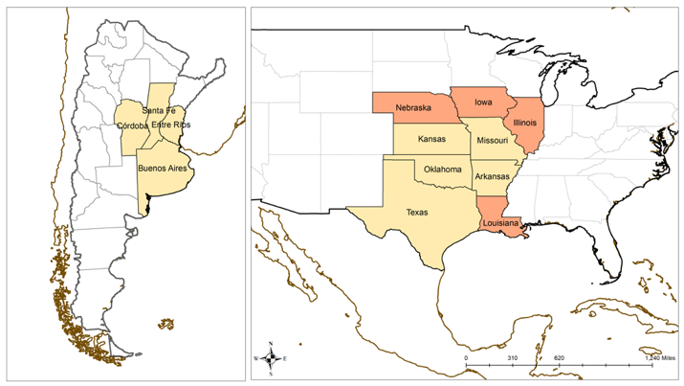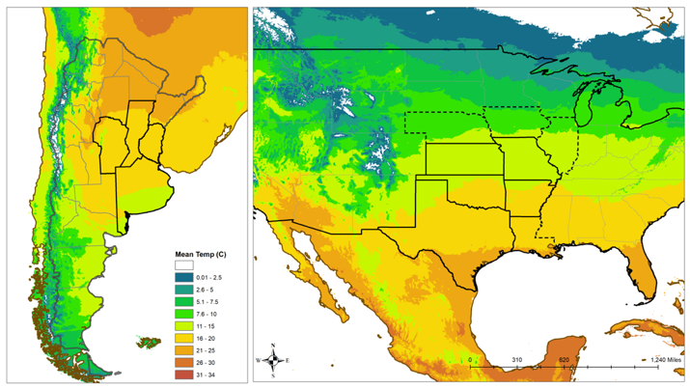
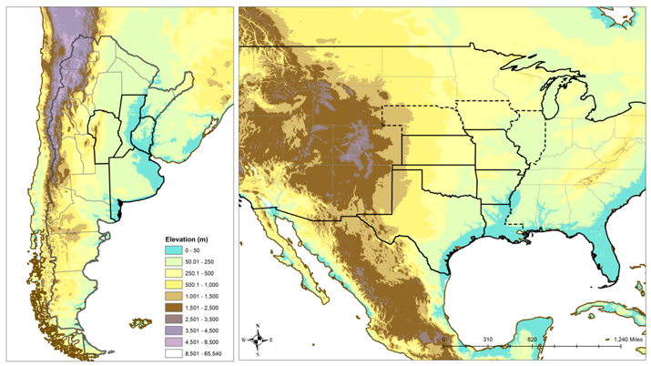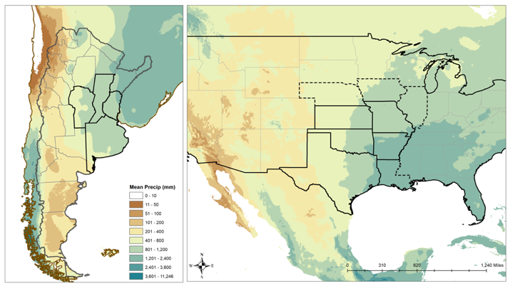
Notes: Top-left: Sample areas with US baseline sample in tan and extended sample tan and orange; top-right: mean temperature (degrees C); bottom-left: elevation (meters above sea level); bottom-right: mean precipitation (mm/year). Maps are drawn by the authors.

To construct geo-climatic descriptions of the historic counties and departments, we extract the area-weighted mean of yearly temperature, precipitation, elevation, and terrain (spatial standard deviation of elevation) using geographical information system software. US 1910 county shapefiles come from the National Historic Geographic Information System produced by the Minnesota Population Center. Argentine department shapefiles are constructed by the authors by modifying a shape file of the current boundaries using Argentina department maps corresponding to 1914 boundaries as provided in Cacopardo (1967).
We extract average normalized attainable yields for wheat and pasture from FAO’s Global Agro-Ecological Zones project v3.0 (IIASA/FAO, 2012). These estimates employ climatic data, including precipitation, temperature, wind speed, sunshine hours, together with crop-specific factors, thermal suitability, water requirements, growth and development parameters. Combining these data, the GAEZ model determines the maximum attainable yield (measured in tons per hectare per year) for each crop in each grid cell of 0.083x0.083 degrees. We use FAO’s measure of agro-climatic yields based solely on climate, not on soil conditions, to eliminate potential endogeneity in soil productivity investments. We consider attainable yields under rain-fed conditions using yields for intermediate levels of inputs/technology.

Table 1: Summary Statistics
 | Argentine Pampas | US Baseline Midwest | US Extended Midwest | Eastern US
County Area | 1,119,606 | 555,676 | 507,696 | 405,969
 | (930,451) | (367,169) | (348,600) | (265,572)
County Population | 24,456 | 19,663 | 23,555 | 34,428
 | (28,653) | (33,080) | (82,488) | (101,932)
Farms | 1,184 | 2,074 | 2,061 | 2,403
 | (836) | (1,336) | (1,229) | (1,360)
Area in Farms (acres) | 949,438 | 384,231 | 363,469 | 278,921
 | (733,163) | (230,718) | (217,877) | (157,079)
Mean Farm Size (acres) | 1,076 | 724 | 533 | 143
 | (1,147) | (2,539) | (2,042) | (188)
Percent of Farms Rented | 0.43 | 0.40 | 0.40 | 0.36
 | (0.18) | (0.18) | (0.17) | (0.20)
Number of Tenant Farms | 509 | 940 | 910 | 936
 | (491) | (849) | (770) | (904)
Number of Cash Rent | 297 | 221 | 259 | 326
 | (273) | (287) | (288) | (488)
Number Share Rent | 213 | 719 | 652 | 610
 | (328) | (702) | (640) | (604)
Percentage Cash Rent | 0.71 | 0.26 | 0.31 | 0.37
 | (0.26) | (0.20) | (0.22) | (0.24)
Number of Cattle | 113,147 | 25,255 | 27,020 | 19,812
 | (95,489) | (15,402) | (17,315) | (16,340)
Cattle per Acre | 127 | 43 | 34 | 10
 | (111) | (167) | (134) | (13)
Cattle per Capita | 6.83 | 4.24 | 3.47 | 1.07
 | (5.45) | (13.15) | (10.66) | (1.25)
Mean Temperature (C) | 16.49 | 15.52 | 14.07 | 12.77
 | (1.55) | (2.85) | (3.71) | (4.26)
Mean Precipitation (mm) | 920 | 896 | 914 | 1,069
 | (148) | (278) | (288) | (260)
Mean Elevation (m) | 128 | 375 | 359 | 256
 | (192) | (293) | (290) | (175)
Roughness | 52 | 36 | 31 | 39
 | (106) | (27) | (25) | (42)
Pasture Suitability | 1,451 | 868 | 959 | 1,280
 | (487) | (571) | (568) | (501)
Wheat Suitability | 4,182 | 4,461 | 4,902 | 5,709
 | (901) | (2,009) | (1,828) | (1,279)
Cropland Acres | 236,925 | 174,470 | 200,900 | 171,285
 | (280,524) | (126,560) | (133,632) | (123,307)
Crop Acres/Farm | 182 | 100 | 112 | 78
 | (165) | (87) | (83) | (64)
Notes: Baseline sample includes all counties in Kansas, Arkansas, Oklahoma, Missouri, and Texas. Extended sample includes in addition all counties in Louisiana, Nebraska, Iowa, and Illinois. Eastern sample includes all counties east of the 100th Meridian. Standard deviations are in parentheses. Suitability measures are in tons per hectare of potential yield. Roughness is the spatial standard deviation of elevation over the county area. Cropland acres and cropland acres per farm are measured slightly differently in Argentina and the United States, as discussed in the text.

From the US census, the number of farms and area in farms are comprehensive counts which include all ownership types and farming activities as well as ranching. These measures correspond most closely to the Argentine Pampas data on number of explotaciones agropecuarias, which includes both farms and ranches, and the area measure corresponding to all these establishments. Due to differing definitions and translation issues, we label as “farms” the US farm/ranch total and total Argentine explotaciones agropecuarias.
In both censuses, the unit of analysis is an individual farm/ranch run by a single operator, and so includes rented farms by tenants as individual observations. The censuses differ slightly in how they report cropland, with the US census reporting improved acres and the Argentine census reporting number and acres in explotaciones agrarias or agriculture. We label both these variables as cropland, but note there may be some systematic differences in what is reported under each measure.
We also collect data from both countries on the number of rented farms. In Argentina, rented farms are further divided into cash-rent and share-rent for establishments in cropland, but only number of renters is provided for ranches—we assume this is because share rent is not a common form of contract for ranch operations. We construct a cumulative number of rentals measure for the Pampas by adding the number of rented farms and ranches. In addition, we construct the proportion share of establishments in cash-rent and share-rent.
In the US, four categories of rent are provided in the census that cover ranches and farms cumulatively. The additional two categories are cash-share rent and unknown rent. To present a consistent comparison, we categorize cash-share rentals as share rentals and unknown rentals as cash rentals.
We calculate the average farm size for each county/department as the total area in farms divided by the total number of farms. While area in tenant farms is not available in Argentina, it is for the US, and we use this approach to construct an average tenant farm size measure. Both censuses provide area cultivated in wheat and the number of cattle.

4.2 Approach
Our empirical approach uses a cross-country comparison of farm organization decisions between the US Midwest baseline sample and the Argentine Pampas provinces, relying on cross-sectional, county-level data. We show that the differences in agricultural organization between the two regions cannot be explained by geo-climatic factors, consistent with our emphasis on differing colonial origins of property rights. Moreover, we show that agricultural organization in Argentina was less responsive to geo-climatic factors.
One key challenge to identification is that other differences between the two areas, for instance differences in land productivity characteristics, could be driving results we attribute to underlying property rights differences. Our choice of the Argentine and US county samples to be similar in geo-climatic characteristics is a broad attempt to compare similar areas. Maps of four farm organization outcomes are provided in Figure 2 to show the variation we seek to explain using geo-climatic dependent variables.
To further control for geo-climatic factors we run a linear regression of a farm organization attribute on an indicator of country, while controlling within each country for geo-climatic variables or measures of potential yield. In these regressions we can examine two types of coefficients: the overall fixed effect of the Argentine Pampas relative to the US Midwest and the differential response to climatic or yield variables between the two regions.
The comparative analysis assumes that the geo-climatic controls sufficiently control for non-institutional factors that might affect outcomes. The differential response comparisons assume that absent institutional differences, farm characteristics in each country would respond similarly in sign and magnitude to factors including precipitation, temperature, roughness, elevation, and productivity suitability. Accordingly, the empirical approach is designed to test the extent to which there are unexplained differences in the organization of farm production that are not related to these geo-climatic factors. This strategy by design cannot directly attribute unexplained differences to a particular cause, but would be consistent with the colonial origins hypothesis.
Figure 2: Comparison of Farm Organization
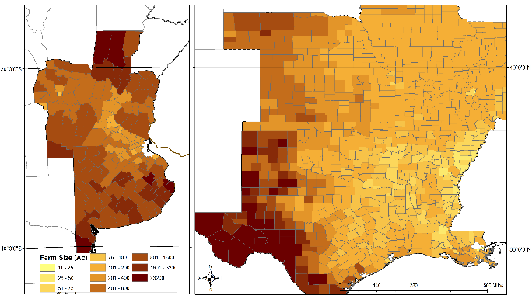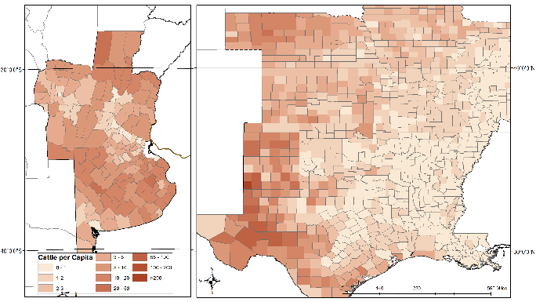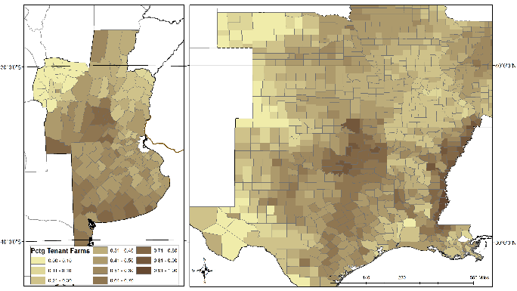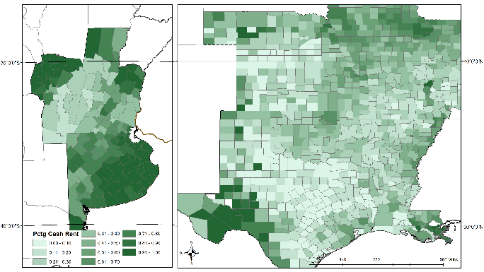
Notes: Figures use US 1910 Ag census data and Argentina 1914 census data. Top-left: mean county farm size (acres); top-right: cattle per capita; bottom-left: percentage of establishments rented; bottom-right: percentage of tenant farms using cash-rent. Maps are drawn by the authors.

4.3 Farm Size
Over time, Argentine farms have been large, to the point of being a worldwide outlier even today (Eastwood et al. 2010; Federico 2008). In 1914, the average of county-level mean farm size in the Pampas as shown in Table 1 was 1,076 acres. This made those farms large relative to the US samples at the time. For the eastern US as a whole, the average of county-mean farm size was just 143 aces. However, the baseline (724 acres) and extended (533 acres) sample farm sizes suggest that Pampas farms were likely large, in part, due to drier geo-climatic conditions. The US baseline sample states are typically drier than are those included in the extended sample and farm sizes grow larger as the climatic and terrain conditions change. They better match those in the Pampas.
Nevertheless, Pampas farms are larger than the baseline sample of Midwest farms. Figure 3 provides histograms comparing the distribution of county/department mean farm sizes in the Pampas and both Midwest samples. Mean farm sizes are smaller for the both the baseline (top-left) and extended (top-right) Midwest samples, with the mean and mass of the distribution well to the left of the Pampas on log scale. While the subset of Midwestern farms operated by owners are larger than those operated by tenants (bottom-left), they are still smaller than Pampas farms. Interestingly, when we look at the number of acres in agricultural production per establishment (bottom-right), the distributions of the two regions become more similar, suggesting that the efficient scale for growing crops was of similar size in both regions, motivating the subletting of portions of estancias for grain production in the Pampas.

Figure 3: Farm Size Comparison
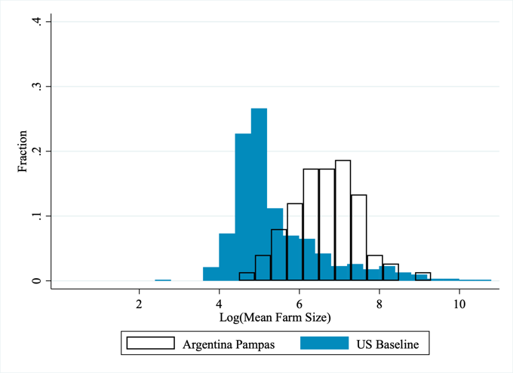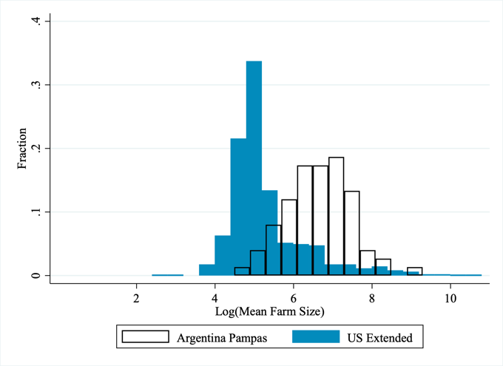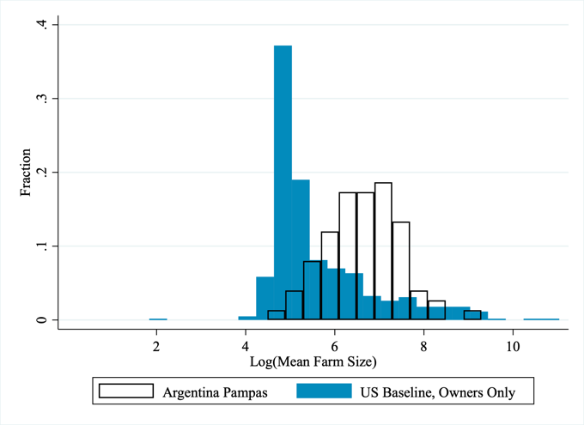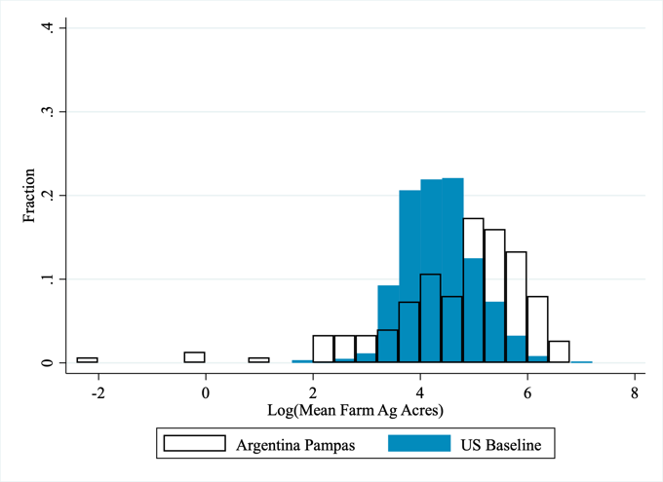
Notes: Table shows histograms of the overall distribution of average farm sizes (logged) in Argentina and the US. The top figures are of the distribution of overall farm size including all types of farms and all land uses (farming and ranching). In the bottom left panel, the US sample is baseline to owner-only farms. The bottom right panel shows the distribution of the average size of cropland acres per establishment. The Argentine sample includes departments in Cordoba, Buenos Aires, Santa Fe, and Entre Rios. The US sample on the top-right is the extended sample includes the baseline sample as well as Nebraska, Illinois, Louisiana, and Iowa. The remaining three figures show the baseline US sample which include counties from Texas, Oklahoma, Kansas, Arkansas, and Missouri.

We regress farm size (in logs) on climatic and productivity factors jointly for both regions, using the baseline Midwest sample with results shown in Table 2. Because departments/counties vary in size and agricultural intensity, here and for the remaining statistical analysis, we provide three specifications using differing importance weights—none, county acres, and farm acres—to provide a robust set of coefficients. Specifications (1) - (3) pool Argentine departments and US counties, with farm sizes decreasing in wheat suitability and precipitation, but increasing in pasture suitability. Specification (4) - (6) control for a country-specific fixed-effect, showing Argentine farms are significantly larger than their US counterparts, even when controlling for geo-climatic characteristics. For instance, the coefficient on ARG in (4) suggests Argentine farms are 61% larger than US farms after controlling for geo-climatic and productivity factors.
Table 2: Basic Geo-climatic Regression Results
 | (1) | (2) | (3) | (4) | (5) | (6)
 | Farm Size | Farm Size | Farm Size | Farm Size | Farm Size | Farm Size
ARG |  |  |  | 0.4757*** | 0.8218*** | 0.7838***
 |  |  |  | [0.1106] | [0.1421] | [0.1451]
Terrain | 0.0012 | 0.0006 | 0.0008 | -0.0062*** | -0.0074*** | -0.0068***
 | [0.0008] | [0.0013] | [0.0011] | [0.0010] | [0.0013] | [0.0014]
Elevation | -0.0009** | -0.0009 | -0.0013** | 0.0006 | 0.0009* | 0.0008
 | [0.0004] | [0.0006] | [0.0005] | [0.0004] | [0.0005] | [0.0006]
Temperature | 0.0340 | 0.0826** | 0.0677* | -0.0720*** | -0.0549* | -0.0628*
 | [0.0223] | [0.0416] | [0.0362] | [0.0219] | [0.0321] | [0.0366]
Precipitation | -0.0041*** | -0.0049*** | -0.0049*** | -0.0019*** | -0.0019*** | -0.0019**
 | [0.0003] | [0.0005] | [0.0005] | [0.0005] | [0.0007] | [0.0008]
Wheat Suit. (log) | -0.3018*** | -0.2937*** | -0.3459*** | 0.1355*** | 0.1411*** | 0.1466***
 | [0.0391] | [0.0517] | [0.0527] | [0.0318] | [0.0304] | [0.0346]
Corn Suit. (log) | 0.0935 | -0.4531 | -0.3294 | 0.8812* | 1.1008 | 1.1903
 | [0.6211] | [0.7837] | [0.8406] | [0.5102] | [0.6784] | [0.7748]
Pasture Suit. (log) | 0.2715** | 0.4290* | 0.3798* | 0.1507 | 0.2220 | 0.1661
 | [0.1306] | [0.2227] | [0.1947] | [0.1652] | [0.2301] | [0.2780]
Constant | 8.9286 | 13.0391* | 12.9587* | -2.9339 | -5.7787 | -6.1638
 | [5.7488] | [7.2867] | [7.7055] | [4.9226] | [6.3708] | [7.3044]
Observations | 766 | 766 | 766 | 766 | 766 | 766
R-squared | 0.5660 | 0.5396 | 0.4946 | 0.3874 | 0.3882 | 0.3131
Weights | none | county acres | farm acres | none | county acres | farm acres
Notes: Table shows coefficient estimates for regression of mean farm size (logged) on factors affecting agricultural production. Argentine sample includes departments in Cordoba, Buenos Aires, Santa Fe, and Entre Rios. US sample is the baseline sample and includes counties from Texas, Oklahoma, Kansas, Arkansas, and Missouri. Farm size is defined as total acres in farming and ranching in a county/department divided by the number of establishments. Robust standard errors in brackets: *** p<0.01, ** p<0.05, * p<0.1.

In Table 3, we show differential responses to geo-climatic covariates. In specifications (1) - (3) the coefficient on ARG, which is the overall farm size differential, is consistent with the Pampas having larger farms than in the baseline Midwest sample, even after controlling for different geo-climatic responses. Coefficients on precipitation for both countries suggest a negative relationship between farm size and precipitation, which is consistent with literature suggesting drier areas require larger viable farm sizes (Libecap 1993, 60; Allen and Lueck 1998, 376; Edwards 2016). Midwest farms also appears to respond to heat, rough terrain, and elevation by having larger farms, while Pampas farms do not appear as sensitive to these variables, suggesting rigidity in farm size adjustments.
In specifications (4) - (6), we focus only on the land within each county used as cropland. These results do not show a similar size differential between the two regions, although in the baseline Midwest sample cropland size still appears much more responsive to climate as indicated by the statistically significant coefficients on the geo-climatic variables. Thus, while overall farm units in the Pampas were quite large, the amount of cropland per establishment was considerably smaller and not different from the baseline Midwest sample. These findings are consistent with the notion that grain production in the Pampas was undertaken on rented plots carved out of larger estates.

Table 3: Midwest and Pampas Farm Size Regression Results
 | (1) | (2) | (3) | (4) | (5) | (6)
 | Farm Size | Farm Size | Farm Size | Ag Size | Ag Size | Ag Size
ARG | 5.6785*** | 3.3417*** | 3.8627*** | -1.3424 | -2.3149 | -2.4405
 | [0.9358] | [1.1318] | [1.0710] | [1.3961] | [1.4127] | [1.4869]
ARG Terrain | -0.0007 | -0.0038** | -0.0028* | -0.0094*** | -0.0136*** | -0.0131***
 | [0.0020] | [0.0017] | [0.0014] | [0.0036] | [0.0039] | [0.0038]
US Terrain | 0.0027* | 0.0040** | 0.0045* | -0.0056*** | -0.0075*** | -0.0065***
 | [0.0015] | [0.0018] | [0.0025] | [0.0010] | [0.0014] | [0.0016]
ARG Temperature | -0.0654 | 0.0852 | 0.0456 | 0.0219 | 0.0618 | 0.0625
 | [0.0594] | [0.0751] | [0.0660] | [0.1123] | [0.0857] | [0.0962]
US Temperature | 0.1133*** | 0.1379*** | 0.1296*** | -0.1188*** | -0.1303*** | -0.1303***
 | [0.0111] | [0.0139] | [0.0156] | [0.0090] | [0.0111] | [0.0122]
ARG Precipitation | -0.0028*** | -0.0029*** | -0.0027*** | -0.0021* | -0.0019 | -0.0019
 | [0.0005] | [0.0006] | [0.0006] | [0.0013] | [0.0012] | [0.0013]
US Precipitation | -0.0020*** | -0.0025*** | -0.0025*** | -0.0015*** | -0.0014*** | -0.0016***
 | [0.0002] | [0.0003] | [0.0003] | [0.0001] | [0.0002] | [0.0002]
ARG Elevation | -0.0012 | 0.0002 | -0.0003 | 0.002 | 0.0047* | 0.0044*
 | [0.0011] | [0.0008] | [0.0008] | [0.0021] | [0.0025] | [0.0025]
US Elevation | 0.0015*** | 0.0012*** | 0.0014*** | -0.0002 | -0.0002 | -0.0003
 | [0.0003] | [0.0003] | [0.0004] | [0.0002] | [0.0002] | [0.0002]
Constant | 4.7957*** | 4.9427*** | 4.9619*** | 7.8136*** | 8.0229*** | 8.1951***
 | [0.3666] | [0.4450] | [0.5018] | [0.2575] | [0.3364] | [0.3322]
Observations | 766 | 766 | 766 | 766 | 766 | 766
R-squared | 0.7171 | 0.7376 | 0.7151 | 0.367 | 0.3965 | 0.3254
Weights | none | county acres | farm acres | none | county acres | farm acres
Notes: Table shows coefficient estimates for regression of mean farm size (logged) on factors affecting agricultural production. Argentine sample includes departments in Cordoba, Buenos Aires, Santa Fe, and Entre Rios. US sample is the baseline sample and includes counties from Texas, Oklahoma, Kansas, Arkansas, and Missouri. In specifications (1) - (3) farm size is defined as total acres in farming and ranching in a county/department divided by the number of establishments. For specifications (4) - (6) farm size is the total acres in agricultural production (Argentina) or improved acres (US) divided by the total number of establishments. Robust standard errors in brackets: *** p<0.01, ** p<0.05, * p<0.1.

Figure 4 shows plots the predicted and actual farm sizes of farms in both countries using the regression in specification (1) of Table 2. Pampas farm sizes generally lie above the 45-degree line, indicating the model under predicts Argentine farm sizes, while generally over predicting the size of Midwest farms.
Figure 4: Actual and Geo-Climatic Predicted Farm Sizes
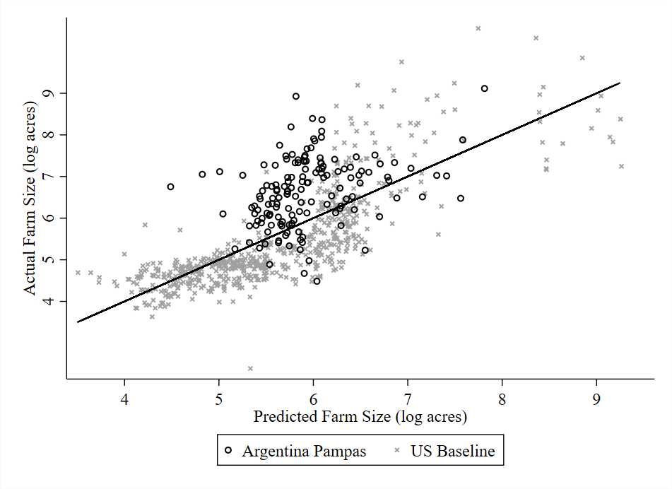
Notes: The predicted mean farm size of a regression on elevation, roughness, temperature, precipitation and corn, wheat, and pasture suitability (logged) plotted against actual farm sizes. Sample includes Argentine Pampas and provinces US baseline Midwest states: Texas, Oklahoma, Kansas, Arkansas, and Missouri.

In Figure 5, we plot the residuals from the same regression to explore state and province specific predictions. Three results from this plot are of interest. First, the large positive residuals in the Midwest baseline sample are exclusively in Texas, the US state in our sample with the most influence from Spanish institutions. Second, Buenos Aires has notably high residuals and is the province with the strongest influence of Spanish colonial property institutions. Third, Cordoba is notable for its lack of high-residual predictions, attributable to its relative aridity (which made larger farms more suitable for the climate) and its later settlement that may have farm size adjustments easier.

Figure 5: State and Province Residual Plots
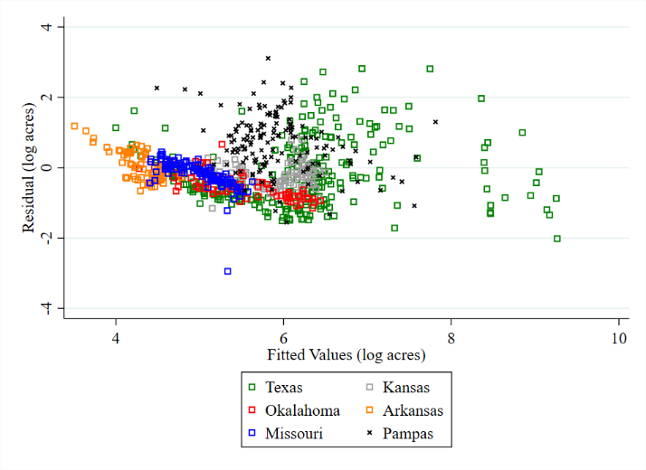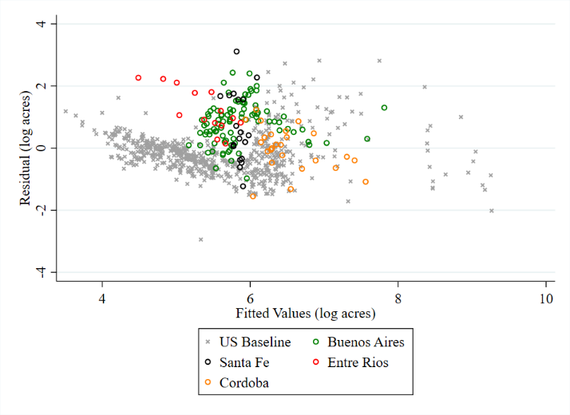
Notes: The residuals and fitted values of a regression on elevation, roughness, temperature, precipitation and corn, wheat, and pasture suitability (logged) plotted against actual farm sizes. Sample includes Argentine Pampas and provinces US baseline Midwest states: Texas, Oklahoma, Kansas, Arkansas, and Missouri.

4.4 Production Decisions
The results from the previous section suggest that farm owners in the Pampas provinces may have been responding to a different set of constraints, beyond geo-climatic ones, relative to their Midwestern counterparts. To support this hypothesis, we can test directly how production responded to climatic conditions. Figure 6 shows indicative relationships in the raw data on climate and production that suggest Pampas farm production was similarly less responsive to on-the-ground conditions. In the left panel, Midwestern baseline sample counties show a positive relationship between acres in wheat and wheat suitability. In the Pampas, however, areas with better suitability for growing wheat have fewer acres in wheat, as demonstrated by the negative linear trend line. Similar opposite trends are observed for cattle production, where Midwest ranchers tend to run more cattle where there is less precipitation and thus, less potential for crop production. By contrast, farms in the Pampas, in addition to having more cattle generally, appear to have had more cattle in wetter areas. While wetter areas can produce more forage and thus, support more cattle, this distribution would likely crowd out other crop production, a trend we do not observe in the Midwest. Overall, Midwest farmers appear to plant more wheat and raise fewer cattle in wetter areas, whereas Pampas farmers comparatively raise more cattle and grew less wheat.

Figure 6: Production Decision Scatterplots
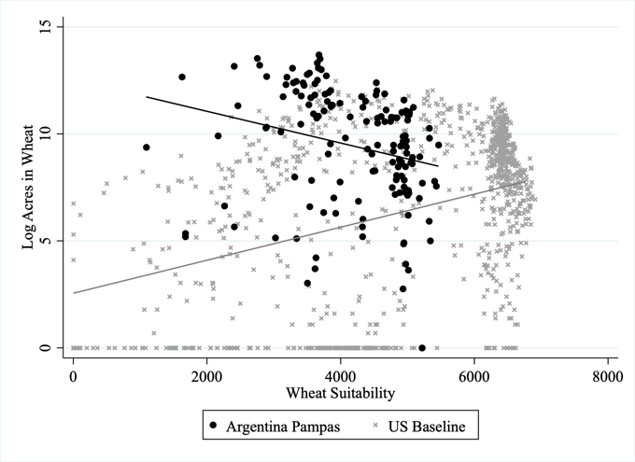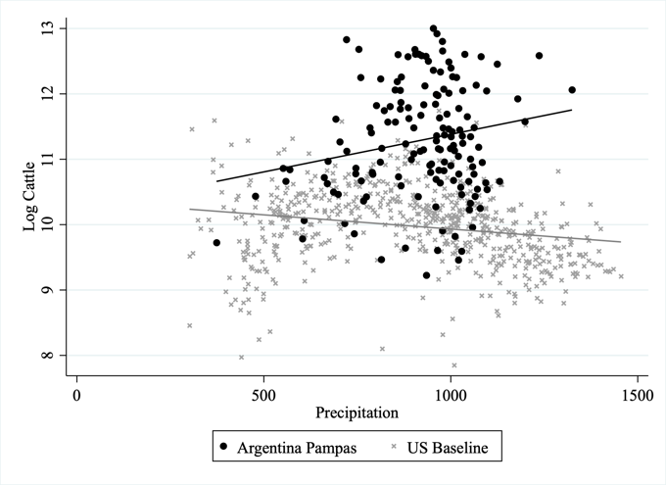

To examine the results statistically, we regress acres in wheat and number of cattle on geo-climatic characteristics as well as potential yields—wheat suitability pasture suitability (in logs). Specifications (1) - (3) show that while farmers in the baseline Midwest counties plant more wheat acres as wheat suitability improves, farmers in the Pampas plant less. After controlling for geo-climatic characteristics, Argentine farms tend to run more cattle as pasture suitability increases. These results suggest that Argentine farms tended to specialize in ranching when suitable, even potentially forgoing productive wheat growing regions to do so.

Table 4: Production Choice Regression Results
 | (1) | (2) | (3) | (4) | (5) |  | (6)
 | Acres Wheat | Acres Wheat | Acres Wheat | Cattle | Cattle |  | Cattle
ARG | 101.82*** | 95.09*** | 94.28*** | 23.75*** | 19.95*** |  | 19.15***
 | [15.6633] | [19.6539] | [19.3391] | [5.3708] | [5.3765] |  | [5.4891]
ARG Terrain | -0.0156** | -0.0196** | -0.0205** | -0.0019 | -0.0034* |  | -0.0038*
 | [0.0074] | [0.0081] | [0.0082] | [0.0019] | [0.0018] |  | [0.0020]
US Terrain | 0.0064 | 0.0082 | 0.0059 | 0.0044*** | 0.0067*** |  | 0.0061***
 | [0.0044] | [0.0061] | [0.0060] | [0.0012] | [0.0009] |  | [0.0011]
ARG Temperature | -0.9864*** | -1.0482*** | -0.9685*** | -0.2289*** | -0.1540*** |  | -0.1520**
 | [0.1925] | [0.2452] | [0.2493] | [0.0731] | [0.0573] |  | [0.0639]
US Temperature | -0.8400*** | -0.8079*** | -0.7731*** | 0.0283* | 0.0402** |  | 0.0256
 | [0.0651] | [0.0784] | [0.0746] | [0.0146] | [0.0172] |  | [0.0169]
ARG Elevation | 0.0038 | 0.0072 | 0.0077 | 0.0008 | 0.0018* |  | 0.0021*
 | [0.0049] | [0.0054] | [0.0053] | [0.0010] | [0.0011] |  | [0.0012]
US Elevation | 0.0005 | 0.0011 | 0.0017 | -0.0007** | -0.0007** |  | -0.0007**
 | [0.0011] | [0.0013] | [0.0013] | [0.0003] | [0.0003] |  | [0.0003]
ARG Precipitation | -0.0010 | -0.0021 | -0.0026 | 0.0003 | 0.0006 |  | 0.0005
 | [0.0033] | [0.0033] | [0.0033] | [0.0009] | [0.0008] |  | [0.0009]
US Precipitation | -0.0131*** | -0.0158*** | -0.0151*** | -0.0028*** | -0.0029*** |  | -0.0026***
 | [0.0011] | [0.0014] | [0.0014] | [0.0002] | [0.0003] |  | [0.0002]
ARG Wheat Suit. | -16.7997*** | -15.6953*** | -15.5425*** | -4.4941*** | -4.1179*** |  | -4.1212***
 | [2.8972] | [3.5396] | [3.4593] | [0.9524] | [0.9734] |  | [0.9892]
US Wheat Suit. | 0.4887*** | 0.1639 | 0.2700* | -0.0615** | -0.0936*** |  | -0.0725***
 | [0.0818] | [0.1810] | [0.1627] | [0.0245] | [0.0290] |  | [0.0257]
ARG Pasture Suit. | 7.7619*** | 8.0571*** | 8.0886*** | 2.6520*** | 2.6203*** |  | 2.6325***
 | [1.9680] | [2.1107] | [2.0489] | [0.5608] | [0.5309] |  | [0.5411]
US Pasture Suit. | 2.7584*** | 3.8012*** | 3.7235*** | 0.5371*** | 0.5950*** |  | 0.4525***
 | [0.4400] | [0.5912] | [0.5696] | [0.0893] | [0.1103] |  | [0.1035]
Constant | 8.9216*** | 6.6967* | 5.1150 | 9.2627*** | 9.0652*** |  | 9.8089***
 | [3.1150] | [3.7132] | [3.6519] | [0.7227] | [0.8367] |  | [0.8162]
Observations | 766 | 766 | 766 | 766 | 766 |  | 766
R-squared | 0.7104 | 0.7406 | 0.7230 | 0.5223 | 0.6817 |  | 0.6683
Weights | None | county acres | farm acres | none |  | county acres |  | farm acres
Notes: Specifications (1) - (3) show estimates for regression of acres in wheat (log of wheat acres+1) on factors affecting agricultural production including the average wheat suitability of a county/department. Specifications (4) - (6) show estimates for regression of the number of cattle (logged) on factors affecting production including the average pasture suitability of a county/department. Argentine sample includes departments in Cordoba, Buenos Aires, Santa Fe, and Entre Rios. US sample is the baseline sample and includes counties from Texas, Oklahoma, Kansas, Arkansas, and Missouri. Robust standard errors in brackets: *** p<0.01, ** p<0.05, * p<0.1.

4.5 Tenancy
The organization of tenant arrangements sheds more light on why farms in Argentina remained large. Table 5 shows the results of a regression of percentage of farms rented on geo-climatic characteristics and wheat suitability. After controlling for geo-climatic characteristics, the Pampas have a higher proportion of renters than in the baseline Midwest sample, as seen in specifications (1) - (3). This result is consistent with the idea that tenancy was the preferred method for large landowners to engage in cereal production in the Pampas. However, while the number of farms rented responds positively to wheat suitability in the Midwest, the relationship is negative for the Pampas.
This relationship allows for a more nuanced explanation of the production regression results, shown in Table 4. Pampas landholdings in the best wheat-growing regions are larger than their Midwest counterparts, but the efficient scale for grain production is on smaller plots. Rather than rent out many small plots and thereby encounter potential moral hazard and other monitoring problems, these large landowners chose to specialize in cattle production, leading to fewer tenants in these areas.
Looking within renters, specifications (4) - (6) show the percentage of renters on a share-based contract. The Pampas had a significantly higher proportion of cash renters. Share contracts allow owners to create smaller farm sizes, while reducing capital constraints and sharing the risk with tenants. In the Midwest, the relative number of share renters remains constant as wheat suitability increases; there is no statistically different coefficient on wheat productivity than in specifications (1) - (3) and point estimates are an order of magnitude lower. However, in the Pampas, where overall rental levels fall as wheat suitability increases, specifications (4) - (6) indicate that share rentals fall even more than overall rentals as wheat suitability increases.
Accordingly, Pampas landowners underutilized share rental agreements in high-yield wheat-growing areas relative to the Midwest. Share tenants in the US were part of the agricultural ladder, saving earnings to eventually purchase the land they worked and aligning incentives for improved profitability (Winters 1982, 137-143; Cheung 1969a, b). The contractual arrangement leading to property ownership increased demand for share contracts, and share contracts are especially appealing in areas with high yields (Alston and Kauffman 1997). In the Pampas, land sales were more limited and tenants did not have a prospect of becoming landowners, reducing interest in share tenancy arrangements. Further, landowners in the best growing regions would have been the most reluctant to engage in the types of rental agreements that provided tenants with a property interest, given that their landholdings were key to political and social status; the rental plots were not intended for sale.

Table 5: Tenancy Regression Results
 | (1) | (2) | (3) | (4) | (5) |  | (6)
 | % Rented | % Rented | % Rented | % Share | % Share |  | % Share
ARG | 2.5479*** | 2.4016*** | 2.2665*** | -0.8776** | -1.0158** |  | -1.2493***
 | [0.1825] | [0.2357] | [0.2024] | [0.3424] | [0.5013] |  | [0.4671]
ARG Terrain | -0.0009*** | -0.0012*** | -0.0010*** | -0.0018*** | -0.0023** |  | -0.0025***
 | [0.0002] | [0.0004] | [0.0003] | [0.0007] | [0.0009] |  | [0.0008]
US Terrain | -0.0015*** | -0.0014*** | -0.0015*** | -0.0005 | -0.0016** |  | -0.0019***
 | [0.0003] | [0.0003] | [0.0003] | [0.0006] | [0.0007] |  | [0.0007]
ARG Temperature | -0.0581*** | -0.0505*** | -0.0552*** | 0.0492** | 0.0304 |  | 0.0524**
 | [0.0088] | [0.0138] | [0.0108] | [0.0201] | [0.0304] |  | [0.0260]
US Temperature | 0.0650*** | 0.0569*** | 0.0520*** | 0.0025 | -0.0104 |  | -0.0075
 | [0.0055] | [0.0066] | [0.0058] | [0.0067] | [0.0092] |  | [0.0087]
ARG Precipitation | 0.0001 | 0.0001 | 0.0001 | 0.0002 | 0.0006 |  | 0.0003
 | [0.0001] | [0.0002] | [0.0002] | [0.0003] | [0.0005] |  | [0.0004]
US Precipitation | -0.0002*** | -0.0001 | 0.0000 | 0.0000 | 0.0001* |  | 0.0002**
 | [0.0001] | [0.0001] | [0.0001] | [0.0001] | [0.0001] |  | [0.0001]
ARG Elevation | -0.0002* | 0.0000 | 0.0000 | 0.0005 | 0.0010** |  | 0.0012**
 | [0.0001] | [0.0002] | [0.0002] | [0.0004] | [0.0005] |  | [0.0005]
US Elevation | 0.0002*** | 0.0003*** | 0.0002*** | -0.0001 | -0.0001 |  | -0.0001
 | [0.0001] | [0.0001] | [0.0001] | [0.0001] | [0.0001] |  | [0.0001]
ARG Wheat Suit. | -0.0001*** | -0.0001** | -0.0001** | -0.0001*** | -0.0002** |  | -0.0001**
 | [0.0000] | [0.0000] | [0.0000] | [0.0000] | [0.0001] |  | [0.0001]
US Wheat Suit. | 0.0001*** | 0.0001*** | 0.0001*** | 0.0000 | 0.0000 |  | -0.0000**
 | [0.0000] | [0.0000] | [0.0000] | [0.0000] | [0.0000] |  | [0.0000]
Constant | -0.9154*** | -0.8964*** | -0.7069*** | 0.7657*** | 0.9532*** |  | 0.9331***
 | [0.1259] | [0.1473] | [0.1314] | [0.1722] | [0.2380] |  | [0.2192]
Observations | 766 | 766 | 766 | 764 | 764 |  | 764
R-squared | 0.4229 | 0.456 | 0.464 | 0.4639 | 0.4341 |  | 0.4695
Weights | None | county acres | farm acres | None |  | county acres |  | farm acres
Notes: Specifications (1) - (3) show estimates for regression of the percentage of all establishments which are rented. Specifications (4) - (6) show estimates for the percentage of all rented establishments which have a share contract. Argentine sample includes departments in Cordoba, Buenos Aires, Santa Fe, and Entre Rios. US sample is the baseline sample and includes counties from Texas, Oklahoma, Kansas, Arkansas, and Missouri. Crane and Loving counties in the US state of Texas report no tenancy in the 1910 census and therefore the share tenancy rate is calculated for 764 of the 766 possible counties. Robust standard errors in brackets: *** p<0.01, ** p<0.05, * p<0.1.

All told, the empirical results are consistent with the hypotheses drawn from the qualitative discussion in Sections (1) – (3) regarding the impact of different property rights allocations on the institutional structure of agricultural production; the impact on market exchange if land ownership conveys bundled commercial and status attributes; and the colonial origins of varying property rights to land between the English US and Spanish Argentina.
We find that farm sizes are larger in the Pampas, all else equal. Pampas estate owners and their tenants are less responsive to shifting geo-climatic variables, particularly critical precipitation. More land in the Pampas specialized in cattle raising and less in grain production than productivity measures would suggest. Cash tenancy rather than share tenancy is more prevalent in the Pampas.

5. Discussion: Implications for Long-run Development
Insofar as there is an inverse relationship between farm size and productivity in the absence of economies of scale, then large landholdings in Argentina imply productivity losses. Misaligned incentives associated with short-term cash rent contracts contribute to moral hazard. Monitoring costs make moral hazard feasible. One source of cost is in under investment in physical capital. By the late 19th century, the Argentine frontier generally was closed and where land was traded, prices were rising, motivating investment in soil. Instead, historians indicate that soil exhaustion was occurring on tenant plots (Scobie 1964, 72-88; Scarzanella 1989, 21; Adelman 1994, 77, 133-135, 202). Adelman references a 1900 Minister of Agriculture report on the problem of over cultivation by tenants whose intensive farming was undermining long-term soil productivity (Adelman 1994 241-249).
As an indication of concern, owners stipulated yearly field crop rotations for wheat and flax across the 2-3 years of a typical tenancy. Flax was a common rotation and export crop used to diversify output, reduce weeds, and lower fertilizer and tillage. Additionally, alfalfa was to be sowed during the last contract year to improve subsequent pasture and to reduce over-cultivation in wheat by tenants at the end of the contract (Cortez Conde 1966; Slutzky 1968; Scarzanella 1989, 3, 5, 13; Palacio 2002).
Contracts also included a layout of the portion of a leasehold that was to be put in crops for the owner and in pasture, gardens, and other uses by the tenant; hours of work; when grains should be harvested; and seed types to be planted. Owners wanted to avoid tenants harvesting too soon when grains were still relatively green (Scarzanella 1989, 21). Equipment and buildings belonging to the owner were to be returned in original condition at the end of the tenancy (Scarzanella 1989, 6-7). These stipulations defined tenant responsibilities to reduce rent dissipation for owners and they required costly monitoring and enforcement to be effective.
Another potential cost is reduced investment in new technologies. While land owners were aware of new seeds, planting and harvest technologies, and cattle breeds developed in Europe and North America, the literature suggests that owners and tenants did not generally invest in them, relying on the inherent richness of Pampa soils (Hennessy 1978, 18, 24, 83; Scobie 1964, 91-97; Campante and Glaeser 2009, 3). Adelman (1994, 198-217; 251-255) argues that under investment in new agricultural technology depressed long-term productivity. Crop yields were claimed to be lower than in the US and Canada (Solberg 1971, 46). Tenants had neither incentive with short contracts nor collateral to purchase new equipment, seeds, and other capital (Scarzanella 1989, 11). Overall, investment in technological innovation for agriculture appears to have been less despite the role of farm exports in the country’s GDP (Solberg 1987, 109-110).
Unlike the US, there was minimal formal agricultural education and less attention to new opportunities and agricultural prizes and competitions (Scobie 1964, 148-152; Solberg 1971, 33; Scarzanella 1989, 21). In 1920 there were 9 agricultural experiment stations in Argentina and a budget that had declined 69% since 1912. The US had at least one experiment station in each state and nearly 4,000 experiment station employees, teachers, and assistants (US Department of Agriculture 1922, 87). These were part of the land-grant college system designed to promote research in agricultural innovation.
A third area is in investment in human capital. Small farm owners in the Midwest supported schooling for their children. The pedagogical focus was practical, pragmatic in emphasis, and egalitarian, aimed at understanding and using new technologies. Educated farmers and their children were better equipped to adopt new technologies, cropping changes, and shifts in market opportunities. The Northwest Ordinance of 1785 created the Public Lands Survey System to promote survey, classification and sale of government lands, also set aside section 16 of each township for public schools (Libecap and Lueck 2011). School governance was decentralized as a local effort with 125,000 independent school districts in America by the 1920s (Goldin 1998, 347, 351; 2001, 279; Goldin and Katz 2010; Go and Lindert 2010, 3-16). Between 1910 and 1960 enrolment and graduation rates were among the highest in Midwestern states with their homogenous populations and wealth distributions. Using census data across states 1900 to 1940 Galor et al. (2009, 145, 172) find a significant positive relationship between the a more equal distribution of land ownership and provision of education.
In the Pampas landed elites were little motivated to advance education among the rural, non-land owning labor force that could increase mobility, raising labor costs and lowering dependence upon patrons. Moreover, mobile tenants had few incentives to invest in local schools or school districts (Scarzanella 1989, 16, 18; Campante and Glaeser 2009, 14). Solberg (1971, 22) claims that in the early part of the 20th century, the bulk of rural children had not attended any school and could not read or write. Even as late as the 1940s, Taylor (1948, 316) claims that 10-20% of rural children between the ages of 6 and 13 in the Pampas had no education. Tenants were often illiterate, and the lack of education contributed to rural labor force with limited human capital (Scobie 1964, 63; Scarzanella 1989, 7). Campante and Glaeser (2009, 2, 3, 10, 15, 30-33) contend that the rural labor that migrated to Buenos Aires from the Pampas in the late 19th and early 20th centuries had far less education than did those who migrated to Chicago from the Midwest.
A fourth area of potential loss is in agricultural strikes. These can be viewed as holdup by cash tenants during key production stages in order to extract contractual changes from owners (Klein, Crawford, and Alchian 1978). Solberg (1971, 24-30, 36) and Scarzanella (1989, 2, 12) describe strikes by tenants in the Argentine grain belt during critical sowing and harvest periods in 1912 and 1913, 1917, 1919, and 1930. About 70,000 farm workers, two-thirds of whom held 2 to 3-year tenant contracts on plots of 150-200 hectares were involved, halting farm work and in some cases, destroying crops (Solberg 1971, 24-26). Their efforts were coordinated by the formation of a tenant cooperative, Federación Agraria Argentina (FAA). They withheld labor, demanding lower rents and crop shares, longer contract tenures with a minimum of 4 years, and later overall land ownership reform (Solberg 1971, 40-52; Scarzanella 1989, 12). There is nothing comparable to these strikes in the US Midwest among small farmers or tenants where incentives were more aligned. In the Pampas, cash tenants had labor contracts and as such were not residual profit claimants.
We lack data to assess the aggregate magnitude of the effects on overall economic growth and welfare in Argentina over time. Together, however, this more qualitative evidence along with the empirical results suggest potential drags on economic performance and welfare. With its rich resource base, in 1913 Argentina was among the 10 richest countries in the world. It later stagnated and lost its relative position. The 1913 measure is a mean value and the distribution of wealth in the Pampas was far more skewed than in the Midwest United States. How much richer might Argentina have been with a different property rights to land regime, different institutional structures of production, and different land acquisition options and labor contracts? Our examination indicates that the costs may have been large. These losses may have been camouflaged by the general prosperity of the country and the desire of landed elites, who bore only a portion of the aggregate costs, to maintain their political and social status.

6. Concluding Remarks
We examine two similar agricultural-producing regions in terms of terrain, soil quality and climate that produced for the same international commodity markets, the Midwestern US and the Pampas of Argentina at the turn of the 20th century. Despite these similarities, the productive units were very different, with small-scale farms in the Midwest relying upon family labor and share tenants, and large estates in the Pampas relying upon short-term, cash tenant labor contracts. The institutional structures of production were due to the exogenous colonial policies of England and Spain that determined the allocation of property rights to land. These practices continued after independence.
A low transaction-cost setting would have allowed for differential property rights to be moderated over time so that productive units would have become more similar under competitive conditions. In the Midwest property ownership primarily brought commercial benefits, and land markets were active. This region provides a baseline for market activity, suggested by Demsetz (1967, 350) for comparison with the Pampas.
In the Pampas ownership conveyed both commercial and status benefits that were difficult to value and exchange, raising transaction costs. Available evidence indicates that large land owners sought to maintain their social positions based on land ownership and did not generally participate in land markets. Any price premiums offered for land apparently were not sufficiently high to compensate for lost political and social status that could be transferred with the land across generations. The incentive to maintain large holdings in the Pampas also influenced the selection of cash tenancy over share tenancy, despite potential greater moral hazard.
Agriculture has been a critical component of the Argentine economy and is fundamental in most developing societies. The broader issue of overall lagging economic outcomes in Spanish versus English colonial areas has long attracted the attention of historians, economic historians and development economists (Engerman and Sokoloff; Sokoloff and Engerman; Acemoglu et al.; Keefer and Vlaicu 2007; Campante and Glaeser; North et al. 2009; Acemoglu and Robinson 2012).
This literature emphasizes endogenous factors affecting Latin America more broadly: factor endowments that encouraged large-scale, extractive production; local disease environments that limited European immigration; and dense native populations that supported use of coerced indigenous labor. Argentina, however, was not characterized by any of these factors. It did share, however, exogenous property rights allocations to large owners as the basis the hierarchical assignment of political, social, and economic status across generations. This bundling of land values inhibited the development land and capital markets and the productivity and general welfare gains they can provide.

References
Abramitzky, R. and Braggion, F. (2006) Migration and human capital: Self-selection of indentured servants to the Americas. Journal of Economic History. 66 (4): 882-905.
Acemoglu, D. (2003). Why not a political Coase theorem? Social conflict, commitment, and politics. Journal of Comparative Economics 31: 620–652.
Acemoglu, D., Johnson, S. and Robinson, J. (2001). The colonial origins of comparative development: An empirical investigation. American Economic Review 91 (5): 1369-1401.
Acemoglu, D., Johnson, S. and Robinson, J. (2002). Reversal of fortune: Geography and institutions in the making of the modern world income distribution. The Quarterly Journal of Economics 117(4): 1231-1294.
Acemoglu, D., Johnson, S. and Robinson, J. (2005). Institutions as a fundamental cause of long-run growth, Aghion, P. and Durlauf, S.N. eds, Handbook of Economic Growth, Amsterdam: Elsevier, Chapter 6, 386-414
Acemoglu, D. and Robinson, J. (2012). Why nations fail, New York: Crown.
Adelman, Jeremy. (1994). Frontier development: Land, labor, and capital on wheat lands of Argentina and Canada, 1890–1914. Oxford: Clarendon Press.
Adelman, Jeremy (1990). Agricultural credit in the province of Buenos Aires, Argentina, 1890-1914, Journal of Latin American Studies, Vol. 22, No. 1, pp. 69-87
Alchian, A.A. and Demsetz, H., (1972). Production, information costs, and economic organization. The American economic review, 62(5), pp.777-795.
Allen, D.W. and Lueck, D., (1998). The nature of the farm. The Journal of Law and Economics, 41(2), pp.343-386.
Alston, L.J. and Ferrie, J.P. (2005) Time on the ladder: Career mobility in agriculture, 1890-1938. Journal of Economic History 65(4): 1058-1081.
Alston, Lee J., and Kyle Kauffman. (1997). “Agricultural Chutes and Ladders: New Estimates of Sharecroppers and ‘True Tenants’ in the South, 1900–1920.” Journal of Economic History 57(2) (June): 464–75.
Álvarez‐Nogal, C. and De La Escosura, L.P., (2013). The rise and fall of Spain (1270–1850) 1. The Economic History Review, 66(1), pp.1-37.
Amaral, S. (1998). The Rise of capitalism on the pampas: The estancias of Buenos Aires, 1785-1870. New York: Cambridge University Press.
Banzato, G. (2013). Tierras rurales. políticas, transacciones y mercados en Argentina, 1780-1914. Prohistoria.
Barzel, Y. (1982). Measurement cost and the organization of markets. Journal of Law and Economics, 25 (1): 27-48.
Barzel, Y, (1989). Economic analysis of property rights. New York: Cambridge University Press.
Barzel, Y. (2004). Standards and the Form of Agreement. Economic Inquiry. 42 (1): 1-13.
Bean, J.M.W. (1991). Landlords. In Thirsk, J. General Editor, The Agrarian History of England and Wales, Miller, E. ed., Volume III, 1348-1500, Chapter 6: 526-586. Cambridge: Cambridge University Press.
Becker, G.S. and Murphy, K.M. 1992. The division of labor, coordination costs, and knowledge. Quarterly Journal of Economics. 1007 (4):1137-1160.
Beckett, J.V (1989). Landownership and Estate Management. In Thirsk, J. General Editor, The Agrarian History of England and Wales, Volume VI, 1750-1850, G.E. Mingay,G. E. ed. Chapter 6, 546-640. Cambridge: Cambridge University Press.
Campante, F. and Glaeser, E.L. (2009). Yet another tale of two cities: Buenos Aires and Chicago, NBER Working Paper No. 15104
Campbell, M. (1942). The English yeoman under Elizabeth and the Early Stuarts, London: The Merlin Press.
Cheung, S.N.S. (1968). Private property rights and sharecropping. Journal of Political Economy. 76 (6): 1107- 1122.
Cheung, S. N.S. (1969a). Transaction costs, risk aversion, and the choice of contractual arrangements. Journal of Law and Economics. 12 (1): 23-42.
Cheung, S.N.S. (1969b). A theory of share tenancy. Chicago: University of Chicago Press.
Cheung, S. N.S. (1983). The contractual nature of the firm. Journal of Law and Economics 26(1) :1- 21.
Coase, R.H. (1937). The nature of the firm. Economica 4 (16): 386–405.
Coase, R.H. (1960). The problem of social cost. Journal of Law and Economics 3: 1–44.
Coase, R.H. (1992). The institutional structure of production. American Economic Review 82(4): 713-719
Cacopardo, M.C., (1967). República Argentina: cambios en los límites nacionales, provinciales y departamentales, a través de los censos nacionales de población (Vol. 47). Instituto Torcuato Di Tella, Centro de Investigaciones Sociales.
Cortés Conde, Roberto. El progreso argentino (1880-1914). Buenos Aires: Sudamericana, 1979.
Demsetz, H. (1964). The exchange and enforcement of property rights. The Journal of Law and Economics, 7: 11-16.
Demsetz, H. (1966). Some aspects of property rights. Journal of Law and Economics. 9 (October): 61-70.
Demsetz, H. (1967). Toward a theory of property rights. The American Economic Review, Papers and Proceedings, 57 (2): 347-359.
Demsetz, H. (1968). The cost of transacting. The Quarterly Journal of Economics, 82 (1): 33-53.
Demsetz, H., (1969). Information and efficiency: another viewpoint. The Journal of Law and Economics, 12(1), pp.1-22.
Demsetz, H., (1988). The theory of the firm revisited. Journal of Law, Economics, & Organization, 4(1), pp.141-161.
de Tocqueville, A. (1835). Democracy in America. Translated by Goldhammer, A. (2004). New York: Penguin Putnam.
Droller F. and Fiszbein, M. (2019). Staple products, linkages, and development: Evidence from Argentina. NBER Working Paper No. 25992.
Eastabrook, L. (1926). Agricultural Survey of South America: Argentina and Paraguay. United States Department of Agriculture Department Bulletin No. 1409. Washington D.C.: Government Printing Office.
Eastwood, R., Lipton, M. and Newell, A. (2010). Farm size. In Pingali, L, Evenson, R.E. eds. Handbook of Agricultural Economics (4): 3323-3397, Amsterdam: North Holland, Elsevier.
Edwards, E.C., (2016). What lies beneath? Aquifer heterogeneity and the economics of groundwater management. Journal of the Association of Environmental and Resource Economists, 3(2): 453-491.
Ellickson, R.C. (1993). Property in land. Yale Law Journal 102: 1315-1400.
Elliott, J.H. (2006). Empires of the Atlantic world: Britain and Spain in America 1492-1830, New Haven: Yale University Press.
Ely, J.W., Jr. (2008). The guardian of every other right: A constitutional history of property rights. New York: Oxford University Press, 3rd Edition.
Engerman, S.L. and Sokoloff, K.L. (1994). Factor Endowments, Institutions, and Differential Paths of Growth Among New World Economies: A View from Economic Historians of the United States. NBER Historical Paper No. 66.
Eswaran, M. and Kotwal, A., (1986). Access to capital and agrarian production organisation. The Economic Journal, 96(382), pp.482-498.
Feder, G., (1985). The relation between farm size and farm productivity: The role of family labor, supervision and credit constraints. Journal of development economics, 18(2-3), pp.297-313.
Federico, G., (2008). Feeding the world: an economic history of agriculture, 1800-2000. Princeton University Press.
Ferrie, J.P. (1993). ‘We are Yankees now’: The Economic Mobility of Two Thousand Antebellum Immigrants to the United States. Journal of Economic History. 53 (2): 388-391.
Ford, A.C. (1910). Colonial precedents of our National Land System as it existed in 1800. Madison: Bulletin of the University of Wisconsin, No. 352, History Series, 2 (2): 321-477.
Foster, A.D. and Rosenzweig, M.R. (2017). Are there too many farms in the world? Labor-market transaction costs, machine capacities and optimal farm size (No. w23909). National Bureau of Economic Research.
Franklin, B. (1751/1845). Observations concerning the increase of mankind, peopling of countries, etc.,” in The Literature of Political Economy: A Classified Catalogue of Selected Publications…with Historical, Critical, and Biographical Notices. McCulloch, J. Boston: Longman, Brown, Green, and Longmans.
Galenson, D.W. and Pope, C.L. (1989). Economic and geographic mobility on the farming frontier: Evidence from Appanoose County, Iowa, 1850-1870. Journal of Economic History 49 (3): 635-655.
Galor, O., Moav, O. and Vollrath, D., (2009). Inequality in landownership, the emergence of human-capital promoting institutions, and the great divergence. The Review of Economic Studies, 76(1), pp.143-179.
Gates, P (1968). History of Public Land Law Development. Washington D.C.: Public Land Law Review Commission. Reprint, New York: Arno Press, 1979.
Go, S. and Lindert, P.N. (2010). The uneven rise of American Public Schools to 1850. Journal of Economic History 70 (1): 1-26.
Goldin, C. (1998). America's graduation from high school: The evolution and spread of secondary Schooling in the twentieth century. Journal of Economic History 58 (2): 345-374.
Goldin, C. and Katz, L.F. (2010). The race between education and technology. Cambridge: Harvard University Press.
Gregson, M.E. (1996). Wealth accumulation and distribution in the Midwest in the late Nineteenth Century. Explorations in Economic History 33 (4): 524-538.
Grubb, F. (1986). Redemptioner immigration to Pennsylvania: Evidence on contract choice and profitability. Journal of Economic History. 46(2): 407-418.
Haines, M.R., (2010). Historical, demographic, economic, and social data: The United States, 1790–2002. Ann Arbor, MI: Inter-university Consortium for Political and Social Research.
Harnett, S. (1991). The land market on the Wisconsin frontier: An examination of land ownership processes in Turtle and La Prairie Townships, 1839-1890. Agricultural History 65 (4): 38-77.
Hart, O. and Moore, J. (1990). "Property rights and the nature of the firm. Journal of Political Economy. 98 (6): 1119–1158.
Hennessy, A. (1978). The frontier in Latin American history. Albuquerque: University of New Mexico Press.
Holdsworth, W. (1927, reprint 2013). An Historical Introduction to the Land Law, London: Oxford University Press; Clark NJ: The Law Book Exchange.
Hora, R, (2001). The landowners of the Argentine Pampas: A social and political history 1860-1945. New York: Oxford University Press.
Jacks, D.S. (2019). From boom to bust: A typology of real commodity prices in the long run. Cliometrica, 13(2): 201-220.
Johnson, A.H. (1909). The disappearance of the small land owner, Ford Lectures, 1909, Oxford: At the Clarendon Press.
Kanazawa, M. T. (1996) Possession is nine points of the law: The political economy of early public land disposal, Explorations in Economic History, 33 (2): 227-249.
Katz, S.N. (1976): Thomas Jefferson and the right to property in revolutionary America. Journal of Law and Economics. 19 (3): 467-488.
Kearl, J. R., Pope, C.L., and Wimmer, L.T. (1980). Household wealth in a settlement economy: Utah, 1850-1870. Journal of Economic History 40, (3): 477-4 96.
Keefer, P. and Vlaicu, R .(2007). Democracy, credibility, and clientelism. Journal of Law, Economics and Organization. 24 (2): 371-406.
Klein, B., Crawford, R.G. and Alchian, A.A. (1978). Vertical integration, appropriable rents, and the competitive contracting process. The Journal of Law and Economics, 21 (2): 297-326.
La Porta, R. Lopez-de-Silanes, F. and Shleifer, A. (2008). The economic consequences of legal origins, The Journal of Economic Literature, 46 (2): 285–332.
Libecap, G. D. (1993). Contracting for property rights. New York: Cambridge University Press.
Libecap, G.D. (2007) The assignment of property rights on the western frontier: Lessons for contemporary environmental and resource policy. The Journal of Economic History, 67 (2): 257-291
Libecap, G.D. and Lueck, D., (2011). The demarcation of land and the role of coordinating property institutions. Journal of Political Economy, 119(3), pp.426-467.
Lindert, P.H. (1987). Who owned Victorian England? The debate over landed wealth and inequality. Agricultural History 61 (4): 25-51.
Lindert, P.H. and Williamson, J.G. (2013). American incomes before and After the revolution, Journal of Economic History, 73 (3): 725-65.
Linklater, A. (2013). Owning the earth: The transforming history of land ownership. New York: Bloomsbury.
North, D. C. and Thomas, R. (1973). The rise of the western world: A new economic history. New York: Cambridge University Press.
North, D. C. (1981). Structure and change in economic history. New York: Norton.
North, D.C. (1990). Institutions, institutional change and economic performance. Cambridge University Press.
North, D. C., Wallis, J.J. and Weingast, B.R. (2009). Violence and social orders: A conceptual framework for interpreting recorded human history. New York: Cambridge University Press.
Oto-Peralias,D. and Romero-Avila, D. (2016). The economic consequences of the spanish reconquest: The long-term effects of medieval conquest and colonization. Journal of Economic Growth 21: 409-464.
Palacio, J.M. (2002). La estancia mixta y el arrendamiento agrícola: Algunas hipótesis sobre su evolución histórica en la región pampeana, 1880-1945. Boletín del Instituto de Historia Argentina y Americana Dr. Emilio Ravignani 25: 37-87.
Priest, C. (forthcoming). Credit Nation. Princeton: Princeton University Press.
Rada, N.E. and Fuglie, K.O., (2019). New perspectives on farm size and productivity. Food Policy, 84, pp.147-152.
Rajan, R. G. and Ramcharan, R. (2011). Land and credit: A study of the political economy of banking in the United States in the early 20th century. The Journal of Finance 66(6: 1895-1931.
Roumasset, J. and Uy, M. (1987) Agency costs and the agricultural firm. Land Economics, 63 (3): 290-302.
Scarzanella, E. (1984), 'Corn Fever': Italian tenant farming families in Argentina (1895-1912), Bulletin of Latin American Research, 3 (1) 1-23.
Scobie, J.R. (1964) Revolution on the pampas: A social history of Argentine Wheat, 1860-1910. Austin: University of Texas Press.
Slutsky, D. (1968). Aspectos sociales del desarrollo rural. Desarrollo Economico y Social 8 (29): 95-136.
Sokoloff, K.L. and S.L. Engerman (2000). History lessons: Institutions, factor endowments, and paths of development in the new world. Journal of Economic Perspectives 14(3): 217-32.
Solberg, C.E. (1971). Rural unrest and agrarian policy in Argentina, 1912-1930. Journal of Interamerican Studies and World Affairs 13 (1): 18-52.
Solberg, C.E., (1987). The prairies and the pampas: agrarian policy in Canada and Argentina, 1880-1930. Stanford University Press.
Spillman, W.J. (1919). The agricultural ladder. The American Economic Review, Supplement 9: 170-179.
Steckel, R. (1989). Household migration and rural settlement in the United States, 1850-1860. Explorations in Economic History 26 (2): 190-218.
Stewart, J.I. (2009). Economic opportunity or hardship? The causes of geographic mobility on the agricultural frontier, 1860-1880. Journal of Economic History 69 (1): 238-68.
Taylor, C.C. (1948). Rural life in Argentina. Baton Rouge: Louisiana University Press.
Turner, F.J. (1893). The Significance of the frontier in american history. Report of the American Historical Association: 199-227. http://www.archive.org/stream/1893annualreport00ameruoft/1893annualreport00ameruoft_djvu.txt.
U.S. Department of Agriculture (1922). Work and Expenditures of the Agricultural Experiment Stations. Washington D.C.: Government Printing Office.
U.S. Public Lands Commission (1880). Report of the Public Lands Commission. 46th Congress, 2nd Session, House Executive Document 46. Washington D.C.: Government Printing Office.
Van Bath, B.H. (1966). The agrarian History of Western Europe A.D. 500-1850, London: Edward Arnold 1963, reprinted 1966.
Wilcox, W.F. International migrations, Volume I: Statistics. Published in 1929 by NBER URL: https://www.nber.org/books/fere29-1
Winch, D. (1965). Classical Political Economy and Colonies. Cambridge: Harvard University Press.
Williamson, O.E. (1975). Markets and hierarchies: Analysis and antitrust implications. New York: Macmillan.
Williamson, O.E. (1985). The economic institutions of capitalism. New York: Macmillan.
Winters, D.L. (1982). Agricultural tenancy in the nineteenth-century middle west: The historiographical debate. Indiana Magazine of History. 78 (2): 128-153.
Yuln, M. (2012). The squared territory. The adaptation of a US territorial model in Argentina, 1850-1890. Discussions. New World, New Worlds. https://doi.org/10.4000/newworld.64653; (https://journals.openedition.org/nuevomundo/64653#tocto1n4).
APPENDIX

Table A3-1: Alternative US and Argentina Farm Size Regression Results
 | (1) |  | (2) | (3) |  | (4) | (5) | (6)
 | Farm Size |  | Farm Size | Farm Size |  | Ag Size | Ag Size | Ag Size
ARG | 9,021.01*** |  | 6,422.00 | 7,943.6794* |  | 375.60* | 199.24 | 154.27
 | [2,386.16] |  | [4,045.11] | [4,103.1545] |  | [210.81] | [309.84] | [309.00]
ARG Terrain | -2.27 |  | -7.36* | -4.7097 |  | -1.33*** | -1.93*** | -1.94***
 | [2.16] |  | [3.97] | [3.4732] |  | [0.42] | [0.48] | [0.51]
US Terrain | 13.94 |  | 26.66 | 36.5481 |  | -0.59*** | -0.76*** | -0.71***
 | [11.89] |  | [19.49] | [30.7366] |  | [0.11] | [0.16] | [0.17]
ARG Temperature | 34.24 |  | 303.18 | 223.1025 |  | 9.92 | 15.25 | 16.93
 | [102.42] |  | [192.94] | [169.6392] |  | [10.41] | [11.12] | [11.74]
US Temperature | 201.34*** |  | 254.57*** | 232.8683*** |  | -9.44*** | -10.59*** | -11.05***
 | [42.00] |  | [62.79] | [70.2234] |  | [1.12] | [1.70] | [1.83]
ARG Precipitation | -4.76*** |  | -7.05** | -6.9046** |  | -0.71*** | -0.65** | -0.66*
 | [1.79] |  | [2.79] | [2.8275] |  | [0.21] | [0.33] | [0.34]
US Precipitation | -0.32 |  | -1.94 | -1.7379 |  | -0.10*** | -0.11*** | -0.13***
 | [0.89] |  | [1.51] | [1.9007] |  | [0.02] | [0.03] | [0.03]
ARG Elevation | -1.61 |  | -0.58 | -1.9119 |  | 0.29 | 0.69** | 0.70**
 | [1.17] |  | [2.15] | [2.1550] |  | [0.25] | [0.33] | [0.35]
US Elevation | 3.16** |  | 2.09 | 2.5398 |  | 0.07* | 0.06 | 0.05
 | [1.43] |  | [1.91] | [2.4925] |  | [0.04] | [0.05] | [0.05]
Constant | -3,802.86** |  | -3,207.06 | -3,523.60 |  | 330.74*** | 368.65*** | 396.34***
 | [1,564.38] |  | [2,241.35] | [2,690.91] |  | [42.22] | [55.23] | [55.51]
Observations | 766 |  | 766 | 766 |  | 766 | 766 | 766
R-squared | 0.23 |  | 0.27 | 0.29 |  | 0.4 | 0.42 | 0.41
Weights | None | county acres |  | farm acres | none |  | county acres | farm acres
Notes: Table shows coefficient estimates for regression of mean farm size on factors affecting agricultural production. Argentine sample includes departments in Cordoba, Buenos Aires, Santa Fe, and Entre Rios. US sample is the baseline sample and includes counties from Texas, Oklahoma, Kansas, Arkansas, and Missouri. In specifications (1) - (3) farm size is defined as total acres in farming and ranching in a county/department divided by the number of establishments. For specifications (4) - (6) farm size is the total acres in agricultural production (Argentina) or improved acres (US) divided by the total number of establishments. Robust standard errors in brackets: *** p<0.01, ** p<0.05, * p<0.1.

Table A3-2: Extended Sample US and Argentina Farm Size Regression Results
 | (1) | (2) | (3) | (4) | (5) | (6)
 | Farm Size | Farm Size | Farm Size | Ag Size | Ag Size | Ag Size
ARG | 5.3684*** | 3.0285*** | 3.8627*** | -0.0289 | -0.9694 | -1.006
 | [0.8796] | [1.0666] | [1.0710] | [1.3758] | [1.3817] | [1.4545]
ARG Terrain | -0.0007 | -0.0038** | -0.0028* | -0.0094*** | -0.0136*** | -0.0131***
 | [0.0020] | [0.0017] | [0.0014] | [0.0035] | [0.0039] | [0.0038]
US Terrain | 0.0012 | 0.0039** | 0.0045* | -0.0072*** | -0.0084*** | -0.0074***
 | [0.0014] | [0.0016] | [0.0025] | [0.0009] | [0.0013] | [0.0015]
ARG Temperature | -0.0654 | 0.0852 | 0.0456 | 0.0219 | 0.0618 | 0.0625
 | [0.0593] | [0.0750] | [0.0660] | [0.1121] | [0.0855] | [0.0960]
US Temperature | 0.0924*** | 0.1146*** | 0.1296*** | -0.0797*** | -0.0883*** | -0.0848***
 | [0.0068] | [0.0088] | [0.0156] | [0.0049] | [0.0071] | [0.0068]
ARG Precipitation | -0.0028*** | -0.0029*** | -0.0027*** | -0.0021* | -0.0019 | -0.0019
 | [0.0005] | [0.0006] | [0.0006] | [0.0013] | [0.0012] | [0.0013]
US Precipitation | -0.0018*** | -0.0022*** | -0.0025*** | -0.0009*** | -0.0009*** | -0.0010***
 | [0.0002] | [0.0002] | [0.0003] | [0.0001] | [0.0001] | [0.0001]
ARG Elevation | -0.0012 | 0.0002 | -0.0003 | 0.002 | 0.0047* | 0.0044*
 | [0.0011] | [0.0008] | [0.0008] | [0.0021] | [0.0025] | [0.0025]
US Elevation | 0.0014*** | 0.0011*** | 0.0014*** | 0.0004*** | 0.0004*** | 0.0003**
 | [0.0002] | [0.0002] | [0.0004] | [0.0001] | [0.0002] | [0.0001]
Constant | 5.1059*** | 5.2558*** | 5.5657*** | 6.5002*** | 6.6774*** | 6.7606***
 | [0.1882] | [0.2434] | [0.2579] | [0.1338] | [0.1856] | [0.1541]
Observations | 1,119 | 1,119 | 1,119 | 1,119 | 1,119 | 1,119
R-squared | 0.7118 | 0.7469 | 0.7356 | 0.4298 | 0.4249 | 0.35
Weights | None | county acres | farm acres | none | county acres | farm acres
Notes: Table shows coefficient estimates for regression of mean farm size (logged) on factors affecting agricultural production. Argentine sample includes departments in Cordoba, Buenos Aires, Santa Fe, and Entre Rios. US sample is the extended sample and includes counties from Iowa, Illinois, Nebraska, Louisiana, Texas, Oklahoma, Kansas, Arkansas, and Missouri. In specifications (1) - (3) farm size is defined as total acres in farming and ranching in a county/department divided by the number of establishments. For specifications (4) - (6) farm size is the total acres in agricultural production (Argentina) or improved acres (US) divided by the total number of establishments. Robust standard errors in brackets: *** p<0.01, ** p<0.05, * p<0.1.

Table A4-1: Alternative Production Choice Regression Results
 | (1) | (2) | (3) | (4) | (5) | (6)
 | Acres Wheat per Capita | Acres Wheat per Capita | Acres Wheat per Capita | Cattle per Capita | Cattle per Capita | Cattle per Capita
ARG | 1.9361*** | 1.5754* | 1.6708** | 9.5688 | -46.8812 | -30.5386
 | [0.6704] | [0.8876] | [0.8392] | [40.1743] | [51.1108] | [44.9678]
ARG Terrain | -0.0009*** | -0.0011*** | -0.0012*** | -0.0032 | -0.0178 | -0.0134
 | [0.0003] | [0.0004] | [0.0003] | [0.0092] | [0.0146] | [0.0122]
US Terrain | -0.0002** | 0.0000 | -0.0001 | -0.0175 | -0.0584 | -0.0587
 | [0.0001] | [0.0001] | [0.0001] | [0.0312] | [0.0453] | [0.0619]
ARG Temperature | -0.0101 | -0.0119 | -0.0107 | -0.9444 | -0.0532 | -0.4477
 | [0.0101] | [0.0129] | [0.0120] | [0.5930] | [0.7947] | [0.5999]
US Temperature | -0.0122*** | -0.0133*** | -0.0139*** | -0.0733 | -0.1346 | -0.1347
 | [0.0014] | [0.0013] | [0.0014] | [0.1928] | [0.3651] | [0.3571]
ARG Elevation | 0.0003* | 0.0005** | 0.0005*** | -0.0022 | 0.0040 | 0.0022
 | [0.0002] | [0.0002] | [0.0002] | [0.0046] | [0.0071] | [0.0064]
US Elevation | -0.0001*** | -0.0001*** | -0.0001*** | 0.0078 | 0.0043 | 0.0075
 | [0.0000] | [0.0000] | [0.0000] | [0.0076] | [0.0085] | [0.0099]
ARG Precipitation | -0.0003*** | -0.0005*** | -0.0005*** | -0.0050 | -0.0089 | -0.0073
 | [0.0001] | [0.0002] | [0.0001] | [0.0062] | [0.0067] | [0.0061]
US Precipitation | -0.0002*** | -0.0002*** | -0.0002*** | 0.0051** | 0.0180** | 0.0185**
 | [0.0000] | [0.0000] | [0.0000] | [0.0025] | [0.0084] | [0.0081]
ARG Wheat Suit. | -0.3859*** | -0.3676** | -0.3973** | -8.7776 | -2.8939 | -6.1236
 | [0.1349] | [0.1616] | [0.1553] | [6.9558] | [7.8875] | [6.9718]
US Wheat Suit. | 0.0029** | 0.0007 | 0.0024* | -4.8209*** | -2.5290 | -3.9099*
 | [0.0014] | [0.0010] | [0.0014] | [1.8532] | [1.8522] | [2.1907]
ARG Pasture Suit. | 0.2106** | 0.2604** | 0.2779*** | 7.3767* | 5.4157 | 7.0439*
 | [0.0988] | [0.1017] | [0.0988] | [4.1422] | [4.1055] | [3.7667]
US Pasture Suit. | 0.0175** | 0.0224*** | 0.0252*** | -0.0672 | -6.0417 | -5.0476
 | [0.0073] | [0.0057] | [0.0071] | [2.4365] | [3.9975] | [3.9601]
Constant | 0.2872*** | 0.3102*** | 0.3149*** | 37.7639*** | 49.3020** | 53.1492**
 | [0.0574] | [0.0471] | [0.0548] | [12.6959] | [21.5674] | [21.5808]
Observations | 766 | 766 | 766 | 766 | 766 | 766
R-squared | 0.3351 | 0.3785 | 0.3742 | 0.3493 | 0.2720 | 0.3212
Weights | None | county acres | farm acres | None | county acres | farm acres
Notes: Specifications (1) - (3) show estimates for regression of acres in wheat per person on factors affecting agricultural production including the average wheat suitability of a county/department. Specifications (4) - (6) show estimates for regression of the number of cattle per person in a county/department on factors affecting production including the average pasture suitability of a county/department. Argentine sample includes departments in Cordoba, Buenos Aires, Santa Fe, and Entre Rios. US sample is the baseline sample and includes counties from Texas, Oklahoma, Kansas, Arkansas, and Missouri. Robust standard errors in brackets: *** p<0.01, ** p<0.05, * p<0.1.

Table A4-2: Extended Sample Production Choice Regression Results
 | (1) | (2) | (3) | (4) | (5) |  | (6)
 | Acres Wheat | Acres Wheat | Acres Wheat | Cattle | Cattle |  | Cattle
ARG | 111.17*** | 102.34*** | 103.85*** | 22.72*** | 18.86*** |  | 18.28***
 | [15.5395] | [19.4588] | [19.1445] | [5.3323] | [5.3318] |  | [5.4440]
ARG Terrain | -0.0156** | -0.0196** | -0.0205** | -0.0019 | -0.0034* |  | -0.0038*
 | [0.0073] | [0.0081] | [0.0082] | [0.0019] | [0.0018] |  | [0.0020]
US Terrain | 0.0019 | 0.0007 | -0.0020 | 0.0058*** | 0.0078*** |  | 0.0075***
 | [0.0044] | [0.0062] | [0.0063] | [0.0011] | [0.0010] |  | [0.0011]
ARG Temperature | -0.9864*** | -1.0482*** | -0.9685*** | -0.2289*** | -0.1540*** |  | -0.1520**
 | [0.1919] | [0.2445] | [0.2486] | [0.0728] | [0.0572] |  | [0.0637]
US Temperature | -0.4003*** | -0.3960*** | -0.3115*** | -0.0039 | -0.0003 |  | -0.0089
 | [0.0503] | [0.0546] | [0.0529] | [0.0097] | [0.0106] |  | [0.0104]
ARG Elevation | 0.0038 | 0.0072 | 0.0077 | 0.0008 | 0.0018* |  | 0.0021*
 | [0.0049] | [0.0053] | [0.0053] | [0.0010] | [0.0011] |  | [0.0012]
US Elevation | 0.0026*** | 0.0029*** | 0.0040*** | -0.0011*** | -0.0010*** |  | -0.0010***
 | [0.0010] | [0.0010] | [0.0010] | [0.0002] | [0.0002] |  | [0.0002]
ARG Precipitation | -0.0010 | -0.0021 | -0.0026 | 0.0003 | 0.0006 |  | 0.0005
 | [0.0033] | [0.0033] | [0.0033] | [0.0009] | [0.0008] |  | [0.0009]
US Precipitation | -0.0082*** | -0.0096*** | -0.0093*** | -0.0030*** | -0.0029*** |  | -0.0027***
 | [0.0009] | [0.0012] | [0.0012] | [0.0002] | [0.0003] |  | [0.0003]
ARG Wheat Suit. | -16.7997*** | -15.6953*** | -15.5425*** | -4.4941*** | -4.1179*** |  | -4.1212***
 | [2.8887] | [3.5292] | [3.4492] | [0.9496] | [0.9705] |  | [0.9863]
US Wheat Suit. | 0.6386*** | 0.2582 | 0.3756* | -0.0842*** | -0.1030*** |  | -0.0829***
 | [0.0896] | [0.2183] | [0.1917] | [0.0236] | [0.0256] |  | [0.0222]
ARG Pasture Suit. | 7.7619*** | 8.0571*** | 8.0886*** | 2.6520*** | 2.6203*** |  | 2.6325***
 | [1.9622] | [2.1045] | [2.0429] | [0.5591] | [0.5293] |  | [0.5396]
US Pasture Suit. | 2.1199*** | 2.7872*** | 2.9926*** | 0.5255*** | 0.5549*** |  | 0.4456***
 | [0.4098] | [0.5648] | [0.5285] | [0.0818] | [0.1013] |  | [0.0926]
Constant | -0.4237 | -0.5531 | -4.4506 | 10.2868*** | 10.1526*** |  | 10.6781***
 | [2.6862] | [2.8867] | [2.8199] | [0.5242] | [0.6217] |  | [0.5872]
Observations | 1,119 | 1,119 | 1,119 | 1,119 | 1,119 |  | 1,119
R-squared | 0.6004 | 0.6509 | 0.6047 | 0.4977 | 0.6376 |  | 0.6361
Weights | None | county acres | farm acres | None |  | county acres |  | farm acres
Notes: Specifications (1) - (3) show estimates for regression of acres in wheat (log of wheat acres+1) on factors affecting agricultural production including the average wheat suitability of a county/department. Specifications (4) –
(6) show estimates for regression of the number of cattle (logged) on factors affecting production including the average pasture suitability of a county/department. Argentine sample includes departments in Cordoba, Buenos Aires, Santa Fe, and Entre Rios. US sample is the extended sample and includes counties from Iowa, Illinois, Nebraska, Louisiana, Texas, Oklahoma, Kansas, Arkansas, and Missouri. Robust standard errors in brackets: *** p<0.01, ** p<0.05, * p<0.1.

Table A4-1: Alternative Production Choice Regression Results
 | (1) | (2) | (3) | (4) | (5) |  | (6)
 | Log (Tenants) | Log (Tenants) | Log (Tenants) | Log(Share Tenants) | Log(Share Tenants) |  | Log(Share Tenants)
ARG | 4.0932*** | 4.4650*** | 3.9501*** | -1.7142 | -2.1648 |  | -3.9133
 | [1.1198] | [1.6346] | [1.5281] | [2.8154] | [3.8467] |  | [3.6601]
ARG Terrain | -0.0075*** | -0.0068*** | -0.0069*** | -0.0187*** | -0.0218*** |  | -0.0241***
 | [0.0017] | [0.0024] | [0.0024] | [0.0056] | [0.0063] |  | [0.0057]
US Terrain | -0.0019 | -0.0037 | -0.0057 | 0.0016 | 0.0021 |  | -0.0004
 | [0.0023] | [0.0036] | [0.0039] | [0.0022] | [0.0029] |  | [0.0034]
ARG Temperature | -0.1722*** | -0.2267*** | -0.1976*** | 0.2557 | 0.0709 |  | 0.2359
 | [0.0565] | [0.0750] | [0.0747] | [0.1630] | [0.2278] |  | [0.1893]
US Temperature | 0.1012*** | 0.0564 | 0.0691 | 0.1454*** | 0.0605 |  | 0.0844**
 | [0.0334] | [0.0497] | [0.0449] | [0.0374] | [0.0442] |  | [0.0426]
ARG Precipitation | 0.0035*** | 0.0043*** | 0.0041*** | 0.0015 | 0.0047 |  | 0.0027
 | [0.0012] | [0.0014] | [0.0015] | [0.0030] | [0.0037] |  | [0.0034]
US Precipitation | -0.0010** | 0 | 0.0001 | -0.0010* | 0 |  | 0.0002
 | [0.0004] | [0.0005] | [0.0005] | [0.0005] | [0.0006] |  | [0.0007]
ARG Elevation | 0.0013 | 0.0017 | 0.0018 | 0.0071* | 0.0113*** |  | 0.0126***
 | [0.0008] | [0.0013] | [0.0013] | [0.0036] | [0.0043] |  | [0.0042]
US Elevation | -0.0019*** | -0.0013** | -0.0014** | -0.0015*** | -0.0013** |  | -0.0013**
 | [0.0004] | [0.0007] | [0.0006] | [0.0005] | [0.0006] |  | [0.0006]
ARG Wheat Suit. | -0.0007*** | -0.0007*** | -0.0007*** | -0.0007* | -0.0008 |  | -0.0005
 | [0.0002] | [0.0002] | [0.0002] | [0.0004] | [0.0005] |  | [0.0005]
US Wheat Suit. | 0.0004*** | 0.0004*** | 0.0003*** | 0.0004*** | 0.0004*** |  | 0.0003***
 | [0.0001] | [0.0001] | [0.0001] | [0.0001] | [0.0001] |  | [0.0001]
Constant | 4.4408*** | 4.3067*** | 4.4643*** | 3.0977*** | 3.8858*** |  | 3.7423***
 | [0.7402] | [1.2564] | [1.1170] | [0.8542] | [0.9992] |  | [0.9909]
Observations | 764 | 764 | 764 | 739 | 739 |  | 739
R-squared | 0.52 | 0.5379 | 0.5188 | 0.4688 | 0.4212 |  | 0.413
Weights | None | county acres | farm acres | none |  | county acres |  | farm acres
Notes: Specifications (1) - (3) show estimates for regression of establishments (log) which are rented. Specifications (4) - (6) show estimates for establishments (log) which have a share contract. Argentine sample includes departments in Cordoba, Buenos Aires, Santa Fe, and Entre Rios. US sample is the extended sample and includes counties from Iowa, Illinois, Nebraska, Louisiana, Texas, Oklahoma, Kansas, Arkansas, and Missouri. Crane and Loving counties in the US state of Texas report no tenancy in the 1910 census and therefore 764 of the 766 possible counties are included; similarly, several counties report no share tenancy. Robust standard errors in brackets: *** p<0.01, ** p<0.05, * p<0.1.

Table A4-2: Extended Sample Tenancy Regression Results
 | (1) | (2) | (3) | (4) | (5) |  | (6)
 | % Rented | % Rented | % Rented | % Share | % Share |  | % Share
ARG | 1.5717*** | 1.6087*** | 1.4270*** | 0.0672 | 0.1197 |  | -0.0952
 | [0.1589] | [0.2087] | [0.1762] | [0.3151] | [0.4615] |  | [0.4324]
ARG Terrain | -0.0009*** | -0.0012*** | -0.0010*** | -0.0018*** | -0.0023** |  | -0.0025***
 | [0.0002] | [0.0004] | [0.0003] | [0.0007] | [0.0009] |  | [0.0008]
US Terrain | -0.0011*** | -0.0008*** | -0.0011*** | -0.0010* | -0.0024*** |  | -0.0028***
 | [0.0002] | [0.0003] | [0.0003] | [0.0005] | [0.0007] |  | [0.0006]
ARG Temperature | -0.0581*** | -0.0505*** | -0.0552*** | 0.0492** | 0.0304 |  | 0.0524**
 | [0.0088] | [0.0138] | [0.0107] | [0.0200] | [0.0303] |  | [0.0259]
US Temperature | 0.0264*** | 0.0274*** | 0.0201*** | 0.0468*** | 0.0410*** |  | 0.0437***
 | [0.0040] | [0.0044] | [0.0038] | [0.0043] | [0.0053] |  | [0.0050]
ARG Precipitation | 0.0001 | 0.0001 | 0.0001 | 0.0002 | 0.0006 |  | 0.0003
 | [0.0001] | [0.0002] | [0.0002] | [0.0003] | [0.0005] |  | [0.0004]
US Precipitation | -0.0002*** | -0.0001** | -0.0001* | -0.0002*** | -0.0001 |  | 0
 | [0.0000] | [0.0001] | [0.0001] | [0.0001] | [0.0001] |  | [0.0001]
ARG Elevation | -0.0002* | 0 | 0 | 0.0005 | 0.0010** |  | 0.0012**
 | [0.0001] | [0.0002] | [0.0002] | [0.0004] | [0.0005] |  | [0.0005]
US Elevation | -0.0001*** | 0 | -0.0001*** | 0.0003*** | 0.0003*** |  | 0.0004***
 | [0.0000] | [0.0000] | [0.0000] | [0.0001] | [0.0001] |  | [0.0001]
ARG Wheat Suit. | -0.0001*** | -0.0001** | -0.0001** | -0.0001*** | -0.0002** |  | -0.0001**
 | [0.0000] | [0.0000] | [0.0000] | [0.0000] | [0.0001] |  | [0.0001]
US Wheat Suit. | 0.0000*** | 0.0001*** | 0.0000*** | 0.0001*** | 0.0001*** |  | 0.0001***
 | [0.0000] | [0.0000] | [0.0000] | [0.0000] | [0.0000] |  | [0.0000]
Constant | 0.0608 | -0.1036 | 0.1326 | -0.179 | -0.1822 |  | -0.2211*
 | [0.0888] | [0.0994] | [0.0865] | [0.1103] | [0.1391] |  | [0.1331]
Observations | 1,119 | 1,119 | 1,119 | 1,117 | 1,117 |  | 1,117
R-squared | 0.3288 | 0.416 | 0.4246 | 0.3687 | 0.3695 |  | 0.4153
Weights | None | county acres | farm acres | none |  | county acres |  | farm acres
Notes: Specifications (1) - (3) show estimates for regression of the percentage of all establishments which are rented. Specifications (4) - (6) show estimates for the percentage of all rented establishments which have a share contract. Argentine sample includes departments in Cordoba, Buenos Aires, Santa Fe, and Entre Rios. US sample is the extended sample and includes counties from Iowa, Illinois, Nebraska, Louisiana, Texas, Oklahoma, Kansas, Arkansas, and Missouri. Crane and Loving counties in the US state of Texas report no tenancy in the 1910 census and therefore the share tenancy rate is calculated for 1,117 of the 1,119 possible counties. Robust standard errors in brackets: *** p<0.01, ** p<0.05, * p<0.1.

Appendix B: Argentine Shapefiles and Original Maps
(a) Santa Fe (b) Cordoba
(c) Entre Rios (d) Buenos Aires

North Carolina State University (Edwards); Boston University and NBER (Fiszbein); and University of California, Santa Barbara and NBER (Libecap). We thank seminar participants at the Seminar on Property, Solstrand, Bergen, Norway; the Property and Environment Research Center, Bozeman, Montana; the Center for Economic Liberty, Arizona State University; as well as Lee Alston for comments and Andrew Hutchins for research assistance.
The Midwestern states in our comparison region (Texas, Oklahoma, Arkansas, Kansas, and Missouri) are chosen based on geo-climatic similarities with the Argentina Pampas due to our interest in isolating the role of differences in property rights allocations and market exchange. This U.S. region is essentially the “Lower Midwest,” though only Kansas and Missouri are included in the Midwest region as defined by the U.S. Census. We obtain the same qualitative results with an extended sample that also includes Louisiana, Nebraska, Iowa, and Illinois (the latter three also part of the Midwest as defined by the US Census).
For instance, as precipitation changes across localities, creating different profit opportunities by farm size and output mix, these outcomes would respond similarly in sign and magnitude in both countries.
There are other related sources of transaction costs that impeded land exchange in the Pampas. These are linked to the distribution of large properties. Agricultural credit markets were relatively underdeveloped, and biased against tenants and smallholders (Adelman 1990). Creditor protection was much weaker in the Spanish legal tradition than in the British one (La Porta el al. 2008), which may have limited the use of land as collateral, and thus hampered the joint development of land and credit markets. Given the political influence of large land owners in Argentina, had it been in their interest to improve credit markets and promote land trade, it would seem plausible that they would have organized to do so (Acemoglu 2003). In a similar context, Rajan and Ramcharan (2011) describe the resistance of large land owners in the US South to promote banking development.
The prominent English jurist, William Blackstone in 1766 stated: “There is nothing which so generally strikes the imagination, and engages the affections of mankind, as the right of property...” (quoted in Ellickson 1993, 1317). In a history of the rise of small farmers in England Campbell (1942, 64) noted that: “The story of the English yeoman is essentially a story of the land. …The fact that the lands were their own, or directly under their control, bred in them a sense of pride and personal interest and responsibility…”.
Historically, parts of estates might be devoted to leaseholds, but not sold as freeholds. Restrictions on the breakup and sale of manors were enforced across generations through a variety of social norms and legal mechanisms, such as entail that restricted inheritance so that ownership remained within the family (Bean, 1991). Later, rules against perpetuities to promote land alienability and exchange were based on new court rulings and acts of Parliament. Entail, for example, eventually was abolished by the Law of Property Act of 1925 (Holdsworth 1927, 2013; 217-227, 545).
In some colonies, a headright of 50 acres or more was given by colonial legislatures to those who would cover immigrant transport costs. Immigrants served as indentured servants to repay and then were offered access to land. Competition to secure migrants was intense, and indenture contracts were supplemented by redemption, whereby migrants were released from their indenture commitments early upon paying off the loan (Ford 1910, 416; Grubb 1986; Abramitsky and Braggion 2006). The headright/indentured servant system may have accounted for 50% to 66% of white male immigration to the North American colonies between 1630 and 1776, or 300,000 to 400,000 people (Priest forthcoming, Chapter 1, 17). Perhaps as many as 35% of indentured servants were female, creating a basis for family formation and internal market development (Elliott 2006, 55).
Alexis de Tocqueville (1835) observed that owning small plots of land changed the way in which Americans thought of themselves, as well as economic and political opportunity (de Tocqueville 1835, quoted in Goldhammer 2004, 273).
By the end of century, a consensus at the time was that US land policy in the Midwest was a success. The US Public Lands Commission looked back over the small-farm, homestead principle and concluded: “The maxim that He who tills the soil should own the soil is accepted as a fundamental principle of political economy… Small holdings distributed severally among the tillers of the soil is believed to be a fundamental condition for the prosperity and happiness of an agricultural population” (US Public Lands Commission, 1880, xxii). Frederick Jackson Turner in 1893 in his famous thesis, “The Significance of the Frontier in American History,” claimed that America ultimately was shaped by small-farm allocations as the underpinnings for economic growth and wellbeing (Turner 1893, 203).
Grazing and agricultural production potentials differed between the two countries, but Mesta restrictions prevented negotiated exchanges between small farmers and large-scale grazers to accommodate livestock and crops.
Partially as a result of their different property rights regimes, Spain had much higher wealth inequality than England, a thinner land market, and lower investments in agricultural human capital by the landed gentry (Oto-Peralias and Romero-Avila 2016). In the 17th century Spanish agricultural output per capita was significantly below that of England, and convergence did not take place until well into the 20th century (Alvarez-Nogal and Prados De La Escosura 2013).
A number of recent case studies indicate that land markets did exist, (e.g., Banzato 2013), but the breadth of evidence suggests that they were far less active than in the US.
For instance, Engerman and Sokoloff (2002) argue that soil and climate influenced agricultural specialization patterns in the Americas in ways that favored land concentration in particular places. Droller and Fiszbein (2020) show that variation in ranching specialization across localities in the Argentine Pampas is partly explained by geo-climatic conditions.
In Argentina, we exclude the small departments in the province of Buenos Aires located around the city of Buenos Aires because (i) they represent little agricultural production and (ii) due to their small size, the ability to match historic boundaries is challenging. The excluded area includes what are today the 26 smallest departments in the four-province region as well as San Fernando, currently the 38th smallest. At the time this area consisted of 13 departments, all among the 23 smallest: Capital Federal, San Miguel, Berazategui, Ituzaingo, Lanus Tres De Febrero, Presidente Peron, Jose C. Paz, Ezeiza, Escobar, Hurlingham, Vicente Lopez.
For reference, appendix B shows the shape files boundaries overlaid on original non-digital maps.
An alternative regression table with farm size in levels is shown in appendix Table A3-1, and Table 3 is replicated using the extended sample in A3-2.
An alternative regression table with per capita measures of wheat acres and cattle is shown in appendix table A4-1, and table 4 is replicated using the extended sample in A4-2.
An alternative regression table with total numbers of tenants (logged) is shown in appendix table A5-1, and table 5 is replicated using the extended sample in A5-2.
Journal of Continental Congress, 28: 375, May 20, 1785.
"Argentina's Economic Crisis: An "Absence of Capitalism"". Heritage.org. April 19, 2001.

